Press release

congatec introduces new platforms and design strategies for 5G connected mobile and stationary devices

Real-Time Over the Air

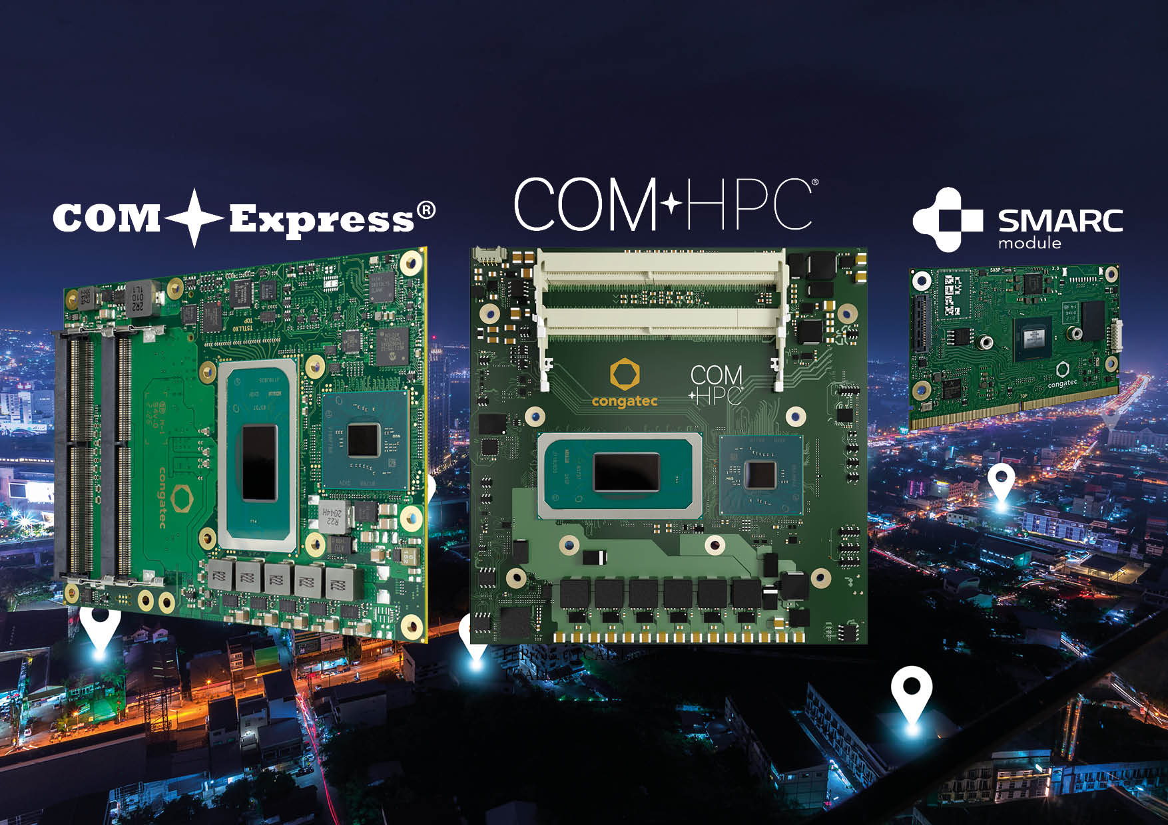

Deggendorf, Germany, 27 October, 2021 * * * congatec – a leading vendor of embedded and edge computing technology – introduces new platforms and design strategies for 5G connected mobile and stationary devices. As important innovation accelerators, 5G edge technologies are in high demand, especially among OEMs in the mobility, transportation, logistics and smart city markets, but also among industrial mobile machinery and robotics vendors. They all need new embedded platforms – most often with real-time capabilities. And they want to be able to control these new platforms over the air with zero downtime to enable a totally new generation of smart mobile and stationary devices. congatec addresses these needs with an array of recently launched Computer-on-Modules. Specifically designed for industrial-grade edge appliances, they enable out-of-band management over IP connectivity even when the devices are down.

“Most important for OEM equipment and embedded system design houses are currently the Intel Core processors based congatec modules that support the extended temperature ranges, which makes them a perfect fit for all outdoor equipment – whether mobile, portable or stationary. The latest congatec modules with soldered RAM also deliver great advantages as they are qualified for applications exposed to extreme shock and vibrations. All modules provide opportunity to deploy TSN capable real-time connected OTA services and Device2x communication. In addition, we also offer virtual machine implementations for enabling different tasks and domains on a single device,” explains congatec’s Director Product Marketing Martin Danzer and adds: “Target platforms, upon which our customers can realize their 5G strategies, range from high-end edge server to low power client platforms.”

COM-HPC: The new standard for innovators
Two new module families based on the brand new COM-HPC specification currently provide the greatest innovation potential for customers: The conga-HPC/cTLU and conga-HPC/cTLH COM-HPC Client modules based on the 11th Gen Intel Core vPro, Intel Xeon W-11000E, and Intel Celeron processors are designed for the most demanding IoT gateway and edge computing applications requiring highest bandwidth with up to 20 PCIe Gen 4 lanes. A congatec starter set is available for both module families to enable instant application development. The starter set includes the conga-HPC/EVAL-Client carrier board, which is based on the ATX form factor. This is highly efficient as engineers can utilize standard PC components for their embedded system designs. For more information on congatec’s COM-HPC portfolio, please visit https://www.congatec.com/en/technologies/com-hpc/

COM Express: Now better than ever before
Another highlight for 5G platform designs is congatec’s extensive COM Express portfolio, which offers the latest processor performance enhancements across the entire feature set. The brand new COM Express Type 6 conga-TS570 modules based on the new Tiger Lake H processors set a new benchmark for massive connected real-time IIoT gateway, edge computing and micro server workloads. For demanding transportation and mobility applications requiring high computing performance in an ultra rugged shape, the new 11th Gen Intel Core based modules are an ideal fit as they support extreme temperature ranges of -40°C to +85°C. For 24/7 connected fanless embedded systems, the conga-TCV2 COM Express Compact Computer-on-Modules based on AMD Ryzen Embedded V2000 processors are another attractive option. Please visit https://www.congatec.com/en/technologies/com-express/ to see the entire broad range of COM Express platforms for 5G connected appliances.

Small form factors: More power for the little things
congatec’s latest modules for the low power performance level are perfectly tailored for 5G connected and solar powered distributed process controls in smart energy grids, remote train and wayside systems, connected autonomous vehicles, and mobile outdoor equipment with limited battery capacity. Flagships with time sensitive networking (TSN) support include Intel Atom x6000E Series, Intel Celeron and Pentium N & J Series processors (code name “Elkhart Lake”) on SMARC, Qseven, COM Express Compact and COM Express Mini Computer-on-Module standards, as well as Pico-ITX Single Board Computers (SBCs).

Real-life system demo
Design setup with TSN support for 5G connected real-time appliances has been realized with congatec’s demo system for workload consolidation: Designed in cooperation with Intel and Real-Time Systems, and qualified by Intel as a ready for production unit, this platform integrates three preconfigured virtual machines to demonstrate how various tasks can be executed on a single platform with full determinism – even if one virtual machine is booting. The 5G enabled platform targets collaborative systems, and is preconfigured to include vision and AI for improved situational awareness.

Edge data center power
For OEMs requiring 5G connected edge server level computing power, congatec’s COM Express Type 7 Server-on-Modules based on the AMD EPYC 3000 Embedded processors support up to 16 cores. Multiple cores open even more options for workload consolidation by utilizing virtual machines on the basis of hypervisor technology from Real-Time Systems. As the EPYC 3000 Embedded processors consume up to 100 watt TDP, congatec has also designed appropriate cooling solutions, making system integration of these high-end embedded platforms an easy task.

The ARM Cortex flagships
SMARC and Qseven platforms on the basis of NXP i.MX 8 processor technologies round off the 5G platform offerings. Here, congatec sets the focus on the latest NXP i.MX 8M Plus processor. With machine and deep learning capabilities, the new ultra-low power SMARC and Qseven modules enable applications to see and analyze their surroundings for situational awareness, visual inspection, identification, surveillance and tracking, as well as gesture-based contactless machine operation and augmented reality. The technology is predestined for e-charging infrastructures requiring load balancing logic for various distributed charging columns and 5G connectivity for payment, services and management. TSN support is a given for all of these platforms.

Further information on congatec’s ecosystem for i.MX 8 based designs can be found at: https://www.congatec.com/imx8
* * *

About congatec
congatec is a rapidly growing technology company focusing on embedded and edge computing products and services. The high-performance computer modules are used in a wide range of applications and devices in industrial automation, medical technology, transportation, telecommunications and many other verticals. Backed by controlling shareholder DBAG Fund VIII, a German midmarket fund focusing on growing industrial businesses, congatec has the financing and M&A experience to take advantage of these expanding market opportunities. congatec is the global market leader in the computer-on-modules segment with an excellent customer base from start-ups to international blue chip companies. Founded in 2004 and headquartered in Deggendorf, Germany, the company reached sales of 127.5 million US dollars in 2020. More information is available on our website at www.congatec.com or via LinkedIn, Twitter and YouTube.

Reader enquiries:  congatec GmbH  Christian Eder  Phone: +49-991-2700-0  info@congatec.com  www.congatec.com | Press contact:  SAMS Network  Michael Hennen  Phone: +49-2405-4526720  info@sams-network.com  www.sams-network.com

Text and photograph available at: https://www.congatec.com/en/congatec/press-releases.html

Intel, the Intel logo, and other Intel marks are trademarks of Intel Corporation or its subsidiaries.

