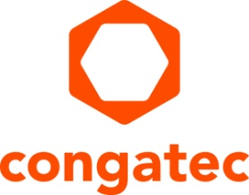
Press release

congatec opens virtual trade show booth for interactive information exchange

Round-the-clock accessibility
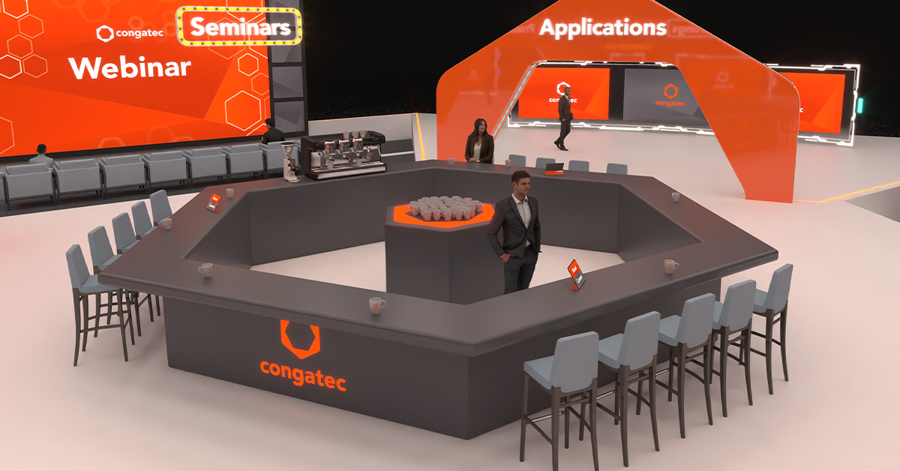

Deggendorf, Germany, 30 November, 2021 * * *, To provide additional learning opportunities for potential customers who are unable to attend trade fairs and exhibitions due to the pandemic, congatec has opened a digital trade show booth as a permanent exhibition on their website. A digital twin of the company’s engagement at real trade shows and events, the virtual trade show provides global access. The new congatec virtual exhibition complements a total of 11 in-person events worldwide by the end of 2021. Booth staff will be available round the clock on weekdays, allowing interested parties looking to get information and share ideas about the latest embedded and edge computing technologies to engage in conversation at any time.

“We invite the embedded community to check out our latest developments, free of any obligations. Visitors can interact with a member of staff via the chat functions. It’s the same low-threshold access to information we provide at live in-person trade shows.,” explains Christian Eder, Director Marketing at congatec.

Visitors can view the latest presentations or chat with booth staff just like at a real trade show using any simple browser. It feels a bit like arriving before the trade show doors have opened, visitors can explore at their leisure with no pressure. Getting the information at the virtual booth is only marginally different from what you’d expect from a visit to an in-person event.

The virtual booth is designed as a central information hub for congatec’s latest technologies, products and service offerings. It includes current product demonstrations and application examples as well as presentations on the latest technologies. A sales partner area and a library to browse through complete the offering. Potential job applicants will also find a list of vacancies and journalists an overview of the latest news. If a press conference is planned, this will be indicated separately as usual and individual invitations sent out. Follow the link to visit the virtual booth: https://www.congatec.com/fileadmin/virtual-fair-v2/

* * *

About congatec
congatec is a rapidly growing technology company focusing on embedded and edge computing products and services. The high-performance computer modules are used in a wide range of applications and devices in industrial automation, medical technology, transportation, telecommunications and many other verticals. Backed by controlling shareholder DBAG Fund VIII, a German midmarket fund focusing on growing industrial businesses, congatec has the financing and M&A experience to take advantage of these expanding market opportunities. congatec is the global market leader in the computer-on-modules segment with an excellent customer base from start-ups to international blue chip companies. Founded in 2004 and headquartered in Deggendorf, Germany, the company reached sales of 127.5 million US dollars in 2020. More information is available on our website at www.congatec.com or via LinkedIn, Twitter and YouTube.

Reader enquiries:  congatec  Christian Eder  Phone: +49-991-2700-0  info@congatec.com  www.congatec.com | Press contact:  SAMS Network  Michael Hennen  Phone: +49-2405-4526720  info@sams-network.com  www.sams-network.com

Text and photograph available at: https://www.congatec.com/en/congatec/press-releases.html

