Press release

congatec presents edge computing platforms with TSN support for real-time factories

Real-time Ethernet with open standards
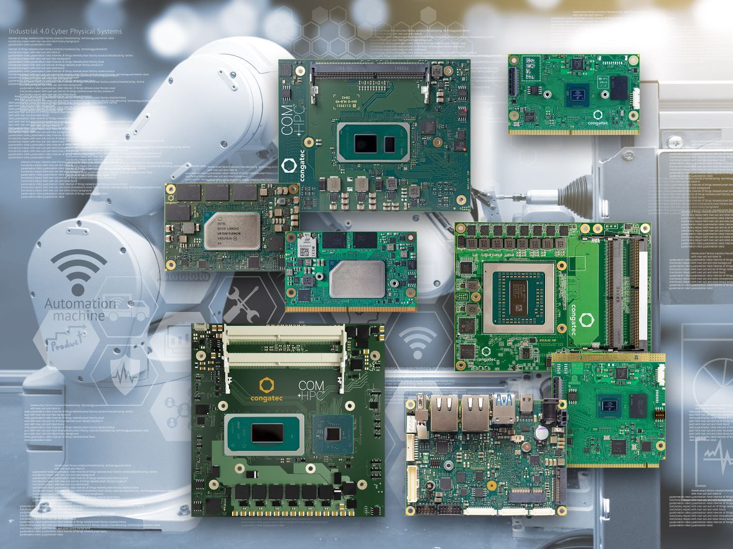

Taipei City, Taiwan, September 8, 2021 * * * congatec – a leading vendor of embedded and edge computing technology – is presenting its latest IIoT edge computing platforms at Smart Factory & Automation World Korea, Booth D136. The focus is on platforms that support Time Sensitive Networking (TSN) to enable real-time Ethernet communication on the basis of open standards. As TSN can even support Single Pair Ethernet, it can be used to substitute proprietary industrial Ethernet protocols as well as fieldbuses. Highlights shown at the congatec booth are edge computing platforms featuring Intel’s latest high-performance processors, including the formerly codenamed Tiger Lake H portfolio. These new COM Express Type 6 and COM-HPC Client Computer-on-Modules with 11th Gen Intel Core vPro, Intel Xeon W-11000E, and Intel Celeron processors are predestined for the design of real-time Ethernet connected edge computers that utilize TSN as the vendor-independent open standard technology for demanding collaborative Industry 4.0 applications.

“Smart factories are increasingly using collaborative robotics as well as CNC or SMT machinery that interacts with autonomous logistics vehicles. This interaction needs determinism. Open standards for real-time communication such as TSN are the next step for accelerating such IIoT scenarios,” explains congatec Korea country manager Yoonsun Kim.

A great setup for system designs with TSN interaction is demonstrated live at the booth with congatec’s demo system for workload consolidation: Designed in cooperation with Intel and Real-Time Systems, this platform integrates three preconfigured virtual machines to demonstrate how various tasks can be executed on a single platform with full determinism – even if one virtual machine is booting. The demo targets collaborative systems, and is preconfigured to include vision and AI for improved situational awareness.

For OEMs requiring edge server level computing power, congatec is showing a live demo of its COM Express Type 7 Server-on-Modules based on the AMD EPYC 3000 Embedded processors. With up to 16 cores, these modules open even more options for workload consolidation by utilizing virtual machines on the basis of hypervisor technology from Real-Time Systems. As these processors can easily consume up to 100 watt TDP, congatec has also designed appropriate cooling solutions, making system integration of these high-end embedded platforms an easy task.

Another accelerator for server-grade TSN enabled embedded systems are the upcoming Computer-on-Modules of the COM-HPC server specification for which the PICMG has recently also launched a Platform Management Interface for remote system management, even out-of-band. The congatec demo shows what those modules will look like, with mechanical samples to inspire engineers to adopt this standard for their next-generation edge server appliances.

Last but not least, there are demonstrations for the low power performance level. Flagships with TSN support include Intel Atom x6000E Series, Intel Celeron and Pentium N & J Series processors (code name “Elkhart Lake”) on the SMARC, Qseven, COM Express Compact and Mini Computer-on-Module standards, as well as Pico-ITX Single Board Computers (SBCs).

SMARC and Qseven platforms on the basis of NXP i.MX 8 processor technologies round off the booth demonstrations. Here, congatec sets the focus on the latest NXP i.MX 8M Plus processor. With its machine and deep learning capabilities, the new ultra-low power SMARC and the upcoming Qseven modules enable to see and analyze their surroundings for situational awareness, visual inspection, identification, surveillance and tracking as well as gesture-based contactless machine operation and augmented reality. TSN support is also a given for all of these platforms.

OEMs in need of TSN expertise are encouraged to contact congatec for comprehensive support and answers to all questions that might arise during the implementation process. As one of the first embedded computing vendors with hands-on software implementation experience of TSN, both on the Ethernet controller and the CPU level, congatec has already gained broad expertise to leverage for customers’ projects.

* * *

About congatec
congatec is a rapidly growing technology company focusing on embedded and edge computing products and services. The high-performance computer modules are used in a wide range of applications and devices in industrial automation, medical technology, transportation, telecommunications and many other verticals. Backed by controlling shareholder DBAG Fund VIII, a German midmarket fund focusing on growing industrial businesses, congatec has the financing and M&A experience to take advantage of these expanding market opportunities. congatec is the global market leader in the computer-on-modules segment with an excellent customer base from start-ups to international blue chip companies. Founded in 2004 and headquartered in Deggendorf, Germany, the company reached sales of 127.5 million US dollars in 2020. More information is available on our website at www.congatec.com or via LinkedIn, Twitter and YouTube.

Reader enquiries:  congatec  Crysta Lee  Phone: +886 2 25978577  info@congatec.com  www.congatec.com | Press contact:  SAMS Network  Michael Hennen  Phone: +49-2405-4526720  info@sams-network.com  www.sams-network.com

Text and photograph available at: https://www.congatec.com/en/congatec/press-releases.html

Intel, the Intel logo, and other Intel marks are trademarks of Intel Corporation or its subsidiaries.

