Press release

New ultra-rugged 11th Gen Intel® Core® congatec modules with soldered RAM

Shock and vibration resistant
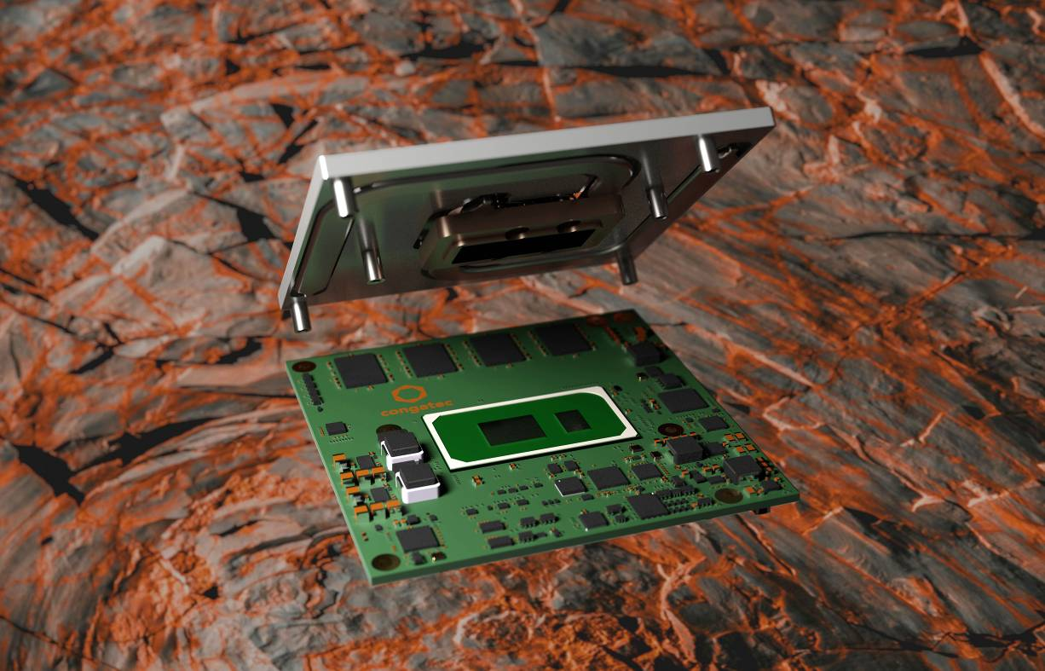

Deggendorf, Germany, 14 July 2021 * * * congatec – a leading vendor of embedded and edge computing technology – introduces new 11th Gen Intel® Core® processor based Computer-on-Modules with soldered RAM for highest shock and vibration resistance. Designed to withstand even extreme temperature ranges of -40°C to +85°C, the new COM Express Type 6 Computer-on-Modules provide full compliance for shock and vibration resistant operation in challenging transportation and mobility applications. For more price sensitive applications, congatec also offers a cost optimized Intel® Celeron® processor based variant for the extended temperature range from 0°C to 60°C. Typical customers for the new range of Computer-on-Modules based on the Tiger Lake microarchitecture are OEMs of trains, commercial vehicles, construction machines, agricultural vehicles, self-driving robots and many other mobile applications in the most challenging outdoor and off-road environments. Shock and vibration resistant stationary devices are another important application area as digitization requires critical infrastructure protection (CIP) against earthquakes and other mission critical events. All these applications can now benefit from super-fast LPDDR4X RAM with up to 4266 MT/s and in-band error-correcting code (IBECC) for single failure tolerance and high data transmission quality in EMI critical environments.

The value package includes rugged mounting options for the COM and carrier bundle, active and passive cooling options, optional conformal coating for protection against corrosion due to moisture or condensation, a list of recommended carrier board schematics, and for highest reliability, shock and vibration resistant components for the extended temperature range. This impressive technical feature set is complemented by a comprehensive service offering that includes shock and vibration tests for custom system designs, temperature screening, and high speed signal compliance testing, along with design-in services, and all required training sessions which simplify the use of congatec’s embedded computer technologies.

The benefits in detail
Based on the new low-power high-density 11th Gen Intel® Core® SoCs, the new modules offer significantly greater CPU performance and nearly 3x higher GPU performance compared to their predecessors, along with state-of-the-art PCIe Gen4 support. The most demanding graphics and compute workloads benefit from up to 4 cores, 8 threads, and up to 96 graphics execution units for massive parallel processing throughput in an ultra-rugged shape. The integrated graphics not only supports 8k displays or 4x 4k; it can also be used as parallel processing unit for convolutional neural networks (CNN) or as an AI and deep learning accelerator. The CPU integrated Intel AVX-512 instruction unit with support for Vector Neural Network Instructions (VNNI) is another feature accelerating AI applications. Using the Intel OpenVINO™ software toolkit, which includes optimized calls for OpenCV, OpenCL™ kernels, and other industry tools and libraries, workloads can be extended across CPU, GPU and FPGA compute units to accelerate AI workloads, including computer vision, audio, speech, and language recognition systems.

The TDP is scalable from 12 W to 28 W, enabling fully sealed system designs with passive cooling only. The impressive performance of the ultra-rugged conga-TC570r COM Express Type 6 module has been made available in a real-time capable design including support for Time Sensitive Networking (TSN), Time Coordinated Computing (TCC) and RTS Realtime Systems’ hypervisor for virtual machine deployments and workload consolidation in edge computing scenarios.

The ultra-rugged COM Express Compact Type 6 11th Gen Intel® Core® (code name Tiger Lake) modules are available in the following standard configurations with customization options upon request:

 | Processor |  | Cores/  Threads |  | Frequency at 28/15/12W TDP,  (Max Turbo) [GHz] |  | Cache [MB] | Graphics [Execution Units]
 | Intel® Core™ i7-1185GRE |  | 4/8 |  | 2.8/1.8/1.2 (4.4) |  | 12 | 96 EU
 | Intel® Core™ i5-1145GRE |  | 4/8 |  | 2.6/1.5/1.1 (4.1) |  | 8 | 80 EU
 | Intel® Core™ i3-1115GRE |  | 2/4 |  | 3.0/2.2/1.7 (3.9) |  | 6 | 48 EU
 | Intel® Celeron® 6305E |  | 2/2 |  | 1.8 |  | 4 | 48 EU

Further information on the new conga-TC570r COM Express Compact module can be found here: www.congatec.com/en/products/com-express-type-6/conga-tc570r/

Information on further Intel Tiger Lake solutions from congatec can be found on the main landing page: https://congatec.com/11th-gen-intel-core/

* * *

About congatec
congatec is a rapidly growing technology company focusing on embedded and edge computing products and services. The high-performance computer modules are used in a wide range of applications and devices in industrial automation, medical technology, transportation, telecommunications and many other verticals. Backed by controlling shareholder DBAG Fund VIII, a German midmarket fund focusing on growing industrial businesses, congatec has the financing and M&A experience to take advantage of these expanding market opportunities. congatec is the global market leader in the computer-on-modules segment with an excellent customer base from start-ups to international blue chip companies. Founded in 2004 and headquartered in Deggendorf, Germany, the company reached sales of 127.5 million US dollars in 2020. More information is available on our website at www.congatec.com or via LinkedIn, Twitter and YouTube.

Reader enquiries:  congatec GmbH  Christian Eder  Phone: +49-991-2700-0  info@congatec.com  www.congatec.com | Press contact:  SAMS Network  Michael Hennen  Phone: +49-2405-4526720  info@sams-network.com  www.sams-network.com

Text and photograph available at: https://www.congatec.com/en/congatec/press-releases.html

Intel, Celeron and Core are trademarks or registered trademarks of Intel Corporation in the U.S. and other countries.

