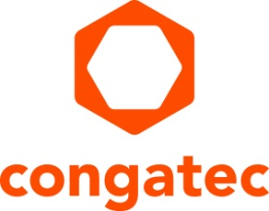
Press release

congatec and SYSGO join forces

Computer-on-Modules meet functional safety and security
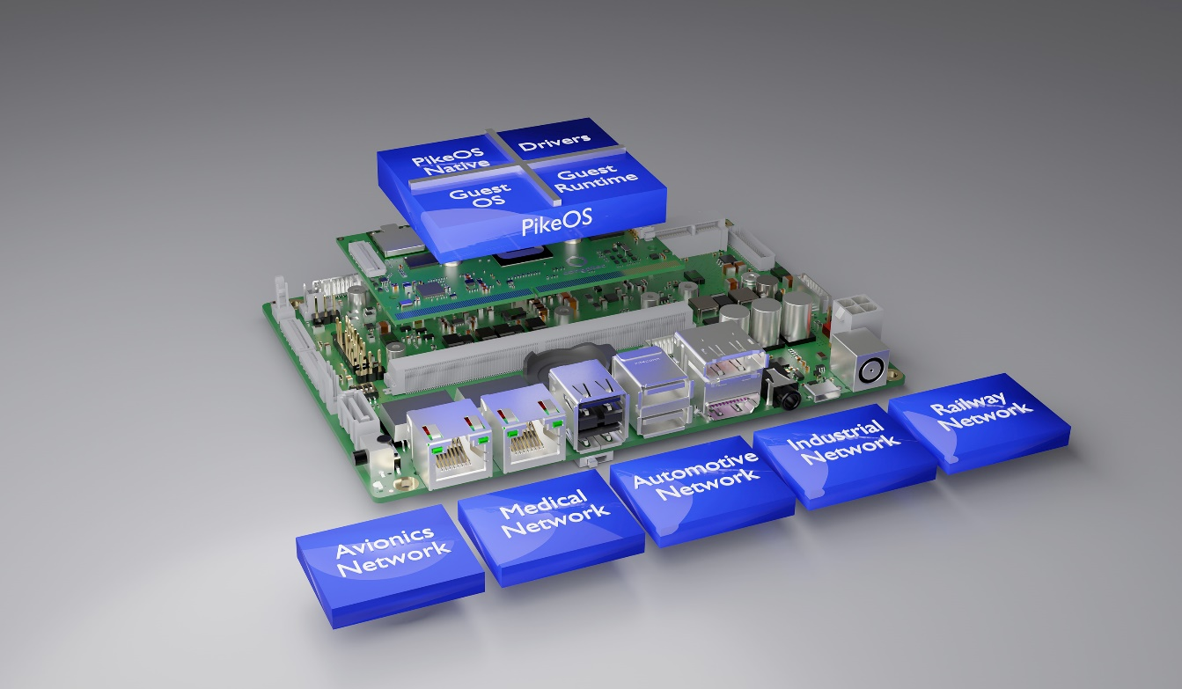

Deggendorf, Germany, 16 November 2021 * * * congatec – a leading vendor of embedded and edge computing technology – announces its strategic partnership with SYSGO, Europe’s number one provider of real-time operating systems for safety and cybersecurity applications. The goal is to provide the critical systems markets – such as industrial automation, medical, smart energy, railway, commercial and autonomous vehicles or construction machinery – with Arm and x86 based turnkey solution platforms that are specifically tailored to address functional safety and cybersecurity requirements. First implementations, certifiable in appropriate designs up to ASIL B or SIL 2, will be made available on x86 and Arm Cortex based Computer-on-Modules. A typical use case is Safety Element out of Context (SEooC) as defined in ISO 26262.

Designed to simplify and shorten the development process of safety and security-critical systems, the full-service offering provided under the new partnership agreement includes comprehensive certification support for the various safety standards analogue to the ICE 61508 standard for functional safety of electronic systems. Support for the SYSGO PikeOS RTOS and hypervisor based platforms ranges from railway (EN 50129 / EN 50657), commercial and agricultural vehicles (ISO 26262), civil avionics (DO-254), as well as PLCs in automation and process control (IEC 61508), to medical applications (IEC 62304). Customers also benefit from the PikeOS EAL3+ security certification according to the Common Criteria standard.

“The partnership with SYSGO extends the scope of congatec’s existing automation, collaborative robotics and railway platforms to safety and security-critical systems. And this cooperation makes great sense for both partners, now that the latest platforms from NXP and Intel make it possible for the first time to develop functional safety-critical systems without additional hardware. The aim of the partnership is to exploit this possibility and to make it available to the customer with considerably reduced effort,” explains Christian Eder, Director Marketing at congatec.

“To lower development and certification costs, manufacturers of functional safety-critical equipment focus on using pre-certified COTS software and hardware. This accelerates the development cycle, mitigates design risks for safety-critical devices, and reduces certification costs. With SYSGO as the leading European RTOS vendor we now have the right partner to offer such functional safety and security packages off-the-shelf, along with any custom design service required on the carrier board level, as and when needed,” underlines Martin Danzer Director Product Management at congatec.

“Entering into a strategic partnership with a world leading vendor of Computer-on-Modules enables us to offer customers scalable integrated hardware and software execution platforms that reduce time to market in complex embedded and edge computing projects. Leveraging multicore technologies and bringing together safety and cybersecurity capability in an all-in-one solution will bring our customers a valuable competitive advantage in their markets, while by design also addressing the increasing connectivity-related cybersecurity challenges,” says SYSGO CEO Etienne Butery.

A strong root of trust is essential for the safety and security of applications in environments that form part of critical infrastructures – aka KRITIS – as specified by the German Federal Office of Civil Protection and Disaster Assistance (BBK) and the Federal Office for Information Security (BSI). Functional safety appliances in critical infrastructures located in rugged environments are predominantly found in the transportation and traffic sector as well as in areas related to energy and water supply.

Engineers who develop IEC 61508 compliant functional safety appliances need embedded and edge computing platforms that are ready for certification – including drivers, BSPs and comprehensive documentation for the respective certificate. For this purpose, the new congatec solution platforms will incorporate a functional safety compliant computing core based on SYSGO’s PikeOS RTOS and hypervisor with Linux, plus certifiable BSPs. The first, Intel and NXP processor based platforms will target mobility appliances for the railway and commercial vehicle markets, including transport logistics. All common standard communication protocols for use in functional safety applications such as Ethernet and serial interfaces will be supported. The turnkey solution platforms will also come with the relevant requirements documents, covering all hierarchy levels that are structured by requirement IDs including traceability, so as to simplify reuse in customers’ own certifications and documentation. This greatly reduces the complexity of the process for the customer. OEMs also benefit from competent contacts, should they have questions regarding security-relevant software implementation, while customers have an expert to turn to with questions about the safety-relevant software implementation.

* * *

About congatec
congatec is a rapidly growing technology company focusing on embedded and edge computing products and services. The high-performance computer modules are used in a wide range of applications and devices in industrial automation, medical technology, transportation, telecommunications and many other verticals. Backed by controlling shareholder DBAG Fund VIII, a German midmarket fund focusing on growing industrial businesses, congatec has the financing and M&A experience to take advantage of these expanding market opportunities. congatec is the global market leader in the computer-on-modules segment with an excellent customer base from start-ups to international blue chip companies. Founded in 2004 and headquartered in Deggendorf, Germany, the company reached sales of 127.5 million US dollars in 2020. More information is available on our website at www.congatec.comor via LinkedIn, Twitter and YouTube.

About SYSGO
SYSGO is the leading European manufacturer of embedded software solutions such as the real-time operating system and hypervisor PikeOS and the embedded industrial-grade Linux ELinOS. Since 1991, SYSGO has been supporting customers in the Aerospace, Automotive, Railway and IIoT industries in the development of Safety-critical applications. SYSGO was the first company worldwide to achieve the Safety requirement level SIL 4 for its multi-core capable real-time operating system and hypervisor PikeOS. PikeOS version 4.2.3 Build S5577 meets the Common Criteria at the EAL 3+ level for ARMv7, ARMv8 and x86_64 and is also certified according to the strictest Safety standards such as IEC 61508, EN 50128, EN 50657 and ISO 26262, thus enabling application development according to the "Safe & Secure by Design" principle. For industrial embedded systems, SYSGO also offers ELinOS, a Linux distribution with real-time extensions for embedded systems. Furthermore, solutions such as the Railway development platform (SAFe-VX) and the Secure Automotive Connectivity Platform (SACoP) for secure data transfer in, with and between automobiles are available.
SYSGO works closely with its customers such as Samsung, Airbus, Thales, Continental, etc., throughout the entire product life cycle and supports them in the formal certification of software according to international standards for functional and IT Security. SYSGO is headquartered in Klein-Winternheim near Frankfurt, has subsidiaries in France and the Czech Republic and maintains a worldwide sales network. The company is ISO 9001:2015 and IEC/ISO 27001:2013 certified and part of the European Thales Group. More information at
www.sysgo.com

Reader enquiries:  congatec GmbH  Christian Eder  Phone: +49-991-2700-0  info@congatec.com  www.congatec.com | Press contact:  SAMS Network  Michael Hennen  Phone: +49-2405-4526720  info@sams-network.com  www.sams-network.com

Media contact SYSGO
Simon Jakob
Digital Content Manager
press@sysgo.com

Text and photograph available at: https://www.congatec.com/en/congatec/press-releases.html

Intel is a trademark or registered trademark of Intel Corporation in the U.S. and other countries.

