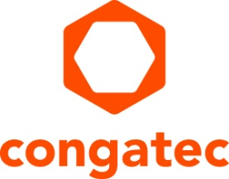
Press release

congatec i.MX 8M Plus starter set for AI accelerated embedded vision applications

Fast track to NPU accelerated smart vision
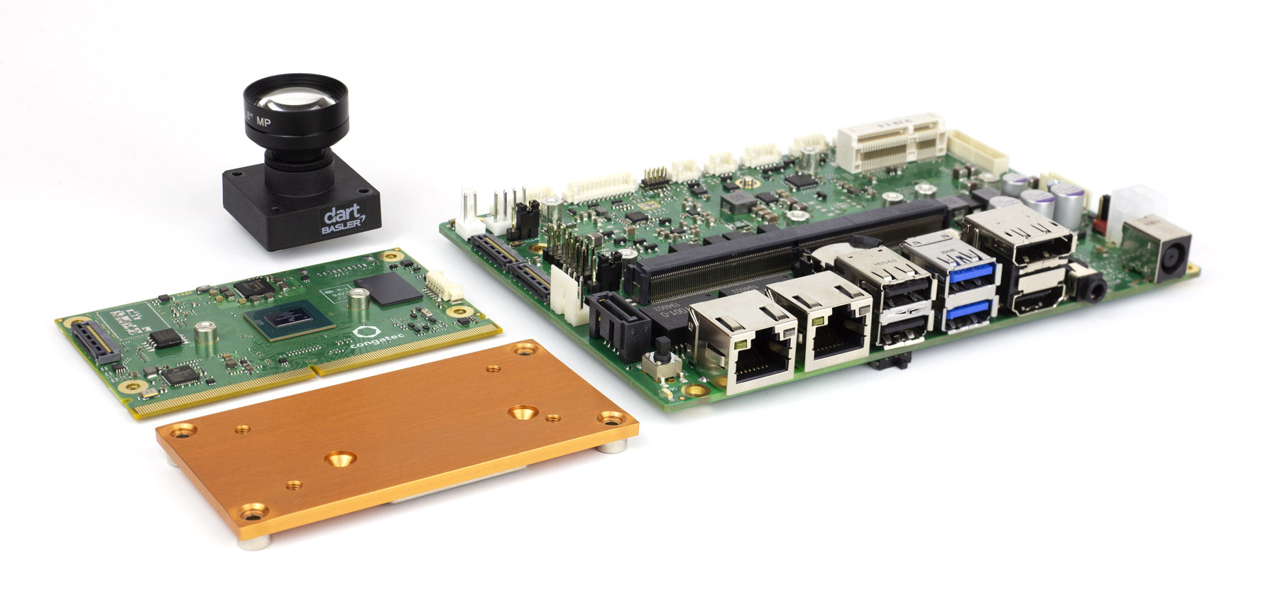
Deggendorf, Germany, 8 June 2021 * * * congatec – a leading vendor of embedded and edge computing technology – extends its i.MX 8 ecosystem with a new starter set for AI accelerated intelligent embedded vision applications. Based on a SMARC Computer-on-Module with i.MX 8M Plus processor, the starter set’s sweet spot is the utilization of the new processor integrated NXP Neural Processing Unit (NPU). Delivering up to 2.3 TOPS of performance for deep learning based artificial intelligence, it can run inference engines and libraries such as Arm Neural Network (NN) and TensorFlow Lite. It also integrates seamlessly with Basler embedded vision software to give OEMs an application ready solution platform for the development of next-generation AI accelerated embedded vision systems. Typical applications are wide ranging, from price sensitive automated checkout terminals in retail to building safety, and from in-vehicle vision for navigation to surveillance systems in busses. Industrial use cases include HMIs with vision based user identification and gesture based machine operation as well as vision supported robotics and industrial quality inspection systems.

“A dedicated processing unit for neural algorithms that is supported by open source AI software solutions such as TensorFlow is an efficiency accelerator for many vision based systems. And when all this is integrated as an application ready, hardware and software validated platform including Basler pylon Camera Software Suite, it puts developers on a fast track to designing NPU accelerated smart vision applications,” explains Martin Danzer, Director Product Management at congatec.

The Basler pylon Camera Software Suite delivers a unified SDK for BCON for MIPI, USB3 vision and GigE vision cameras, and enables camera access from source code, GUI or 3rd party software. The high-performance pylon viewer is perfect for camera evaluation. Thanks to integration in the congatec i.MX 8M Plus starter set for AI accelerated vision applications, engineers get instant access to important AI supported machine vision features such as triggering, individual image capture, and highly differentiated camera configuration options plus easy access to customized inference algorithms on the basis of the Arm NN and TensorFlow Lite ecosystem.

The feature set in detail
The new starter set for AI accelerated vision applications contains the entire ecosystem developers need to instantly start designing applications on the basis of this next-generation platform, which offers highly efficient vision and AI integration. At the heart of the set is the new SMARC 2.1 Computer-on-Module conga-SMX8-Plus. It features 4 powerful Arm Cortex®-A53 cores, 1x Arm Cortex®-M72 controller and the NXP NPU to accelerate deep learning algorithms and comes with passive cooling. The 3.5 inch carrier board conga-SMC1/SMARC-ARM directly connects the 13 MP Basler dart daA4200-30mci BCON for MIPI camera with an F1.8 f4mm lens via MIPI CSI-2.0 without any additional converter modules. Next to MIPI CSI-2.0, USB and GigE vision cameras are also supported. On the software side, congatec provides a bootable SD card with preconfigured boot loader, Yocto OS image, matching BSPs, and processor-optimized Basler embedded vision software enabling immediate AI inference training on the basis of captured images and video sequences.

Further information on congatec’s ecosystem for i.MX 8 based designs can be found at: https://www.congatec.com/imx8

congatec will be presenting its comprehensive ecosystem for the i.MX 8 processor range at the virtual NXP Technology Days from June 8 to June 30: https://www.nxp.com/design/training/nxp-technology-days/nxp-technology-days-connectivity:NXP-TECHNOLOGY-DAYS-CONNECTIVITY

* * *

About congatec
congatec is a rapidly growing technology company focusing on embedded and edge computing products and services. The high-performance computer modules are used in a wide range of applications and devices in industrial automation, medical technology, transportation, telecommunications and many other verticals. Backed by controlling shareholder DBAG Fund VIII, a German midmarket fund focusing on growing industrial businesses, congatec has the financing and M&A experience to take advantage of these expanding market opportunities. congatec is the global market leader in the computer-on-modules segment with an excellent customer base from start-ups to international blue chip companies. Founded in 2004 and headquartered in Deggendorf, Germany, the company reached sales of 127.5 million US dollars in 2020. More information is available on our website at www.congatec.com or via LinkedIn, Twitter and YouTube.

Reader enquiries:  congatec GmbH  Christian Eder  Phone: +49-991-2700-0  info@congatec.com  www.congatec.com | Press contact:  SAMS Network  Michael Hennen  Phone: +49-2405-4526720  info@sams-network.com  www.sams-network.com

Text and photograph available at: https://www.congatec.com/en/congatec/press-releases.html

