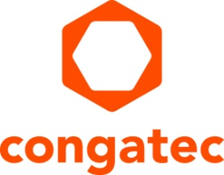
Press release

congatec announces the foundation of congatec Korea Ltd.

congatec to expand its business in Korea

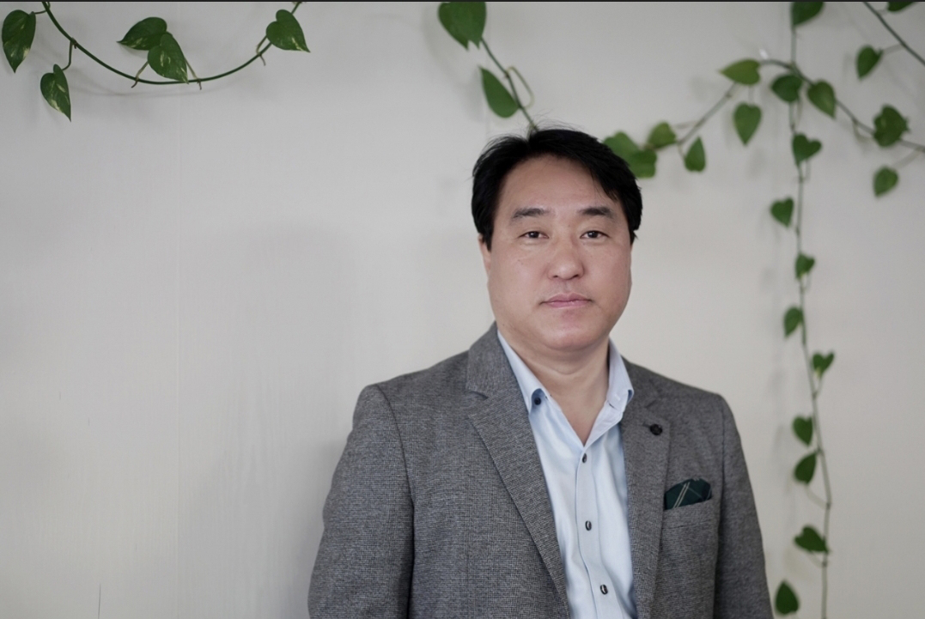
Yoonsun Kim, South Korea country manager at congatec

Deggendorf, Germany, 26 May, 2021 * * * congatec – a leading vendor of embedded and edge computing technology – announces the foundation of congatec Korea Ltd. to meet increasing customer demand in South Korea. The establishment of a new subsidiary underlines the importance of Korea for congatec’s global business success. In South Korea, congatec addresses many key markets for embedded and edge computing technologies, including medical equipment, automation, mobility, and semiconductor manufacturing where Korea is particularly strongly positioned. Customers benefit from efficient local technology support with the ‘made in Germany’ quality seal.

“Having a local branch makes it far easier to extend our business in Korea as it allows us to intensify our strong design-in support for our customers and optimize the supply chain and service organization for customers’ series production. For this purpose, we have now installed local FAE support and will be continuously increasing the team size based on our expected strong business growth,” explains congatec Korea country manager Yoonsun Kim.

The main strategic lever of growth is the ability of the local organization to continuously deliver strong support services and on-time deliveries. Here, congatec Korea’s expansion strategy is supported by the ability to access FAE, R&D and RMA services from the Asian headquarter in Taiwan to provide resources quickly, efficiently and without time zone differences. Those engineers are already experienced in delivering support with German quality and will help to accelerate the growth strategy of congatec Korea.

* * *

About congatec
congatec is a rapidly growing technology company focusing on embedded and edge computing products and services. The high-performance computer modules are used in a wide range of applications and devices in industrial automation, medical technology, transportation, telecommunications and many other verticals. Backed by controlling shareholder DBAG Fund VIII, a German midmarket fund focusing on growing industrial businesses, congatec has the financing and M&A experience to take advantage of these expanding market opportunities. congatec is the global market leader in the computer-on-modules segment with an excellent customer base from start-ups to international blue chip companies. Founded in 2004 and headquartered in Deggendorf, Germany, the company reached sales of 127.5 million US dollars in 2020. More information is available on our website at www.congatec.com or via LinkedIn, Twitter and YouTube.

Reader enquiries:  congatec GmbH  Christian Eder  Phone: +49-991-2700-0  info@congatec.com  www.congatec.com | Press contact:  SAMS Network  Michael Hennen  Phone: +49-2405-4526720  info@sams-network.com  www.sams-network.com

Text and photograph available at: https://www.congatec.com/en/congatec/press-releases.html

