Press release

congatec starter set for COM-HPC™ with 11th Gen Intel® Core™ processors

Getting in the fast lane to Gen4

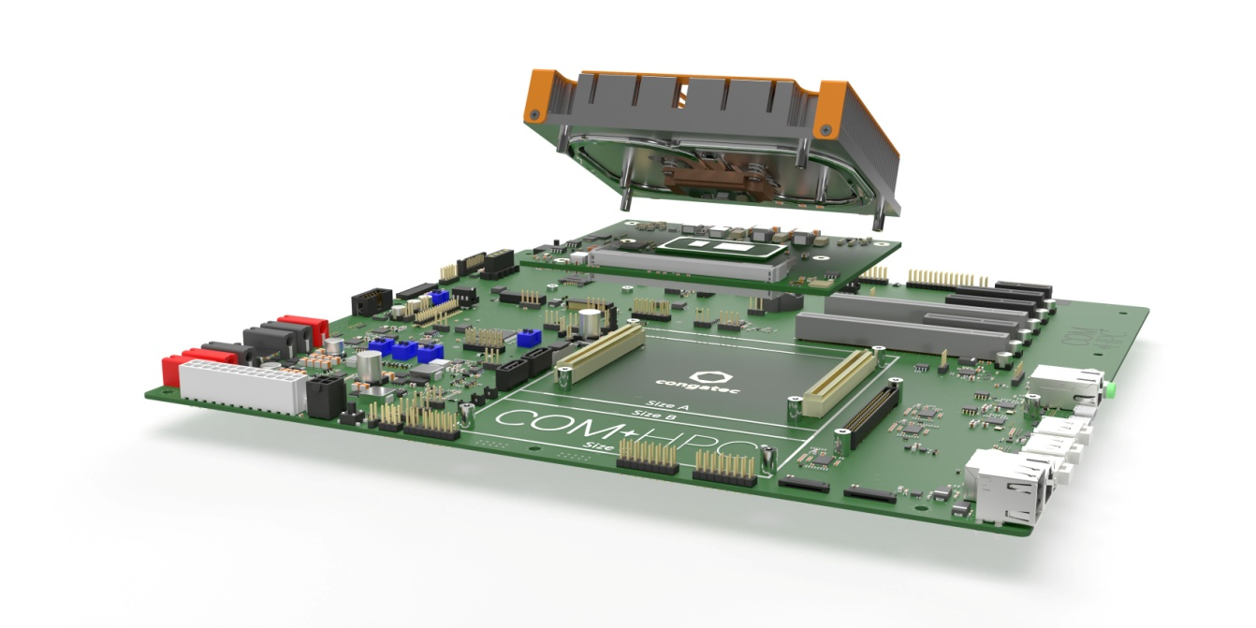
Deggendorf, Germany, March 2, 2021 * * * congatec – a leading vendor of embedded and edge computing technology – presents a brand new COM-HPC™ starter set at embedded world 2021 DIGITAL. Optimized for modular system designs utilizing the latest high-speed interface technologies such as PCIe Gen4, USB 4.0 and up to ultra fast 2x25 GbE connectivity as well as integrated MIPI-CSI vision capabilities, the starter set is based on congatec’s PICMG COM-HPC Computer-on-Module conga-HPC/cTLU, which leverages 11th Gen Intel® Core™ processor technology (code name Tiger Lake). This new high-end embedded module generation targets system engineers working on the broadband connected edge devices that are emerging in industrial IoT. Target markets include medical, automation, transportation and autonomous mobility, as well as vision based inspection and video surveillance systems, to name just a few.

“Our new COM-HPC starter set – which can be ordered with a choice of individually compiled components from our COM-HPC ecosystem – puts engineers in the fast lane to Gen4 interface technology and further ultra fast connectivity,” says Martin Danzer, Director Product Management at congatec. “PCIe Gen4 doubles the throughput per lane compared to Gen3, which has massive effects on system designs as it enables engineers to double the number of connected extension devices. Handling all this under more complex design rules to achieve the required signal compliance makes it even more important to have a mature evaluation and benchmark platform for own system designs.”

The starter set’s various Ethernet configuration options range from 8x 1GbE switching options and 2x 2.5 GbE including TSN support up to dual 10 GbE connectivity. congatec’s comprehensive AI support for MIPI-CSI connected cameras from Basler adds further application readiness to IIoT and Industry 4.0 connected embedded systems. AI and inferencing acceleration can be achieved with Intel® DL Boost running on the CPU vector neural network instructions (VNNI), or with 8-bit integer instructions on the GPU (Int8). Attractive in this context is the support of the Intel Open Vino ecosystem for AI, which comes with a library of functions and optimized calls for OpenCV and OpenCL kernels to accelerate deep neural network workloads across multiple platforms to achieve faster, more accurate results for AI inference. The starter set presented at embedded world 2021 DIGITAL is based on the following components of congatec’s COM-HPC ecosystem:

ATX compliant carrier board conga-HPC/EVAL-Client
The ATX compliant carrier board conga-HPC/EVAL-Client incorporates all interfaces specified by the new COM-HPC Client standard and supports the extended temperature range from -40°C to +85°C. It comes with two massively performant PCIe Gen4 x16 connectors plus a variety of LAN data bandwidths, data transfer methods and connectors, including 2x 10 GbE, 2.5 GbE and 1GbE support. Over mezzanine cards, the carrier can run even higher-performance interfaces up to 2x25 GbE, making this evaluation platform a perfect fit for massively connected edge devices. The board supports the COM-HPC sizes A, B and C, and includes all interfaces engineers require for programming, firmware flashing and reset.

New conga-HPC/cTLU COM-HPC Client module
The heart of the presented starter set for COM-HPC Client designs, the conga-HPC/cTLU computer-on-module, is available in different processor configurations. For each of these configurations, three different cooling solutions are available that fit the entire configurable 12-28W TPD range of the 11th Gen Intel® Core™ processors.

 | Processor |  | Cores/  Threads |  | Frequency at 28/15/12W TDP, (Max Turbo) [GHz] |  | Cache [MB] |  | Graphics Execution Units |  | Ext. Temp. range |  | InBand ECC
 | Intel® Core™ i7-1185G7E |  | 4/8 |  | 2.8/1.8/1.2 (4.4) |  | 12 |  | 96 |  | - |  | -
 | Intel® Core™ i7-1185GRE |  | 4/8 |  | 2.8/1.8/1.2 (4.4) |  | 12 |  | 96 |  | yes |  | Yes
 | Intel® Core™ i5-1145G7E |  | 4/8 |  | 2.6/1.5/1.1 (4.1) |  | 8 |  | 80 |  | - |  | -
 | Intel® Core™ i5-1145GRE |  | 4/8 |  | 2.6/1.5/1.1 (4.1) |  | 8 |  | 80 |  | yes |  | yes
 | Intel® Core™ i3-1115G4E |  | 2/4 |  | 3.0/2.2/1.7 (3.9) |  | 6 |  | 48 |  | - |  | -
 | Intel® Core™ i3-1115GRE |  | 2/4 |  | 3.0/2.2/1.7 (3.9) |  | 6 |  | 48 |  | yes |  | yes
 | Intel® Celeron® 6305E |  | 2/2 |  | 1.8 (n/a) |  | 4 |  | 48 |  | - |  | -

The product page of the conga-HPC/cTLU can be found at:
https://www.congatec.com/en/products/accessories/conga-hpceval-client/

For information about the COM-HPC standard and the entire congatec ecosystem please visit: https://www.congatec.com/com-hpc

Text and photograph available at: https://www.congatec.com/en/congatec/press-releases.html

***

Reader enquiries:  congatec GmbH  Christian Eder  Phone: +49-991-2700-0  info@congatec.com  www.congatec.com | Press contact:  SAMS Network  Michael Hennen  Phone: +49-2405-4526720  info@sams-network.com  www.sams-network.com

About congatec
congatec is a rapidly growing technology company focusing on embedded and edge computing products. The high-performance computer modules are used in a wide range of applications and devices in industrial automation, medical technology, transportation, telecommunications and many other verticals. Backed by controlling shareholder DBAG Fund VIII, a German midmarket fund focusing on growing industrial businesses, congatec has the financing and M&A experience to take advantage of these expanding market opportunities. congatec is the global market leader in the computer-on-modules segment with an excellent customer base from start-ups to international blue chip companies. Founded in 2004 and headquartered in Deggendorf, Germany, the company reached sales of 126 million US dollars in 2019. More information is available on our website at www.congatec.com or via LinkedIn, Twitter and YouTube.

Intel, Celeron and Core are trademarks or registered trademarks of Intel Corporation in the U.S. and other countries.

