Reader enquiries: | Press contact:
congatec AG | SAMS Network
Christian Eder | Michael Hennen
Phone: +49-991-2700-0 | Phone: +49-2405-4526720
info@congatec.com  www.congatec.com | info@sams-network.com  www.sams-network.com

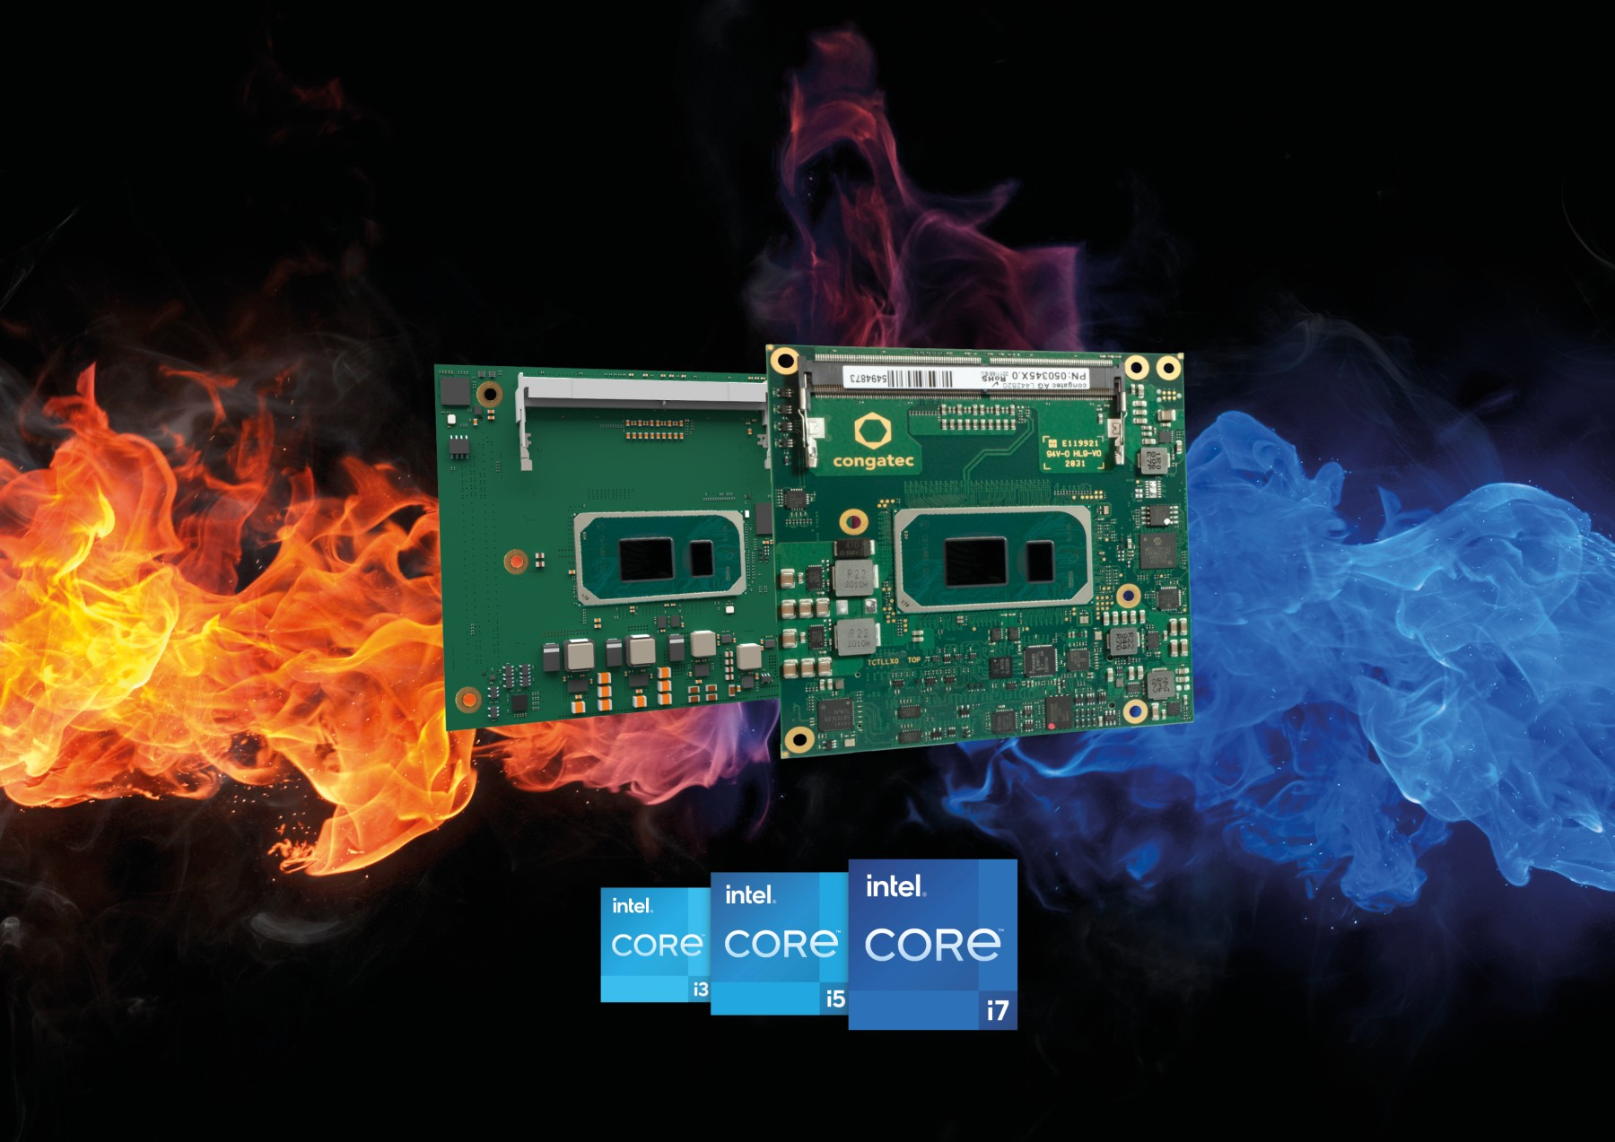
Text and photograph available at: https://www.congatec.com/en/congatec/press-releases.html
Press release
New congatec modules with 11th Gen Intel Core processors
for outdoor and in-vehicle applications

Hot stuff for extreme temperatures

Deggendorf, Germany, 10 November 2020 * * * congatec – a leading vendor of embedded and edge computing technology – introduces six new Computer-on-Modules with 11th Gen Intel Core processors for the extended temperature range. Built with high-quality components designed to withstand extreme temperatures from -40 to +85°C, the new COM-HPC and COM Express Type 6 Computer-on-Modules provide all features and services required for reliable operation in the most challenging environments.

The value package includes rugged passive cooling options, optional conformal coating for protection against corrosion due to moisture or condensation, a list of recommended carrier board schematics and suitable components for the extended temperature range for highest reliability. This impressive technical feature set is complemented by a comprehensive service offering that includes temperature screening, high speed signal compliance testing along with design-in services and all training sessions required to simplify the use of congatec’s embedded computer technologies.

Typical use cases for the new industrial-grade COM-HPC and COM Express modules can be found in any kind of rugged applications, outdoor edge devices and in-vehicle installations, which increasingly leverage embedded vision and artificial intelligence (AI) functions for which congatec provides extensive support as well. Typical verticals are industrial automation, railway and transportation, smart infrastructure including mission critical applications such as the energy, oil and gas sector, mobile ambulance equipment, telecommunication, or security and video surveillance, to name just a few.

Based on the new low-power high-density Tiger Lake SoCs, the new modules for wide temperature environments offer significantly greater CPU performance and nearly 3x higher GPU performance [1], along with state-of-the-art PCIe Gen4 and USB4 support. The most demanding graphics and compute workloads benefit from up to 4 cores, 8 threads and up to 96 graphics execution units for massive parallel processing throughput in an ultra-rugged shape. The integrated graphics can be used as parallel processing unit for convolutional neural networks (CNN) or as an AI and deep learning accelerator. Using the Intel OpenVINO software toolkit that includes optimized calls for OpenCV, OpenCL™ kernels, and other industry tools and libraries, workloads can be extended across CPU, GPU and FPGA compute units to accelerate AI workloads, including computer vision, audio, speech, language, and recommendation systems.

The TDP is scalable from 12W to 28W, enabling truly immersive 4k UHD system designs with passive cooling only. The impressive performance of the ultra-rugged conga-HPC/cTLU COM-HPC module and the conga-TC570 COM Express Type 6 module has been made available in a real-time capable design and also includes real-time hypervisor support from Real-Time Systems for virtual machine deployments and workload consolidation in edge computing scenarios.

“Services and support are absolutely key for standard based products. That’s why we complement our rugged product offering for all the new edge applications in challenging environments with a comprehensive eco system for each product.. This includes optimization for real-time computing – including support for Time Sensitive Networking (TSN), Time Coordinated Computing (TCC) and RTS Realtime Systems Hypervisor, remote management support and finally all required signal compliance services as high-speed signaling with PCIe Gen 4 and USB4 is a serious challenge these days, making carrier board design tasks increasingly complex,” explains Andreas Bergbauer, Product Line Manager at congatec.

The feature set in detail
The conga-HPC/cTLU COM-HPC Client Size A module, as well as the conga-TC570 COM Express Compact module will be available with new scalable 11th Gen Intel Core processors for extreme temperatures ranging from -40 to +85°C. Both modules are the first to support PCIe x4 in Gen 4 performance to connect peripherals with massive bandwidth. In addition, designers can leverage 8x PCIe Gen 3.0 x1 lanes. Where the COM-HPC module offers latest 2x USB 4.0, 2x USB 3.2 Gen 2, and 8x USB 2.0, the COM Express module offers 4x USB 3.2 Gen 2 and 8x USB 2.0 in compliance to the PICMG specification. For networking, the COM-HPC module offers 2x 2.5 GbE, whereas the COM Express module executes 1x GbE, with both supporting TSN. Sound is provided via I2S and SoundWire in the COM-HPC version, and HDA on the COM Express modules. Comprehensive board support packages are provided for all leading RTOS, including hypervisor support from Real-Time Systems as well as Linux, Windows and Android.

The two 11th Gen Intel Core processor based COM-HPC and COM Express Compact Type 6 modules are available in the following extended temperature range options:

 | Processor |  | Cores/  Threads |  | Frequency at 28/15/12W TDP, (Max Turbo) [GHz] |  | Cache [MB] | Graphics Execution Units
 | Intel® Core™ i7-1185GRE |  | 4/8 |  | 2.8/1.8/1.2 (4.4) |  | 12 | 96
 | Intel® Core™ i5-1145GRE |  | 4/8 |  | 2.6/1.5/1.1 (4.1) |  | 8 | 80
 | Intel® Core™ i3-1115GRE |  | 2/4 |  | 3.0/2.2/1.7 (3.9) |  | 6 | 48

Further information on the new conga-HPC/cTLU COM-HPC Client module can be found at: www.congatec.com/en/products/com-hpc/conga-hpcctlu/

The conga-TC570 COM Express Compact module has its landing page here:
www.congatec.com/en/products/com-express-type-6/conga-tc570/

Further information about congatec’s Intel Tiger Lake UP3 launch can be found on the main landing page: https://congatec.com/11th-gen-intel-core/

About congatec
congatec is a rapidly growing technology company focusing on embedded and edge computing products. The high-performance computer modules are used in a wide range of applications and devices in industrial automation, medical technology, transportation, telecommunications and many other verticals. congatec is the global market leader in the computer-on-modules segment with an excellent customer base from start-ups to international blue chip companies. Founded in 2004 and headquartered in Deggendorf, Germany, the company reached sales of 126 million US dollars in 2019. More information is available on our website at www.congatec.com or via LinkedIn, Twitter and YouTube.

* * *

[1] Source: Intel. Performance claim based on SPEC CPU 2017 metrics estimated by measurements on Intel internal reference platforms completed on August 27, 2020.
Graphics claim based on 3DMark11_V1.0.4 Graphics Score estimated by measurements on Intel internal reference platforms on August 27, 2020.
Testing configuration:
Processor: Intel® Core™ i7 1185G7E PL1=15W TDP, 4C8T Turbo up to 4.4GHz
Graphics: Intel Graphics Gen 12 gfx
Memory: 16GB DDR4-3200
Storage: Intel SSDPEKKW512GB (512 GB, PCI-E 3.0 x4)
OS: Windows 10 Pro (x64) Build 19041.331 (2004/ May 2020 Update). Power policy set to AC/Balanced mode for all benchmarks. All benchmarks run in Admin mode & Tamper Protection Disabled / Defender Disabled.
Bios: Intel Corporation TGLSFWI1.R00.3333.A00.2008122042
OneBKC: tgl_b2b0_up3_pv_up4_qs_ifwi_2020_ww32_4_01
Processor: Intel® Core™ i7 8665UE 15W PL1=15W TDP, 4C8T Turbo up to 4.4GHz
Graphics: Intel Graphics Gen 9 gfx
Memory: 16GB DDR4-2400
Storage: Intel SSD 545S (512GB)
OS: Windows 10 Enterprise (x64) Build 18362.175 (1903/ May 2019 Update). Power policy set to AC/Balanced mode for all benchmarks. All benchmarks run in Admin mode & Tamper Protection Disabled / Defender Disabled.
Bios: CNLSFWR1.R00.X208.B00.1905301319

