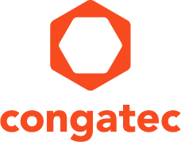
Reader enquiries: | Press contact:
congatec AG | SAMS Network
Christian Eder | Michael Hennen
Phone: +49-991-2700-0 | Phone: +49-2405-4526720
info@congatec.com  www.congatec.com | info@sams-network.com  www.sams-network.com

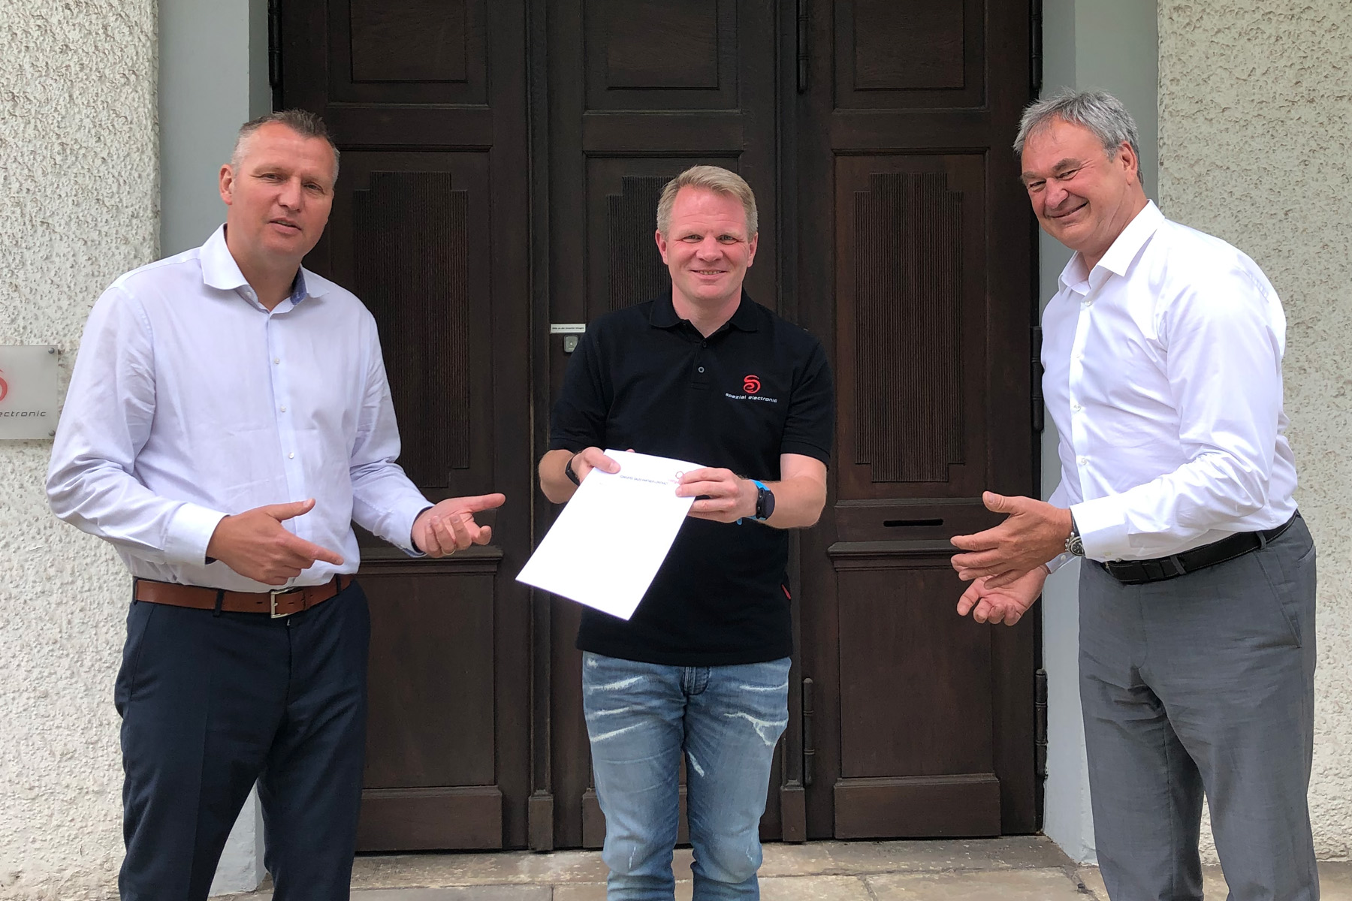
FLTR: Diethard Fent (congatec), Christopher Wuttke (SE), Roland Judith (congatec)
Text and photograph available at: https://www.congatec.com/en/congatec/press-releases.html

Press release
congatec and SE Spezial-Electronic sign distribution agreement
Leveraging synergies to increase customer benefits

Deggendorf/Bückeburg, Germany, 27 August 2020 * * * congatec – a leading vendor of embedded computing technology – and international electronic component distributor SE Spezial-Electronic are pleased to announce that they have signed a distribution agreement. SE Spezial-Electronic will now distribute the entire congatec product portfolio. The non-exclusive distribution agreement covers the entire DACH region as well as Poland and Great Britain.

“Computer-on-Modules and industrial single board computers from congatec are an attractive addition to SE Spezial-Electronic‘s memory and display offerings. The created synergies are excellent and have great potential to benefit customers. SE Spezial-Electronic is therefore predestined to become a strong sales channel partner,” says Diethard Fent, Sales Partner Manager EMEA at congatec.

“We are very pleased that our sales partnership with congatec will allow us greater access into the core of embedded applications,” comments Christopher Wuttke, CEO of SE Spezial-Electronic. “It marks a highlight in this special year – in which SE celebrates its 50th anniversary – to be able to add another really attractive product area and partner to our portfolio.”

The line managers of the new Embedded Group at SE Spezial-Electronic, Johannes Lange, Benjamin Bräuer and Jean-Paul Thom, also see significant synergies between their current product areas and the congatec solutions. “With congatec, we now have a five-star partner from Germany at our side who is the market leader in the field of Computer-on-Modules, provides innovative products and shares our philosophy of full development support. This enables us to provide our customers with an even more extensive choice of products,” adds Marius Wüstefeld, head of Inside Sales at SE Spezial-Electronic.

In addition to Computer-on-Modules and single board computers from congatec, SE Spezial-Electronic’s embedded offering includes sensor technology, storage solutions, displays, GNSS solutions and products for wireless communication (Bluetooth & WiFi).

About SE
SE Spezial-Electronic GmbH was founded in 1970 and is today an internationally operating distributor of electronic components. Headquartered in Bückeburg, Germany, the company has branches in Dortmund, Ellwangen, Munich, London and Amsterdam as well as subsidiaries in Poland, the Czech Republic, Russia and the USA. The product range includes ICs for the analog signal path, A/D and D/A conversion, and communication via radio and cable, modules and antennas for mobile communications, GNSS, Bluetooth, WLAN, RFID transponders and readers, sensors, quartz and silicon-based timing products, TFT, passive LC, LED, OLED and touch displays, flash memories, DRAMs and EEPROMs, discrete semiconductors, as well as passive and electromechanical components. For more information visit https://www.spezial.com

About congatec
congatec is a rapidly growing technology company focusing on embedded computing products. The high-performance computer modules are used in a wide range of applications and devices in industrial automation, medical technology, transportation, telecommunications and many other verticals. congatec is the global market leader in the computer-on-modules segment with an excellent customer base from start-ups to international blue chip companies. Founded in 2004 and headquartered in Deggendorf, Germany, the company reached sales of 126 million US dollars in 2019. More information is available on our website at www.congatec.com or via LinkedIn, Twitter and YouTube.

* * *

