Reader enquiries: | Press contact:
congatec AG | SAMS Network
Christian Eder | Michael Hennen
Phone: +49-991-2700-0 | Phone: +49-2405-4526720
info@congatec.com  www.congatec.com | info@sams-network.com  www.sams-network.com

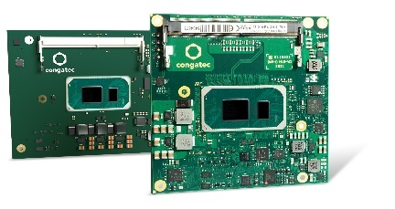
Text and photograph available at: https://www.congatec.com/en/congatec/press-releases.html

Press release
congatec fuels launch of 11th Gen Intel® Core™ processors
with two great new design options

First COM-HPC and next-gen COM Express

Deggendorf, Germany 03 September 2020 * * * In parallel with the 11th Gen Intel® Core™ processor launch (code named “Tiger Lake”), congatec – a leading vendor of embedded computing technology – announces the availability of both its first COM-HPC Client size A module and a next generation COM Express Compact Computer-on-Module. This provides engineers the choice to further scale the performance of their existing systems or develop the next generation of products utilizing COM-HPC’s broader array of interfaces. OEMs will benefit from the substantial performance improvements as well as communication enhancements that the new modules based on 11th Gen Intel Core processors deliver to the high-end computing sector. Typical applications can be found in many high-end solutions, from embedded systems and edge computing nodes to network hubs, and local fog data centers to core network appliances, as well as ruggedized central cloud data centers for critical government applications.

“congatec’s modules based on the 11th Gen Intel Core processors feature high-performance CPU/GPU compute with integrated AI acceleration for critical applications that demand high-speed processing, and computer vision,” explains Gerhard Edi, CTO at congatec. The highlights of the 11th Gen Intel Core processors provide a massive CPU performance boost, fast DDR4 memory, expansive PCIe Gen4 and USB 4.0 bandwidth. These performance enhancements are complemented by features that are critical for communication connected edge computers such as congatec’s support for hypervisor technologies e.g. from Real-Time Systems. All this comes in a powerful and energy-efficient package leveraging Intel’s SuperFin technology delivering increased power savings, physical density and providing even more compute power for given thermal envelopes.

The benefits of choice
“For the first time, design engineers now have the choice to go either with COM Express or COM-HPC. Each provide unique benefits for example, we have an improved next-gen connector for COM Express that is expected to offer better bandwidth capacities compared to what was available in the past. This is essential information for engineers thinking about utilizing the high bandwidth interfaces such as PCIe Gen 4. Engineers choosing COM-HPC will benefit from by far more high-speed interfaces delivered over 800 signal pins in total. This is almost twice as many pins as COM Express Type 6 modules deliver with 440 pins,” explains Andreas Bergbauer, Product Line Manager at congatec. To help engineers make the best choice, congatec provides engineering support and is creating a COM Express and COM-HPC design decision guide and a whitepaper, which will be available on congatec’s 11th Gen Intel Core processors page.

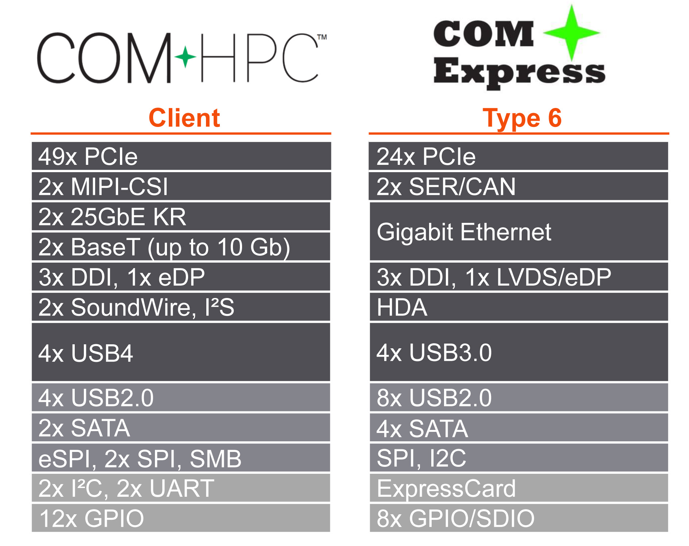
11th Gen Intel® Core™ processor comes on both form factors
COM Express (conga-TC570) and COM HPC (conga-HPC/cTLU)

Even more innovations and benefits
It is important to mention that besides PCIe Gen 4, the new congatec Computer-on-Modules with low-power 11th Gen Intel Core processors also offer USB 4.0, which is fundamentally based on Intel’s Thunderbolt technology. USB 4.0 supports amazing data transfer rates of up to 40 Gbit/s and tunneling of PCIe 4.0 as well as DP-Alt mode supporting video signals of up to 8k resolution with 10-bit HDR at 60 Hz.

The feature set in detail
The COM-HPC Client size A module conga-HPC/cTLU as well as the COM Express Compact conga-TC570 will become available with the 11th Gen Intel Core processors. Both modules are the first to support PCIe x4 in Gen 4 quality to connect external peripherals with massive bandwidth. In addition, designers can leverage 8x PCIe Gen 3.0 x1 lanes. Where the COM-HPC module offers latest 2x USB 4.0 and 2x USB 3.2 Gen 2 and 8x USB 2.0, the COM Express module offers 4x USB 3.2 Gen 2 and 8x USB 2.0 in compliance to the PICMG specification. Sound is provided via I2S, SoundWire by COM-HPC, and HDA by COM Express modules. Comprehensive board support packages are provided for all leading OS’s like Linux, Windows and Chrome, as well as hypervisor support from Real-Time Systems.

Further information about congatec’s new modules based on 11th Gen Intel Core processors can be found on the main landing page congatec.com/11th-gen-intel-core/

Further information on the new conga-HPC/cTLU COM-HPC Client module can be found at: https://www.congatec.com/en/products/com-hpc/conga-hpcctlu/

The conga-TC570 COM Express Compact module has its landing page here:
https://www.congatec.com/en/products/com-express-type-6/conga-tc570/

About congatec
congatec is a rapidly growing technology company focusing on embedded computing products. The high-performance computer modules are used in a wide range of applications and devices in industrial automation, medical technology, transportation, telecommunications and many other verticals. congatec is the global market leader in the computer-on-modules segment with an excellent customer base from start-ups to international blue chip companies. Founded in 2004 and headquartered in Deggendorf, Germany, the company reached sales of 126 million US dollars in 2019. More information is available on our website at www.congatec.com or via LinkedIn, Twitter and YouTube.

* * *

Intel and Core are trademarks or registered trademarks of Intel Corporation in the U.S. and other countries.

