Reader enquiries: | Press contact:
congatec AG | SAMS Network
Christian Eder | Michael Hennen
Phone: +49-991-2700-0 | Phone: +49-2405-4526720
info@congatec.com  www.congatec.com | info@sams-network.com  www.sams-network.com

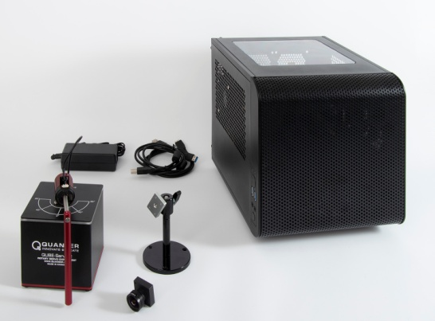
Text and photograph available at: https://www.congatec.com/en/congatec/press-releases.html
Press release
congatec presents Intel® IoT RFP Kit for workload consolidation in vision based situational awareness applications

See and understand

Deggendorf, Germany, 16 June 2020 * * * congatec – a leading vendor of embedded computing technology – presents its brand new workload consolidation kit for vision based situational awareness that is qualified by Intel as Intel® IoT RFP (Ready For Production) Kit. Based on a COM Express Type 6 module equipped with Intel® Xeon® E2 processor, the RFP kit has three virtual machines (VMs) built on Real-Time Systems’ hypervisor technology for workload consolidation in vision applications. One VM runs a vision based AI application on the basis of Intel® OpenVino® software for situational awareness, the second VM is real-time capable and runs deterministic control software, and the third VM operates a IIoT/Industry 4.0 gateway. The congatec kit designed in cooperation with Intel® and Real-Time Systems targets the next generation of vision based collaborative robotics, automation controls and autonomous vehicles that have to tackle multiple tasks in parallel, including situational awareness utilizing deep learning based AI algorithms.

The Real-Time Systems based virtual machines make it possible to consolidate the different tasks on a single edge computing platform, which ultimately saves costs. The Intel® OpenVino® software delivers the appropriate artificial intelligence for situational awareness. OEMs just need to load their control to the real-time VM and they are ready to enrich their real-time control with data from the situational awareness VM and to communicate in real-time with IIoT/Industry 4.0 counterparts to enable tactile internet controls.

“Workload consolidation demand is rapidly increasing in vision based situational awareness applications: Machine controls, collaborative robotics and autonomous vehicles need virtualization, as OEMs don’t want to assign the different control, vision and networking tasks to multiple dedicated systems,” explains Martin Danzer, Director Product Management at congatec.

The workload consolidation RFP kit unpacked
congatec’s ‘Intel® IoT RFP Kit’ for workload consolidation in vision based situational awareness applications includes a COM Express Type 6 module based platform with Intel® Xeon® E2 processor, a Basler vision camera, a pendulum controlled by a demo controller, and an Intel® Arria® 10 FPGA card from REFLEX CES. The platform has three pre-installed application ready VMs on the basis of Real-Time Systems’ hypervisor technology. One VM analyses videos on the basis of Intel® OpenVino® software, the second VM runs real-time Linux to control the balance of an inverted pendulum in real-time. The third partition hosts a gateway for IIoT/Industry 4.0 connectivity. More information about the new Intel® IoT RFP Kit for workload consolidation is available at:
https://marketplace.intel.com/s/offering/a5b3b000000ThjQAAS/realtime-workload-consolidation-starter-set
and https://www.congatec.com/workload-consolidation

About congatec
congatec is a rapidly growing technology company focusing on embedded computing products. The high-performance computer modules are used in a wide range of applications and devices in industrial automation, medical technology, transportation, telecommunications and many other verticals. congatec is the global market leader in the computer-on-modules segment with an excellent customer base from start-ups to international blue chip companies. Founded in 2004 and headquartered in Deggendorf, Germany, the company reached sales of 126 million US dollars in 2019. More information is available on our website at www.congatec.com or via LinkedIn, Twitter and YouTube.

* * *

Intel, Xeon, Arria and OpenVino are trademarks or registered trademarks of Intel Corporation in the U.S. and other countries.

