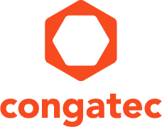
Reader enquiries: | Press contact:
congatec AG | SAMS Network
Christian Eder | Michael Hennen
Phone: +49-991-2700-0 | Phone: +49-2405-4526720
info@congatec.com  www.congatec.com | info@sams-network.com  www.sams-network.com

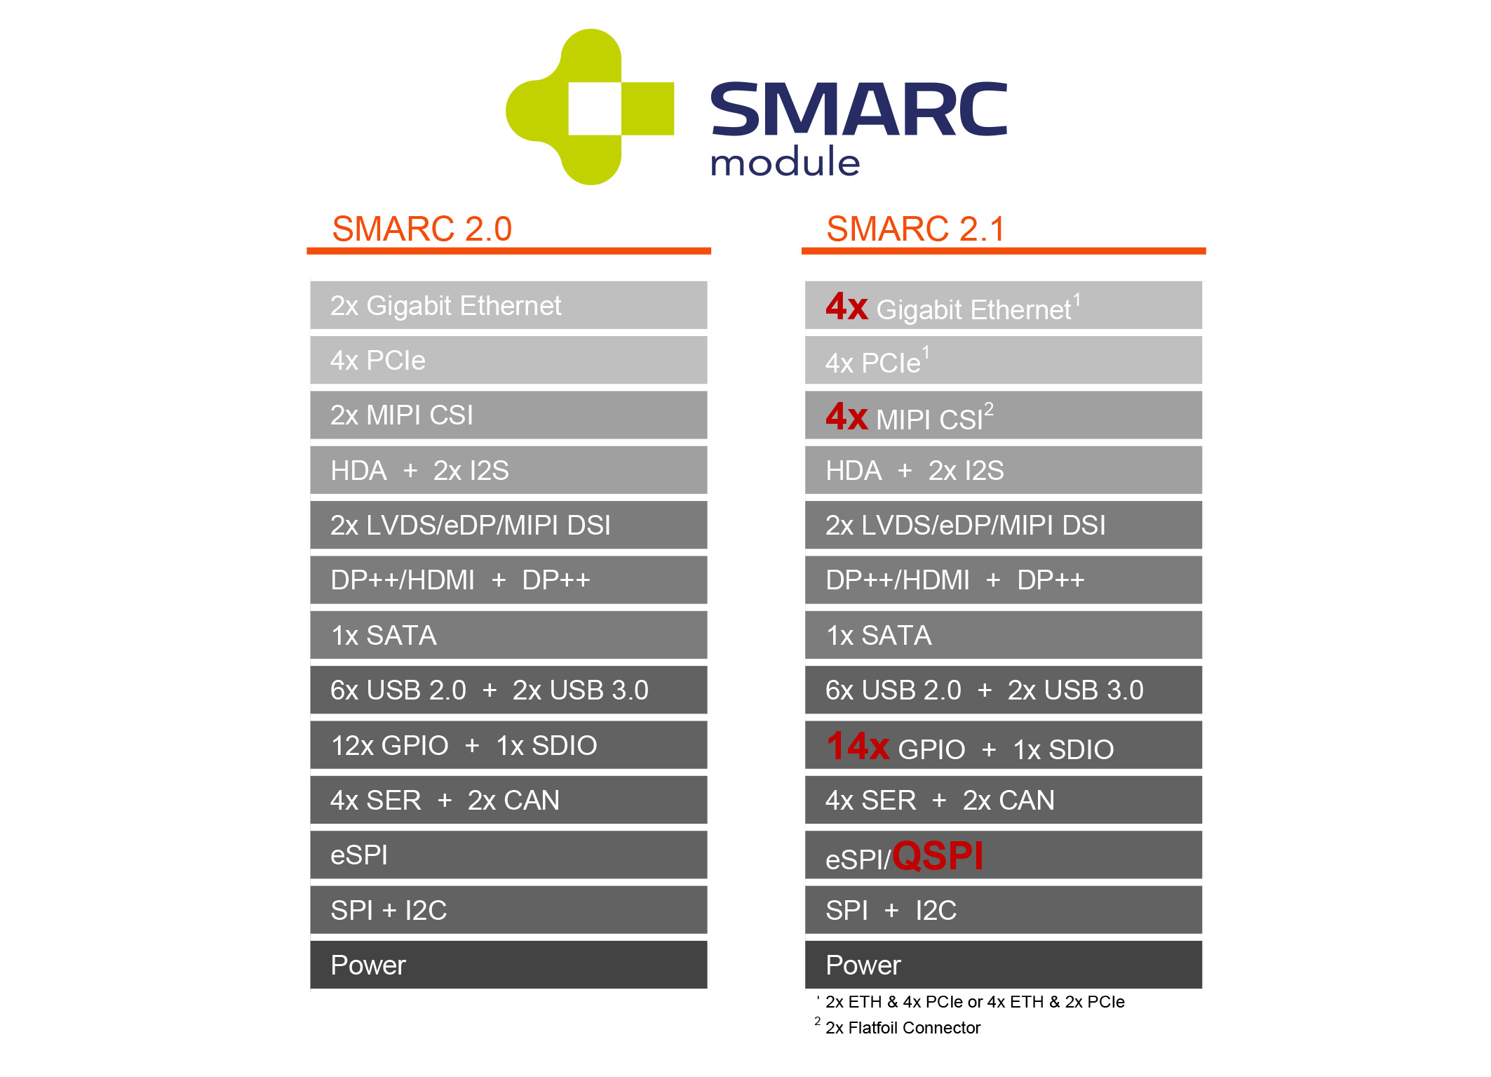
Text and photograph available at: https://www.congatec.com/en/congatec/press-releases.html
Press release
SGET adopts SMARC 2.1 specification
Advanced connectivity for embedded vision and the edge

Deggendorf, Germany, 23 March 2020 * * * congatec – a leading supplier of embedded computing technology – announces that SGET has approved the new SMARC 2.1 specification. With Christian Eder as editor, congatec was instrumental in shaping the specification. The new revision brings numerous additional features, such as SerDes support for extended edge connectivity and up to 4 MIPI-CSI camera interfaces to meet the increasing demand for a fusion of embedded computing and embedded vision. The new features are backward compatible with Rev. 2.0, which means that 2.1 modules can be integrated on 2.0 carriers. All extensions to Rev.2.0 are also optional, so all congatec SMARC 2.0 modules are automatically compatible with SMARC 2.1.

“The new SMARC 2.1 specification is an important step towards embedding MIPI-CSI camera technology, which is widely used in smartphones, firmly and for the first time within the standard of an embedded computing specification. We need this extremely cost-effective technology in order to be able to integrate it into any embedded application. For this purpose, SMARC 2.1 provides not only one or two, but up to four interfaces for comprehensive situational awareness and highest device efficiency,” explains Christian Eder, Director Marketing at congatec and SGET editor of the SMARC 2.1 specification.

As current studies by Industry Research.co show, demand for machine vision cameras is growing at clear double-digit rates. Growth is particularly strong in various non-industrial applications such as surveillance, forensics, robotic surgery, intelligent traffic systems, border control and health monitoring. In addition, camera technology continues to be used for process inspections to reduce errors such as incorrect fill levels, faulty products in the production line and packaging defects. Autonomous logistics vehicles also take up a large market share in the industrial sector.

With comprehensive Ethernet support for more connectivity at the edge gaining increasing significance, two of the four supported PCIe lanes now offer two additional Ethernet ports via SerDes signals. These can also be used for vision through the connection of GigE vision cameras.

Other new features include PCIe clock request signals, which can be used to switch off unused PCIe lanes to save power, and 14 instead of 12 GPIOs (General Purpose Input/Output). In response to many requests, the specification document was also completely restructured to optimize readability.

Further information on the new SMARC 2.1 specification can be found at SGET https://sget.org/standards/smarc/ .
Additionally, congatec prepared an updated white paper on the advantages of the SMARC specification which is available for download at: https://www.congatec.com/en/technologies/smarc.html

Further information on the SMARC 2.1 compatible conga-SMX8 with Arm based NXP i.MX 8 processors can be found at: https://www.congatec.com/en/products/smarc/conga-smx8.html

Further information on the SMARC 2.1 compatible conga-SA5 with Intel Atom® processors (code name Apollo Lake) can be found at: https://www.congatec.com/en/products/smarc/conga-sa5.html

About congatec
congatec is a rapidly growing technology company focusing on embedded computing products. The high-performance computer modules are used in a wide range of applications and devices in industrial automation, medical technology, transportation, telecommunications and many other verticals. congatec is the global market leader in the computer-on-modules segment with an excellent customer base from start-ups to international blue chip companies. Founded in 2004 and headquartered in Deggendorf, Germany, the company reached sales of 133 million US dollars in 2018. More information is available on our website at www.congatec.com or via LinkedIn, Twitter and YouTube.
* * *
Intel and Intel Atom are registered trademarks of Intel Corporation in the U.S. and other countries.

https://www.marketwatch.com/press-release/machine-vision-camera-market-trends-in-2020-estimated-growth-rate-by-cagr-industry-trends-size-share-top-leading-players-forecast-to-2024-industry-researchco-2020-01-30

