Reader enquiries: | Press contact:
congatec AG | SAMS Network
Christian Eder | Michael Hennen
Phone: +49-991-2700-0 | Phone: +49-2405-4526720
info@congatec.com  www.congatec.com | info@sams-network.com  www.sams-network.com

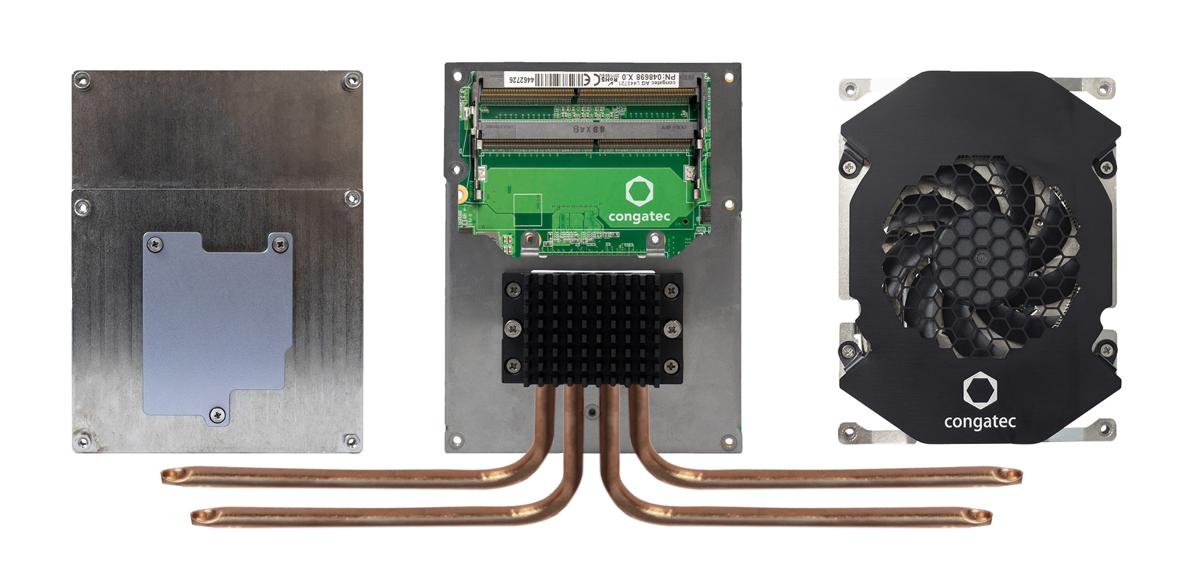
Text and photograph available at: https://www.congatec.com/en/congatec/press-releases.html
Press release

congatec presents new cooling solutions for 100 Watt edge server ecosystem

Keeping it cool

Deggendorf/Nuremberg, Germany, 25 February 2020 * * * congatec – a leading vendor of standardized and customized embedded computer boards and modules – presents three cooling solutions for the new 100 Watt edge server ecosystem that is being built around AMD EPYCTM Embedded 3000 Series Processors. With rugged cooling solutions and processor modules for 24/7 operation from a single source, OEMs no longer need to think about how to design in a processor waste heat management system. In fact, recommendations for system ventilation design are also often included, so that the thermal design effort at the system level is significantly reduced. Perfectly matched cooling solutions are essential for the 100 Watt edge server ecosystem, as overheating can lead to rapid aging and system failure. Edge servers with real-time requirements also need optimum protection against thermally induced performance degradation to ensure deterministic behavior, which further underscores the importance of high-performance cooling systems in industrial computer systems.

“The AMD EPYC Embedded 3000 Series Processors provide a new level of high-performance computing for embedded edge server systems. But with such embedded system designs, it is critical to manage the thermal envelope of any high-performance part. That’s why we’ve worked hard to create a 100 Watt ecosystem for high-performance COM Express modules that meets the rugged design requirements for 24/7 operation. We are now presenting three of these solutions for the first time at Embedded World 2020,” explains Andreas Bergbauer, Product Line Manager at congatec.

“The AMD EPYC Embedded 3000 Series Processors allow for a wide range of embedded edge server designs. It is great to see that companies such as congatec invest in offering a complete ecosystem with Server-on-Modules and all required accessories, such as these powerful cooling solutions, which will help simplify designs and help end customers get systems faster,” explains Stephen Turnbull, director of product management and business development, Embedded Solutions, AMD.

The congatec cooling solutions for the 100 watt ecosystem around the AMD EPYC Embedded 3000 Series Processors come in three variants, all based on the COM Express heatspreader specification that has been standardized by the PICMG, i.e. heatspreader with heatpipe adapter; heatspreader with integrated heatpipe; and an active cooling solution. Together with standard COM Express heatspreaders, OEMs can now choose between four variants that cover the entire range of processor cooling solutions.

Heatpipe adapter for COM Express heatspreader
The conga-B7E3/HPA heatpipe adapter absorbs the waste heat from the heatspreader via up to four heatpipes and directs it, for example, towards other passive heat sinks mounted on the housing. This allows the design of extremely powerful passively cooled systems for up to 100 Watt.

COM Express heatspreader with integrated heatpipe
The solution with integrated heatpipe, with the product name conga-B7E3/HSP-HP, was developed primarily for particularly flat embedded systems where a standard height COM Express heatspreader must be coupled to the housing. Here, the integrated heatpipe distributes the waste heat from the processor evenly over the entire heatspreader so that no hotspots are created, even in applications with a TDP of up to 100 Watt.

Active cooling system for rugged 24/7 operation
The fan-based active cooling system conga-B7E3/CSA-HP is specifically designed for 24/7 operation in harsh industrial environments. In this complete cooling system for COM Express Computer-on-Modules the fans are not only mounted extra securely, but also specifically fixed to reduce wear and tear. In addition, the bearings are equipped with a special seal and additional cover to provide maximum protection for mechanics and lubricant. With a high-performance synthetic oil as lubricant, the fan has an MTBF of several decades – and this in the industrial temperature range from -45 to +85°C and with industrial-grade shock and vibration resistance. The functional scope of this fan-based active cooling system is rounded off by the additional integration of a heatpipe to distribute the waste heat from the processor even before it reaches the active fan.
More information about congatec’s cooling solutions for the new 100 Watt ecosystem surrounding AMD EPYC Embedded Processor-based COM Express Computer-on-Modules can be found at: https://www.congatec.com/en/technologies/com-express/com-express-type-7/amd-epyc-embedded-3000-eco-system.html

About congatec
congatec is a rapidly growing technology company focusing on embedded computing products. The high-performance computer modules are used in a wide range of applications and devices in industrial automation, medical technology, transportation, telecommunications and many other verticals. congatec is the global market leader in the Computer-on-Module segment with an excellent customer base from start-ups to international blue chip companies. Founded in 2004 and headquartered in Deggendorf, Germany, the company reached sales of 133 million US dollars in 2018. More information is available on our website at www.congatec.com or via LinkedIn, Twitter and YouTube.

* * *
AMD, the AMD logo, EPYC, and combinations thereof are trademarks of Advanced Micro Devices, Inc.

