

|  |  |
| --- | --- |
| **Reader enquiries:** | **Press contact:** |
| **congatec AG** | **SAMS Network** |
| Christian Eder | Michael Hennen |
| Phone: +49-991-2700-0 | Phone: +49-2405-4526720 |
| [info@congatec.com](mailto:info@congatec.com)  [www.congatec.com](http://www.congatec.com) | [info@sams-network.com](mailto:info@sams-network.com)  [www.sams-network.com](http://www.sams-network.com) |

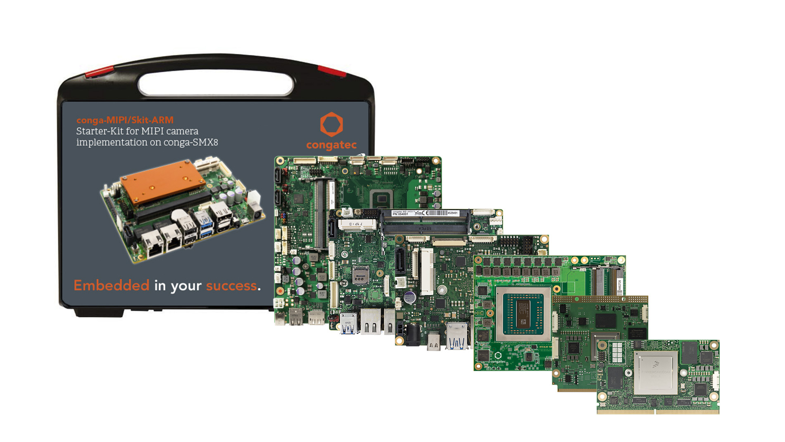

*Text and photograph available at:* [*https://www.congatec.com/en/congatec/press-releases.html*](https://www.congatec.com/en/congatec/press-releases.html)

Press release

congatec to focus on embedded edge computing at Embedded World

**From high-end to ultra-low-power edge servers**

**Deggendorf, Germany, 06 February 2020 * * \*** In its Embedded World 2020 showcase, congatec will be covering the entire spectrum of embedded edge computing, ranging from high-end edge servers to headless systems for ultra-low-power edge logic. Highlights include the upcoming PICMG COM-HPC standard, which congatec is driving with Christian Eder as chairman of the COM-HPC subcommittee, as well as congatec’s extended SMARC ecosystem for the NXP i.MX8 family, which is designed for the seamless use of MIPI camera technology and artificial intelligence, among other things. The breadth of the spectrum will be underscored by a new starter kit for real time workload consolidation as well as presentations from Basler and Hacarus. Innovative fanless cooling solutions for particularly robust embedded servers and systems that can dissipate up to 100 watts of TDP will complete the congatec Embedded World showcase.

“The innovations around COM-HPC are extremely significant as they establish a new standard for edge servers and extend the success of COM Express into new application areas. This is why they take center stage in our presentation,” explains Martin Danzer, Director Product Management at congatec. “What is also crucial is the fact that congatec covers the entire range of embedded edge logic, from high-end edge servers to deeply embedded ultra-low-power edge logic based on ARM processors. We provide comprehensive OEM Hardware and Firmware support across all these platforms, ensuring optimum connectivity, highest security and most convenient remote maintenance together with vision and AI integration, which is becoming increasingly important in many edge devices. With these hardware-centric additional services we offer our customers much more than simple interface support. We provide them with highly customized solution platforms for the easiest possible integration of their embedded edge computers.”

The COM-HPC presentations will focus on the already pre-released pinout of the upcoming specification, highlighting the choice of form factors and the different versions for embedded edge servers and embedded clients. The edge server variants come in two footprints, offering up to 64 PCIe lanes, 8x 25 GbE, and up to 8 DIMM sockets for 1 TB of RAM. The smaller COM-HPC client modules are available in three different footprints. They have four video interfaces and two camera inputs, and offer up to 4 SODIMM sockets.

In the presentations centering on the SMARC and Qseven ecosystems for the extremely energy-efficient and versatile NXP i.MX8 processor family, congatec will be highlighting innovative solutions with regards to vision and AI and easiest WiFi implementation. All are designed to make it easier for customers to integrate the new processors – from the i.MX 8X, to the i.MX 8M Mini, and the i.MX8. For an immediate design start off-the-shelf, congatec provides individually compiled binaries via Git-Hub that allow developers to boot their platforms directly.

The new Intel RFP Ready Kit for real time workload consolidation that congatec has compiled together with Intel and Real-Time Systems enables OEMs to directly start with the development next generation of vision-based collaborative robotics, automation controls and autonomous vehicles that have to tackle multiple tasks in parallel, including situational awareness utilizing deep learning based AI algorithms. The RFP Ready Kit utilizes the RTS Hypervisor from Real-Time Systems on congatec’s COM Express Type 6 based Intel® Xeon® E2 industrial application server platform and comes ready to order with everything designers need.

In cooperation with Basler and Hacarus, congatec will also be presenting application ready vision and AI development kits. The MIPI-CSI 2 Smart Camera Kit for vision systems at the edge integrates all hardware and software components that OEMs need for the development of embedded vision-based applications. A special highlight is the SMARC carrier board, featuring flat-foil connectors for the direct connection of Basler’s MIPI cameras.

The AI Development Kit, which is offered in cooperation with Hacarus, allows developers to directly evaluate the advantages of sparse modeling based AI. The kit integrates an AI system based on the highly scalable and powerful congatec Qseven modules with Intel ‘Apollo Lake’ processors. Thanks to sparse modeling it is possible – for the first time – to perform AI training tasks on the edge in addition to inference algorithms. This opens up completely new application areas for machine learning.

Innovative cooling solutions for the development of ultra-high-performance edge servers, designed for use in harsh environments away from air-conditioned data centers, complete the congatec showcase. Such powerful cooling is needed to allow users to take advantage of the full performance of the 16-core COM Express Type 7 modules with 3 GHz dual-die AMD EPYC Embedded 3000 processors.

With such a wide range from the low-power to the high end, and from modules to complete development kits, all user groups will benefit from stopping by at the congatec booth. So, come and visit congatec at Embedded World in Hall 1, Booth 358.

Further information on congatec’s Embedded World showcase can be found at: <https://www.congatec.com/ew2020>

**About congatec**

congatec is a rapidly growing technology company focusing on embedded computing products. The high-performance computer modules are used in a wide range of applications and devices in industrial automation, medical technology, transportation, telecommunications and many other verticals. congatec is the global market leader in the Computer-on-Module segment with an excellent customer base from start-ups to international blue chip companies. Founded in 2004 and headquartered in Deggendorf, Germany, the company reached sales of 133 million US dollars in 2018. More information is available on our website at [www.congatec.com](http://www.congatec.com) or via [LinkedIn](https://www.linkedin.com/company/455449), [Twitter](https://mobile.twitter.com/congatecAG) and [YouTube](http://www.youtube.com/congatecAE).

* * *