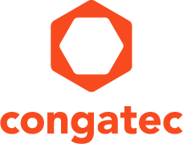
Reader enquiries: | Press contact:
congatec AG | SAMS Network
Christian Eder | Michael Hennen
Phone: +49-991-2700-0 | Phone: +49-2405-4526720
info@congatec.com  www.congatec.com | info@sams-network.com  www.sams-network.com

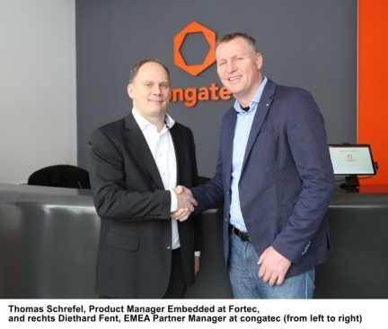
Thomas Schrefel, Product Manager Embedded at Fortec (left) and Diethard Fent, EMEA Partner Manager at congatec (right), are pleased about the sales partnership.

Text and photograph available: http://www.congatec.com/press

Press Release
congatec signs sales partnership with Fortec

congatec drives sales by broadening its market reach

Deggendorf, Germany, 19 February 2019 * * * congatec – a leading vendor of standardized and customized embedded computer boards and modules – has signed a sales partnership with Fortec. The goal is to expand the market reach of congatec’s embedded computer boards and modules as well as to create new higher value-added offerings. In addition to embedded computer technology, Fortec distributes displays and power supplies, on the basis of which the company also develops its own products. Thanks to the cooperation with congatec, the range of aligned solution platforms can now be widened.

“Fortec aims to add value through system integration, not just sell products. This matches the congatec direction perfectly: Simplify the use of embedded computer technology as much as possible for our customers. We are therefore looking forward to cooperating closely and expanding our solution platform offering as a result,” explains Diethard Fent, EMEA Partner Manager at congatec

Thanks to the sales partnership, Fortec wins one of the world’s leading providers of embedded computer technologies, also headquartered in Germany. This has many advantages for Fortec as well as their customers.

“The Fortec customer base includes primarily fast-growing high-tech companies in the medical technology, instrumentation & measurement, industrial automation and transportation industries. Among them there are customers who are keen to use embedded computer technology from congatec. As part of our sales partnership, they will also benefit from our development competence for Systems, HMI, control panel and display platforms,” says Thomas Schrefel, Product Manager at Fortec, who is delighted with the expansion of his line card.

About Fortec

Fortec Elektronik AG has been a leading distributor of standard solutions since 1984. The company’s portfolio includes embedded computer technology, displays and power supplies. In addition, the Fortec Group also offers custom-specific and complete system development. With five sales offices in Germany and Austria, as well as subsidiaries in Switzerland, the UK and the USA, the company serves over 5,000 customers.

About congatec
congatec is a leading supplier of industrial computer modules using the standard form factors COM Express, Qseven and SMARC as well as single board computers and customized services. congatec’s products can be used in a variety of industries and applications, such as industrial automation, medical, entertainment, transportation, telecommunication, test & measurement and point-of-sale. Core knowledge and technical know-how includes unique extended BIOS features as well as comprehensive driver and board support packages. Following the design-in phase, customers are given support via extensive product lifecycle management. The company’s products are manufactured by specialist service providers in accordance with modern quality standards. Headquartered in Deggendorf, Germany, congatec currently has entities in USA, Taiwan, China, Japan and Australia as well as United Kingdom, France, and the Czech Republic. More information is available on our website at www.congatec.com or via Facebook, Twitter and YouTube.
* * *

