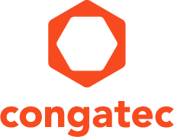

|  |  |
| --- | --- |
| **Reader enquiries:** | **Press contact:** |
| **congatec AG** | **SAMS Network** |
| Christian Eder | Michael Hennen |
| Phone: +49-991-2700-0 | Phone: +49-2405-4526720 |
| [info@congatec.com](mailto:info@congatec.com)  [www.congatec.com](http://www.congatec.com) | [info@sams-network.com](mailto:info@sams-network.com)  [www.sams-network.com](http://www.sams-network.com) |

*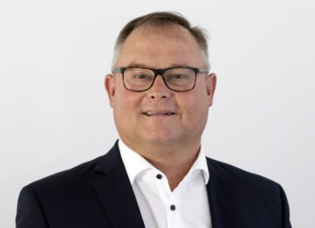  
Thomas Schultze, new Chief Operating Officer (COO) at congatec*

*Text and photograph available at:* [*https://www.congatec.com/en/congatec/press-releases.html*](https://www.congatec.com/en/congatec/press-releases.html)

Press release

**congatec appoints new Chief Operating Officer**

**Deggendorf, Germany, 24 September, 2019** * * * congatec – a leading supplier of standardized and customized embedded computer boards and modules – has appointed Thomas Schultze as new member of the Executive Board and new Chief Operating Officer (COO) with effect as of July 2019.

“We are excited to welcome Thomas Schultze to the team at congatec and look forward to working together with him as we continue to drive growth through operational excellence. As a strongly growing technology company we will benefit from his extensive experience leading operations in larger organizations”, says Jason Carlson, CEO of congatec.

The main task of Thomas Schultze will be to further increase the global operational efficiency and drive excellence in the supply chain. His focus areas include agile processes to improve customer service, ensure first class quality and technical support as well as cost efficiency. As an asset light company with fabless production at multiple sites around the globe, digitization also plays an increasingly important role for congatec.

With a business engineering degree and a General Management Master from the SGMI Management Institute St. Gallen, Thomas Schultze offers more than 20 years of experience in operations management, gained most recently as Vice President Global Operations at medical device market leader Ziehm Imaging. Prior to that, he held leading positions in companies such as laboratory equipment manufacturer Heidolph and automotive systems supplier Harman.

**About congatec**

congatec is a rapidly growing technology company focusing on embedded computing products. The high-performance computer modules are used in a wide range of applications and devices in industrial automation, medical technology, transportation, telecommunications and many other verticals. congatec is the global market leader in the computer-on-modules segment with an excellent customer base from start-ups to international blue chip companies. Founded in 2004 and headquartered in Deggendorf, Germany, the company reached sales of 133 million US dollars in 2018. More information is available on our website at [www.congatec.com](http://www.congatec.com) or via [Facebook](http://www.facebook.com/Congatec), [Twitter](https://mobile.twitter.com/congatecAG) and [YouTube](http://www.youtube.com/congatecAE).

* * *