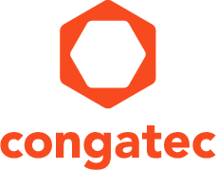
Reader enquiries: | Press contact:
congatec AG | SAMS Network
Christian Eder | Michael Hennen
Phone: +49-991-2700-0 | Phone: +49-2405-4526720
info@congatec.com  www.congatec.com | info@sams-network.com  www.sams-network.com

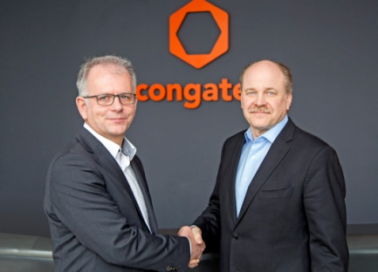
Jason Carlson (right), CEO of congatec, and Gerd Lammers, CEO at Real-Time Systems, shake hands on the deal

Text and photograph available at: http://www.congatec.com/press
Watch the video at: www.congatec.com/rts-video

Press release
congatec AG acquires Real-Time Systems GmbH
congatec accelerates real-time hypervisor adoption
for the embedded market

Nuremberg/Deggendorf, Germany, 27 February 2018 * * * congatec – a leading vendor of standardized and customized embedded computer boards and modules – has acquired Real-Time Systems GmbH (RTS), headquartered in Ravensburg, Germany. Founded in 2006, RTS is a leading provider of hypervisor software for real-time applications in the embedded market.

“The congatec strategy is to simplify the use of embedded computing technologies”, explains Jason Carlson, CEO of congatec. “As the connected IIoT and Industry 4.0 world is getting more and more complex, one of the most important strategic levers to meet this objective is to invest in software.” Getting the chance to acquire a market-proven and established hypervisor technology that perfectly matches the IIoT and Industry 4.0 needs is a significant milestone for congatec.

RTS will become a wholly owned subsidiary of congatec. The company will continue to operate independently, doing business as it always has, providing it’s software to run on any x86 hardware, but now with worldwide sales and technical support teams ready to support the product.

“If customers need a hypervisor with the best possible real-time performance, easy installation and configuration for any x86 multicore platform, supporting all popular real-time as well as general purpose operating systems, then the RTS Hypervisor from Real-Time Systems is the preferred choice,” explains Gerd Lammers, CEO at Real-Time Systems GmbH. “Our RTS Hypervisor therefore fits perfectly into congatec’s strategy of simplifying the use of embedded technology under very demanding circumstances. We are confident that our customers will benefit from our joined forces as it gives us the chance to grow faster, extend our offerings to new markets and improve our services on a global base.”

Real-Time Systems’ customers are OEMs from markets such as robotics, automation, mechanical engineering, medical technology or test and measurement systems. New markets further arise from the increasing real-time requirements of IIoT and Industry 4.0 applications as well as real-time broadcasting and streaming. Other customers are embedded computer technology manufacturers who qualify the platforms they develop as ODMs for OEMs for the RTS Hypervisor.

“We are investing in the sustainable growth of Real-Time Systems. For instance, we want to extend the functionalities of the RTS Hypervisor in order to open up new markets in the field of transportation. All RTS customers will benefit from these investments; this is because the RTS Hypervisor is independent of any RTOS and GPOS, which gives us the chance to set new standards. The explicit goal is therefore to continue to attract embedded computer manufacturers as customers and to maintain existing customers in this segment,” explains Gerhard Edi, CTO at congatec. “We will take all necessary organizational measures to achieve these goals. Discussions with these customers have already been initiated in connection with this acquisition announcement.”

About congatec
congatec is a leading supplier of industrial computer modules using the standard form factors COM Express, Qseven and SMARC as well as single board computers and customizing services. congatec’s products can be used in a variety of industries and applications, such as industrial automation, medical, entertainment, transportation, telecommunication, test & measurement and point-of-sale. Core knowledge and technical know-how includes unique extended BIOS features as well as comprehensive driver and board support packages. Following the design-in phase, customers are given support via extensive product lifecycle management. The company’s products are manufactured by specialist service providers in accordance with modern quality standards. Headquartered in Deggendorf, Germany, congatec currently has entities in USA, Taiwan, China, Japan and Australia as well as United Kingdom, France, and the Czech Republic. More information is available on our website at www.congatec.com or via Facebook, Twitter and YouTube.

* * *

