Reader enquiries: | Press contact:
congatec AG | SAMS Network
Christian Eder | Michael Hennen
Phone: +49-991-2700-0 | Phone: +49-2405-4526720
info@congatec.com  www.congatec.com | info@sams-network.com  www.sams-network.com

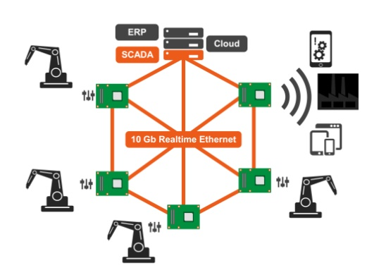
Text and image available at: http://www.congatec.com/press

Press release

congatec presents smart manufacturing IT platforms for
‘Made in China 2025’ solutions at CIIF

congatec brings German Industry 4.0 expertise to China

Deggendorf, Germany /Shanghai, China, November 2, 2017 * * * The Taiwan located subsidiary of congatec – a leading technology company for embedded computer modules, single board computers and embedded design and manufacturing services – is presenting smart manufacturing IT platforms for ‘Made in China 2025’ (MIC 2025) solutions at CIIF, China International Industry Fair (Hall 6.1H, Booth A065) in Shanghai. These instantly deployable computing platforms enable Chinese machine building and manufacturing systems engineers to develop smart, connected manufacturing equipment as well as robotics and intra-logistics devices with situational awareness for collaborative manufacturing.

The new congatec MIC 2025 platforms are based on embedded motherboards and single board computers as well as Computer/Server-on-Modules, leveraging open standards that are freely accessible all over the world. With congatec acting as a fabless platform vendor, they can facilitate any logistical requirements for Chinese customers wishing to export their MIC 2025 manufacturing solutions globally.

The showcased congatec MIC 2025 computer platforms feature all required interface functionalities and software support for smart connected manufacturing systems – including IIoT based machine control and monitoring as well as maintenance clouds.

“congatec brings its German Industry 4.0 and IIoT expertise to the Chinese market with the extensive open standards based MIC 2025 computer platforms. This will help the Chinese economy reach the ‘Made in China 2025’ goals while at the same time fueling our own growth strategies, as high-quality production requires smart manufacturing capabilities and our open standards based embedded computing technologies offer the fundamental building blocks for this intelligence”, explains Becky Lin, Sales Director at congatec China. “We have FAEs and partners in all major economic regions such as Beijing, Shanghai, Shenzhen and Chengdu that are experienced in our IIoT and German Industry 4.0 technology. With the additional support of our experts in Taiwan and the German headquarters, we can competently address all major questions and service demands from local machine building and manufacturing systems engineers.”

One of the various MIC 2025 demonstrations at CIIF includes a presentation featuring virtualized COM Express Type 7 Computer-on-Modules based on the new Intel® Atom™ C3000 platform (code name Denverton) and focusing on the real-time capabilities of virtualized industrial server platforms. The installation is tailored for industrial and carrier-grade cloud, edge and fog servers as well as smart real-time controls, robotics and manufacturing cells that need a virtualized environment to cater for various tasks in parallel. Examples are deterministic, hard real-time machine control; IIoT and cloud connectivity; and horizontal real-time communication in Industry 4.0 environments.

Additional presentations include multifunctional gateway technologies for smart sensor networks which offer all the fundamental gateway logic off-the-shelf and based on open standard initiatives. The goal is to reduce the engineering effort for the manifold tasks of smart manufacturing gateways, such as converting and analyzing local sensor data, as well as decision making and communication in all vertical and horizontal directions. This presentation is based on congatec’s conga-IoT Gateway and Cloud API for IoT Gateways that has been designed to set the foundation of a standard for building a vendor independent ecosystem for IoT gateway logic within the specifications of the Standardization Group for Embedded Technologies (SGET).

About congatec AG
Headquartered in Deggendorf, Germany, congatec AG is a leading supplier of industrial computer modules using the standard form factors COM Express, Qseven and SMARC as well as single board computers and EDM services. congatec’s products can be used in a variety of industries and applications, such as industrial automation, medical, entertainment, transportation, telecommunication, test & measurement and point-of-sale. Core knowledge and technical know-how includes unique extended BIOS features as well as comprehensive driver and board support packages. Following the design-in phase, customers are given support via extensive product lifecycle management. The company’s products are manufactured by specialist service providers in accordance with modern quality standards. Currently congatec has entities in USA, Taiwan, China, Japan and Australia as well as United Kingdom, France, and the Czech Republic. More information is available on our website at www.congatec.com or via Facebook, Twitter and YouTube.

* * *

Intel and Intel Atom are registered trademarks of Intel Corporation in the U.S. and other countries.

