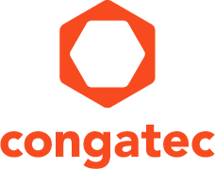
Reader enquiries: | Press contact:
congatec AG | SAMS Network
Christian Eder | Michael Hennen
Phone: +49-991-2700-0 | Phone: +49-2405-4526720
info@congatec.com  www.congatec.com | info@sams-network.com  www.sams-network.com

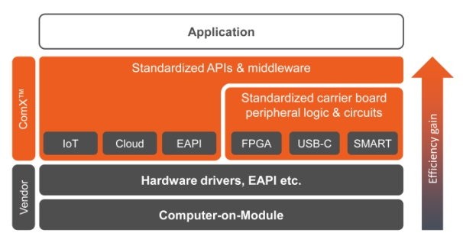
Text and photograph available at: http://www.congatec.com/press

Press release

ESEC 2017: congatec announces ComX™ standardization initiative

congatec again pushes standardization to boost
design efficiency

Deggendorf, Germany / Tokyo, Japan, 09 May, 2017 * * * congatec – a leading technology company for embedded computer modules, single board computers and embedded design and manufacturing services – announces at the Embedded Systems Expo & Conference (ESEC 2017) in Japan (West Hall 1F , Booth W4-20) the extended standardization initiative ComX™ that goes beyond the current specifications for computer-on-modules. This ComX™ standardization targets two pillars, the API and middleware standardization including APIs for IoT Gateways or embedded features of COM Express Type 7 server-on-modules as well as approved circuit diagrams and logic for demanded carrier board implementations such as FPGA integration, switching logic for USB-C, or for SMART battery logic.

“Significant improvements for design efficiency are highly demanded by embedded and IoT system engineers, who are faced with the design challenge of having to deliver more new product designs in the same or even shorter time frames. They can meet these challenges by switching from full custom, single PCB designs to more flexible designs based on application ready computer-on-modules. We can boost this efficiency even more, by offering an additional standardization on top of the computer-on-module centric specifications”, explains Christian Eder, director marketing at congatec and draft editor of various PICMG and SGET specifications.

For custom specific designs, computer-on-modules deliver the vendor independent, standardized and application ready computing core, thereby making the realization of individual board configurations far less time consuming. By utilizing computer-on-modules engineers can immediately equip their designs with the latest processor technology, with the additional benefit that the modules come not only as components but also with comprehensive driver support, which is mainly focused on the module functions.

The goal of the ComX™ standard is to establish an additional design-in and API standardization on top of the core standards to further simplify the development of customers’ dedicated applications based on standardized embedded computing building blocks. ComX™ standardization addresses everything beyond the existing module centric standards. A selection of standardized options is showcased at the congatec ESEC booth and additional vendors are invited to help further establish the standardization of these features within the PICMG and SGET.

One highlight of the ESEC showcase is the quick boot demo based on congatec’s new Qseven conga-UMX6 computer-on-module with NXP’s (former Freescale) i.MX6 processors. i.MX6 processors enable a highly customizable quick boot of systems in less than a second from power off to full operation including running applications. This is vital for delivering the best user experience at maximum power savings. Typical use cases range from kiosk systems and video surveillance applications with motion detection to any other application that needs to be instantly available after an active impulse, such as in-car infotainment systems and multiple HMI/GUIs of any machinery. “ComX™ standardization includes the CPU technology independent implementation of a carrier board. A clever designed carrier board can utilize I2S for ARM and HDA for x86 sound implementation”, explains Eder.

Also brand new and impressive is the new SMARC 2.0 computer-on-module demonstration based on of Intel® Atom™, Celeron® and Pentium® processors (codename Apollo Lake) where congatec presents the implementation of fully featured USB Type C connectivity with USB 3.1 Gen1, power and graphics. By demonstrating this universally applicable form of plug & play functionality, congatec greatly simplifies the use of embedded technology. Fully featured USB-C jacks are still rare and present a real breakthrough for standardizing the fragmented world of cable-based external interconnects. “Such standardization is very beneficial for system engineers as well as system integrators and device users. System engineers don’t need to think about the interface setup anymore”, comments Eder.

A highlight for the high-end embedded and edge sever sectors are the new COM Express Type 7 based server-on-modules offering server-grade performance and functionality with their Intel® Xeon® D processors, 2x 10 GbE and 32 PCIe lanes. The latter can be used for powerful intra system expansions such as GPGUs and NVMe based ultra-fast storage devices as well as multi-module configurations on one single carrier board for high performance computing (HPC) designs. Application areas for the server-on-modules can be found in various scenarios from IT and carrier-grade server farms and cloudlets to edge, fog and Industry 4.0 servers. “An important standardization within the server sector was accomplished by launching the COMe Type 7 specification. Now we need to extend the EAPI standardization for server type functionality”, highlights Eder.

The presentation of the new congatec Cloud API (Application Programming Interface), that is designed for IoT gateways and edge servers and a proposed element of SGETs API standardizations, rounds off the innovations displayed by congatec, one of the world’s leading vendors of boards, modules and embedded design and manufacturing services. This API is made available to become the universal hub between local sensor networks and the IoT clouds. congatec’s new Cloud API for IoT Gateways communicates with local smart sensors, processes and converts the acquired data and executes automated actions based on a local rule engine, reducing traffic to the IoT cloud and enabling fast local actions. Secure bidirectional data exchange with any suitable clouds is achieved by using the TLS secured MQTT protocol. Clients can access this cloud via https in client or administrator mode. All these features make the new congatec Cloud API for IoT Gateways an ideal starting point for OEMs that wish to access smart sensor networks via IoT gateways and IoT edge servers on the basis of congatec’s comprehensive boards and module offerings ranging from COM Express, Qseven and SMARC modules to Pico-ITX and Mini-ITX motherboards plus various designs on IoT gateway level. Custom specific configurations of the congatec cloud API can be made available by congatec’s Embedded Design & Manufacturing Services (EDMS).

congatec also showcases its broad portfolio of embedded boards and modules based on the latest Intel® Atom™, Celeron® and Pentium® processors (codename Apollo Lake) and Intel® Core™ processors (codename Kaby Lake).

More information about congatec’s Qseven computer-on-module with quick boot can be found at http://www.congatec.com/en/products/qseven/conga-umx6.html

More information on congatec’s new SMARC 2.0 conga-SA5 computer-on-modules can be found at http://www.congatec.com/products/smarc/conga-sa5.html

More information on congatec’s IoT gateway solution with Cloud API can be found at http://www.congatec.com/products/iot-gateway/conga-iot.html

More information on congatec’s new COM Express Type 7 server-on-modules can be found at http://www.congatec.com/products/com-express-type7/conga-b7xd.html

About congatec AG
Headquartered in Deggendorf, Germany, congatec AG is a leading supplier of industrial computer modules using the standard form factors COM Express, Qseven and SMARC as well as single board computers and EDM services. congatec’s products can be used in a variety of industries and applications, such as industrial automation, medical, entertainment, transportation, telecommunication, test & measurement and point-of-sale. Core knowledge and technical know-how includes unique extended BIOS features as well as comprehensive driver and board support packages. Following the design-in phase, customers are given support via extensive product lifecycle management. The company’s products are manufactured by specialist service providers in accordance with modern quality standards. Currently congatec has entities in USA, Taiwan, China, Japan and Australia as well as United Kingdom, France, and the Czech Republic. More information is available on our website at www.congatec.com or via Facebook, Twitter and YouTube.

* * *

Intel and Intel Atom, Celeron, Pentium and Xeon are registered trademarks of Intel Corporation in the U.S. and other countries.

