Reader Enquiries: | Press contact:
congatec AG | SAMS Network
Christian Eder | Michael Hennen
Phone: +49-991-2700-0 | Phone: +49-2405-4526720
info@congatec.com  www.congatec.com | info@sams-network.com  www.sams-network.com

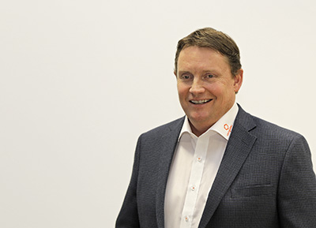
Fred Barden, new Vice President Worldwide Sales
Text and photograph available at: http://www.congatec.com/press

Press release

congatec steps up globalization strategy

congatec appoints Fred Barden as Vice President, Worldwide Sales

Deggendorf, Germany, 13 January, 2016 * * *congatec, a leading technology company for embedded computer modules, single board computers (SBCs) and embedded design and manufacturing (EDM) services, appoints Fred Barden as Vice President, Worldwide Sales. The position has been created to unite congatec’s global sales force in order to serve the top global players more effectively in the various markets for embedded and IoT computer technologies.

Jason Carlson, CEO of congatec, explains this strategic step: “I am excited to have Fred join the congatec team in this newly created role. Fred is an experienced sales leader with global market knowledge and experience building and managing world class sales organizations. He will lead congatec's talented and capable sales team to the next level, and in doing so help to accelerate growth by focusing on larger opportunities on a worldwide scale.”

Fred Barden is a seasoned professional with 25 years of sales and sales management experience in the embedded computing industry. He started his career as a manufacturer's local representative, selling embedded technologies into the Silicon Valley market, and then progressively grew into strategic national and global sales management roles with major embedded system players including Kontron, Continuous Computing, Radisys, and Artesyn Embedded Technologies.

Fred Barden comments on his new role: "I am excited to have the opportunity to lead congatec's talented sales professionals into a unified global sales force. This is an exciting time at congatec building from a position of technical leadership, then becoming the market leader in EMEA, and now focusing on global leadership. I look forward to working closely with our CEO, Jason Carlson who is passionate about these efforts, and I am confident that together we will achieve our plans. Leveraging the strengths congatec has created in local markets is exactly what is needed to win large global accounts and further accelerate growth."

About congatec AG
Headquartered in Deggendorf, Germany, congatec AG is a leading supplier of industrial computer modules using the standard form factors Qseven, COM Express, XTX and ETX, as well as single board computers and EDM services. congatec’s products can be used in a variety of industries and applications, such as industrial automation, medical, entertainment, transportation, telecommunication, test & measurement and point-of-sale. Core knowledge and technical know-how includes unique extended BIOS features as well as comprehensive driver and board support packages. Following the design-in phase, customers are given support via extensive product lifecycle management. The company’s products are manufactured by specialist service providers in accordance with modern quality standards. Currently congatec has entities in Taiwan, Japan, China, USA, Australia and the Czech Republic. More information is available on our website at www.congatec.com or via Facebook, Twitter and YouTube.

* * *

