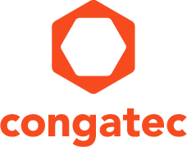
Reader enquiries: | Press contact:
congatec AG | SAMS Network
Christian Eder | Michael Hennen
Phone: +49-991-2700-0 | Phone: +49-2405-4526720
info@congatec.com  www.congatec.com | info@sams-network.com  www.sams-network.com

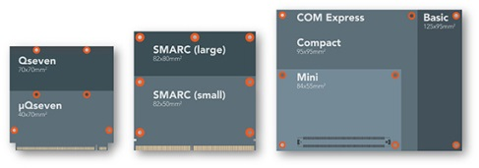

congatec provides full support of new Computer-on-Module specifications COM Express 3.0, Qseven 2.1 and SMARC 2.0
Text and photo available at: http://www.congatec.com/press

Press release
congatec presents roadmap for SMARC 2.0, Qseven 2.1 and COM Express 3.0
congatec fully supports the upcoming new
SGET and PICMG Computer-on-Module specifications

Deggendorf, Germany, 23 February 2016 * * * congatec, a leading technology company for embedded computer modules, single board computers (SBCs) and embedded design & manufacturing (EDM) services, announced at Embedded World that it fully supports the upcoming new SGET and PICMG Computer-on-Module specifications SMARC 2.0, Qseven 2.1 and COM Express 3.0. Modules complying with these standards are already in development and will be announced in time with the launch of the next processor generations.

SMARC and Qseven roadmap
congatec will fully support the SMARC 2.0 specification. SMARC 2.0 modules will become available for the full range of relevant processor technologies – from the Intel® Atom™ processor to various ARM designs.
congatec continues to support all current low-power processors for Qseven 2.1 designs as well.

The essential difference between the two standards is the number of supported interfaces with Qseven providing up to 230, and SMARC 2.0 up to 314 pins. SMARC is intended to interface richer systems with the smallest footprints; while Qseven is ideal for slimmer and less complex module and carrier board designs.

congatec has played a significant and active role in the development of all standards. For the Qseven and SMARC specifications congatec even assumed the role of editor and is consequently a key technology provider for highly compact SFF designs based on Computer-on-Modules – a market where congatec has established itself as the industry leader.

Christian Eder, director marketing at congatec, SGET board member and SMARC spec editor states, “By taking the big step from SMARC 1.1 to 2.0, we have succeeded in giving this standard a clear perspective for the future. This major leap has brought many new interfaces and eliminated a lot of outdated features. Although designs based on 1.1 may no longer be compatible with 2.0, users are compensated by numerous new features.”

The COM Express roadmap
COM Express 3.0 will primarily offer a new pinout type specifically for Server-on-Modules. The server-focused Intel® Xeon® and Intel Core™ processors as well as the AMD Embedded R-Series processors are prime targets, with ARM based platforms another possible option.

“All new specifications provide developers with support for the latest interfaces and many detail improvements. Next to the all-new SMARC 2.0 for highly compact multifunction systems, the new COM Express pinout for Server-on-Modules is particularly innovative. It enables us to target the new markets for decentralized, real-time edge servers that are used in media streaming as well as IoT, M2M, medical and automation applications,” explains Martin Danzer, product director at congatec.

With congatec’s personal integration service, developers will find it easy to integrate the new revisions into future system designs. Since most features are backward compatible, it is in many cases possible to upgrade existing carrier boards with new modules. This gives OEMs investment protection for existing system designs.

About congatec AG
Headquartered in Deggendorf, Germany, congatec AG is a leading supplier of industrial computer modules using the standard form factors Qseven, COM Express, XTX and ETX, as well as single board computers and EDM services. congatec’s products can be used in a variety of industries and applications, such as industrial automation, medical, entertainment, transportation, telecommunication, test & measurement and point-of-sale. Core knowledge and technical know-how includes unique extended BIOS features as well as comprehensive driver and board support packages. Following the design-in phase, customers are given support via extensive product lifecycle management. The company’s products are manufactured by specialist service providers in accordance with modern quality standards. Currently congatec has entities in Taiwan, Japan, China, USA, Australia and the Czech Republic. More information is available on our website at www.congatec.com or via Facebook, Twitter and YouTube.

* * *

Intel and Intel Atom, Core, Xeon are registered trademarks of Intel Corporation in the U.S. and other countries.

