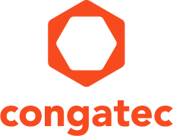
Reader Enquiries: | Press contact:
congatec AG | SAMS Network
Christian Eder | Michael Hennen
Phone: +49-991-2700-0 | Phone: +49-2405-4526720
info@congatec.com  www.congatec.com | info@sams-network.com  www.sams-network.com
Technagon GmbH
Peter Müller
Phone: +49-8555-51700-00
office@technagon.de
www.technagon.de

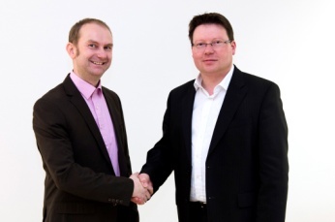
Peter Müller, Technagon, and Matthias Klein, congatec, are in full agreement (fl)

Text and photograph available at: http://www.congatec.com/press
Press release

congatec and Technagon cooperate
congatec appoints Technagon as sales technology partner

Deggendorf, Germany, 23 February 2016 * * * congatec, a leading technology company for embedded computer modules, single board computers (SBCs) and embedded design & manufacturing (EDM) services, has appointed design services company Technagon as sales technology partner to strengthen its portfolio of customer-specific system design & manufacturing services for point-of-sale (POS) and ticketing systems, vending machines and systems, digital signage and eMobility applications.

Technagon specializes in the design and development of customized systems for various industries. For POS applications, digital signage, eMobility and embedded systems, the company also offers production ready building blocks – such as application-ready concepts for authentication, payment and billing or vandalism and tamper protection – and integrates them quickly and efficiently into individual customer solutions. Customers save a lot of time and cost, and they will benefit from the extensive and proven know-how, which has been already invested into the development of these building blocks and components. Through the cooperation, congatec technology becomes an integral part of Technagon’s solution kit that ranges from application-specific carrier boards, embedded box PCs and system integration of all components to the design and manufacturing of custom housings.

"The cooperation with congatec significantly strengthens our engineering services, and provides a more efficient solution. Our close sales technology partnership allows us to tackle innovative projects together and to integrate the latest processor technology into customer projects faster. This gives our customers an enormous technology lead, and time- to-market advantage. In addition, we can also optimize our support for application developers because congatec’s personal Integration Services can now be requested directly from us," said Peter Müller, Business Development Manager at Technagon.

"With its design and development solutions for customized POS, digital signage and eMobility systems, Technagon is a highly efficient partner of many well-known OEMs. The sales technology partnership with Technagon opens up a whole new market presence for us in this segment. Customers, benefit from a comprehensive solution offering that can significantly speed up their time-to-market," comments Matthias Klein, COO at congatec.

About Technagon
Established in 2009, Technagon is a rapidly growing supplier of Original Design & Manufacturing (ODM) services. The company’s winning concept is to offer OEMs a comprehensive solution for their entire system requirements all from one single source. Technagon designs, develops and manufactures carrier boards, mechatronic assemblies and embedded systems as well as complete devices and system solutions on behalf of customers. Organization and logistics services plus complementary software services are provided whenever a project or application requires this. Customers of the fabless and hence highly flexible ODM service provider include well-renowned companies such as Porsche, Audi, STRÖER Media, Infoscreen, friendlyway, ELIN, Karl Bachl, InfoGate and Veniox.

About congatec AG
Headquartered in Deggendorf, Germany, congatec AG is a leading supplier of industrial computer modules using the standard form factors Qseven, COM Express, XTX and ETX, as well as single board computers and EDM services. congatec’s products can be used in a variety of industries and applications, such as industrial automation, medical, entertainment, transportation, telecommunication, test & measurement and point-of-sale. Core knowledge and technical know-how includes unique extended BIOS features as well as comprehensive driver and board support packages. Following the design-in phase, customers are given support via extensive product lifecycle management. The company’s products are manufactured by specialist service providers in accordance with modern quality standards. Currently congatec has entities in Taiwan, Japan, China, USA, Australia and the Czech Republic. More information is available on our website at www.congatec.com or via Facebook, Twitter and YouTube.

* * *

