Reader enquiries: | Press contact:
congatec AG | SAMS Network
Christian Eder | Michael Hennen
Phone: +49-991-2700-0 | Phone: +49-2405-4526720
info@congatec.com  www.congatec.com | info@sams-network.com  www.sams-network.com

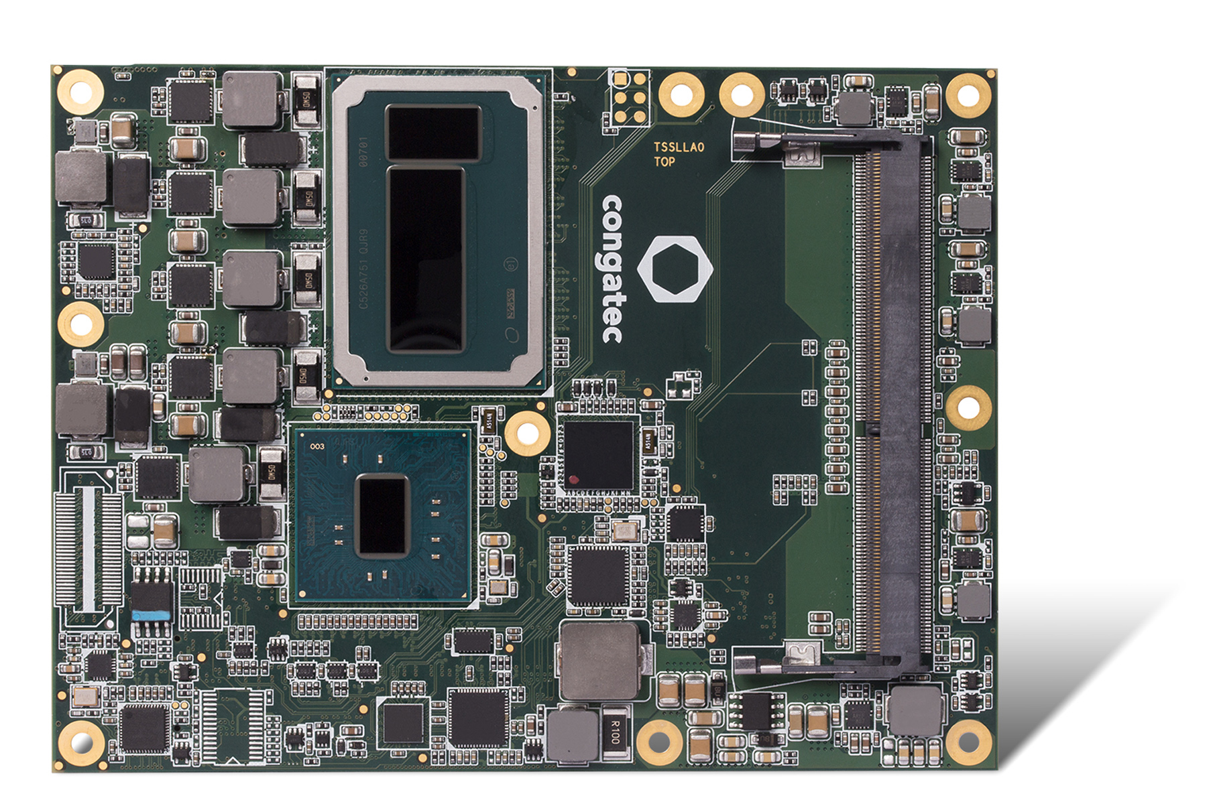
Server-on-Module: The new module with Intel® Iris™ Pro graphics offers three times more parallel execution power than the Skylake architecture without Iris graphics.

Text and photograph available at: http://www.congatec.com/press

Press release

congatec triples graphics performance of its Server-on-Modules
New congatec COM Express module with Intel® Xeon® processor and Intel® Iris™ Pro graphics

Deggendorf, Germany, 23 February 2016 * * * congatec, a leading technology company for embedded computer modules, single board computers (SBCs) and embedded design & manufacturing (EDM) services, has added a particularly powerful graphics version to its COM Express Basic Server-on-Module portfolio. The new module features the Intel® Xeon® Processor E3-1515M v5, fast DDR4 memory and Intel® Iris™ Pro graphics. The GPU of the new SoC module provides 128 MB eDRAM and with 72 execution units it has three times more parallel execution power than the Skylake architecture without Iris graphics. Developers of tightly packed COM Express based system designs now have access to a new performance class that would have previously required a dedicated graphics unit.

Thanks to its outstanding performance, the new conga-TS170 Computer-on-Module will be in big demand for high-performance image processing applications in industrial and medical technology as well as industrial-grade IoT edge node servers and media servers with virtualization. For example GPGPU-based video transcoding, deep packet inspection or big data analytics. Further application fields include industrial thin client servers with virtual desktop infrastructure (VDI). To manage these distributed IoT, M2M and Industry 4.0 applications, the new conga-TS170 module also offers powerful server-class tools. Thanks to Intel® vPro™ technology and congatec's board management controller with watchdog timer and power loss control, the module comes fully equipped for remote monitoring, management and maintenance tasks, right up to out-of-band management.

The feature set in detail
The conga-TS170 module features the latest 14nm Intel® Xeon® Processor E3-1515M v5 and Mobile Intel® CM236 Chipset. It supports up to 32 GB super-fast SO-DIMM DDR4-2133 memory with ECC for data-sensitive server applications. The integrated Intel® Gen9 Iris™ Pro graphics provides 72 execution units with a maximum clock rate of 1150 MHz. For parallel computing tasks it supports OpenCL 2.0. and DirectX 12 as well as Open GL 4.4 for the highest performance 3D graphics on up to 3 independent 4K (3840 x 2160) displays via HDMI 1.4 and DisplayPort 1.2. For legacy applications, a dual-channel LVDS output and VGA are available. Hardware-accelerated encode and decode of HEVC, VP8, VP9 and VDENC video is also supported.

In addition to PCI Express Gen 3.0 Graphics (PEG), the choice of available I/O interfaces includes 8x PCI Express Gen 3.0 lanes, 4x USB 3.0, 8x USB 2.0, LPC and I²C. SSD and other non volatile mass storage can be connected via 4x SATA 3.0, including RAID 0, 1, 5, 10 support. All major Linux and Microsoft Windows operating systems are supported, including Windows 10. A comprehensive set of add-ons for easier design-in – such as cooling solutions, carrier boards and starter kits – completes the offer.

A data sheet plus additional information on the new conga-TS170 computer module are available at: http://www.congatec.com/en/products/com-express-type6/conga-ts170.html

About congatec AG
Headquartered in Deggendorf, Germany, congatec AG is a leading supplier of industrial computer modules using the standard form factors Qseven, COM Express, XTX and ETX, as well as single board computers and EDM services. congatec’s products can be used in a variety of industries and applications, such as industrial automation, medical, entertainment, transportation, telecommunication, test & measurement and point-of-sale. Core knowledge and technical know-how includes unique extended BIOS features as well as comprehensive driver and board support packages. Following the design-in phase, customers are given support via extensive product lifecycle management. The company’s products are manufactured by specialist service providers in accordance with modern quality standards. Currently congatec has entities in Taiwan, Japan, China, USA, Australia and the Czech Republic. More information is available on our website at www.congatec.com or via Facebook, Twitter and YouTube.

* * *

Intel, Intel Iris, Intel vPro, and Intel Xeon are registered trademarks of Intel Corporation in the U.S. and other countries.

