Reader contact: | Press contact:
congatec AG | SAMS Network
Christian Eder | Michael Hennen
Phone: +49-991-2700-0 | Phone: +49-2405-4526720
info@congatec.com  www.congatec.com | info@sams-network.com  www.sams-network.com

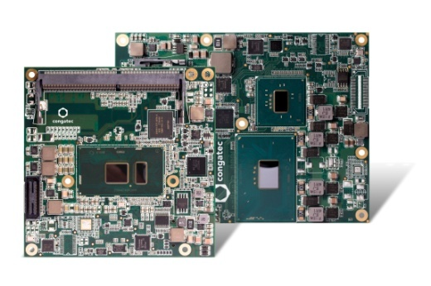
congatec‘s new COM Express Basic and Compact modules with Intel® Celeron® processors target cost sensitive applications

Text and photo also available online at http://www.congatec.com/press

Press release
congatec’s new COM Express modules with latest Intel® Celeron® processors, codenamed Skylake

congatec integrates today’s most cost efficient Intel® Celeron® processor with fast DDR4 SO-DIMM memory support

Deggendorf, Germany, 19 May 2016 * * * congatec, a leading technology company for embedded computer modules, single board computers (SBCs) and embedded design & manufacturing (EDM) services, increases the scalability of its COM Express Computer-on-Modules with two new entry-level models based on the latest Intel 14nm microarchitecture (formerly codename Skylake). The Intel® Celeron® processor-based COM Express Basic and Compact modules combine cost efficient dual-core CPU performance with state of the art features such as 4k multiscreen support, high-speed DDR4 RAM with increased bandwidth and four USB 3.0 ports. This significant performance increase over earlier Intel® Celeron® processor generations constitutes a giant performance leap for developers targeting the broad and particularly price-sensitive field of mid-range applications.

The key applications for the new Computer-on-Modules include all kinds of 4k multi-screen solutions in which one embedded computer module controls up to three independent screens without the need for a dedicated graphics card. Applications can be found in operating rooms and medical diagnostics terminals, HMIs in industrial machinery and facilities, digital signage, vending and retail applications as well as gaming and infotainment terminals.

The technical innovations in detail
The new COM Express Compact module conga-TC170 features the 2GHz dual-core Intel® Celeron® Processor 3955U with a configurable Thermal Design Power (cTDP) of 10-15W, which facilitates adapting the application to the energy concept of the system. The slightly larger new conga-TS170 COM Express Basic modules are available with the Intel® Celeron® Processor G3900E with 2.4GHz and 35W TDP or with the G3902E featuring 1.6 GHz and 25 W TDP. All modules support up to 32 GB of DDR4 dual channel memory which yields significantly more bandwidth and greater energy efficiency than DDR3L implementations. The Intel® Gen9 HD Graphics 510 drives up to three independent displays with 4k @ 60 Hz via DisplayPort 1.2 and DMI 2.0. For even richer Windows 10 based 3D graphics there is DirectX 12 support. Thanks to hardware-accelerated encode and decode of HEVC, VP8, VP9 and VDENC video it is for the first time possible to stream HD video energy-efficiently in both directions.

The new computer modules from congatec support the COM Express Type 6 pinout including PCI Express Gen 3.0, USB 3.0 and USB 2.0, SATA Gen 3, Gigabit Ethernet as well as low speed interfaces such as LPC, I²C and UART. The modules run Microsoft Windows 10 as well all other current Microsoft Windows and Linux operating systems. A comprehensive set of add-ons for easier design-in – such as cooling solutions, carrier boards and starter kits plus SMART battery management module – completes the congatec eco system.

For further information about the new COM Express Compact module conga-TC170 visit:
http://www.congatec.com/en/products/com-express-type6/conga-tc170.html

For further information about the new COM Express Basic module conga-TS170 visit:
http://www.congatec.com/en/products/com-express-type6/conga-ts170.html

About congatec AG
Headquartered in Deggendorf, Germany, congatec AG is a leading supplier of industrial computer modules using the standard form factors Qseven, COM Express, XTX and ETX, as well as single board computers and EDM services. congatec’s products can be used in a variety of industries and applications, such as industrial automation, medical, entertainment, transportation, telecommunication, test & measurement and point-of-sale. Core knowledge and technical know-how includes unique extended BIOS features as well as comprehensive driver and board support packages. Following the design-in phase, customers are given support via extensive product lifecycle management. The company’s products are manufactured by specialist service providers in accordance with modern quality standards. Currently congatec has entities in Taiwan, Japan, China, USA, Australia and the Czech Republic. More information is available on our website at www.congatec.com or via Facebook, Twitter and YouTube.

Intel® and Intel® Celeron® are registered trademarks of Intel® Corporation in the U.S. and other countries.

