Reader enquiries: | Press contact:
congatec AG | SAMS Network
Christian Eder | Michael Hennen
Phone: +49-991-2700-0 | Phone: +49-2405-4526720
info@congatec.com  www.congatec.com | info@sams-network.com  www.sams-network.com

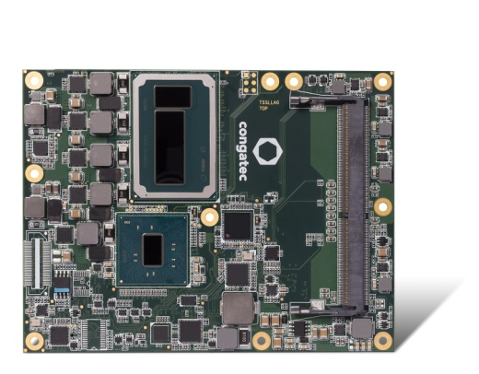
conga-TS170 Server-on-Modules with the latest Intel® Xeon® E3-1578L and E3-1558 processors offer true real-time media processing capabilities for up to 15 VHEC streams.

Text and photograph available at: http://www.congatec.com/press
Press release video available: https://youtu.be/LzZZ1qybq-E

Press release

New congatec Server-on-Modules for real-time media processing

congatec introduces new Server-on-Modules with high transcoding performance based on the latest Intel® Xeon® processors

Deggendorf, Germany, 9 June 2016 * * * congatec, a leading technology company for embedded computer modules, single board computers (SBCs) and embedded design and manufacturing (EDM) services, has introduced two new Server-on-Modules which have been especially designed for real-time media processing. The new conga-TS170 Server-on-Modules are based on the latest Intel® Xeon® E3-1578L and E3-1558 processors. A distinguishing feature of the new modules is the integrated Intel® Iris™ Pro Graphics accelerated by 128 MB fast eDRAM and double graphics base frequency for outstanding transcoding and video processing performance. Additionally, with the Media Studio Server package they offer comprehensive software support. congatec’s new Server-on-Modules come with an extensive ecosystem including complete Board Support Packages, comprehensive driver support and instantly application-ready carrierboards and evaluation kits, simplifying individual embedded server configurations.

Edge and fog computers for industrial IoT applications are one of the two major application areas for the new Server-on-Modules. Their task is pre-processing and transcoding big data as well as managing and controlling local processes. In close proximity to the field-level such servers are highly responsive and real-time capable allowing both the horizontal and the vertical networking of any industrial IoT-connected smart sensors, actuators and complex equipment and machines. High-level media processing performance brings benefits to numerous application fields. Examples are autonomous driving, drone control, vision-based robotics as well as self-learning machines with complex Deep Learning algorithms and neuronal network structures, which also profit from the high-level media and GPGPU processing capacities of the new Xeon processors.

Equally important is the second field of application where densely packed servers in content delivery networks at carriers, service or third party providers are used for high-quality and high-density video transcoding to provide end-users a best quality experience. These networks featuring carrier-grade availability and durability are implemented in commercial media streaming and video conference systems as well as a variety of new video-based security and surveillance applications, which can also be used for virtual vision in maintenance and service applications.

“Media processing in IoT networks opens up a whole new range of applications in lots of different industries. Our Server-on-Modules help developers by simplifying the design and scalability of their industrial-grade platforms. Where performance demands are stepped up, upgrades can be carried out quickly, as the modular computing cores can be replaced by new ones at any time,” Christian Eder, Marketing Manager at congatec explains. Parallel to this, the Server-on-Modules offer a great level of flexibility to fulfill the individual size and ruggedness demands. This is extremely important for all the different industrial applications. This flexibility is achieved with minimum effort using the Server-on-Modules, as many building blocks can be supplied application-ready. As the congatec Server-on-Modules comply with the PICMG’s COM Express Basic, developers profit from maximum design security.

The feature set in detail
The new conga-TS170 COM Express basic modules are equipped with the new Intel® Xeon® processors E3-1578L and E3-1558 with Intel® Iris™ Pro Graphics. Compared to previous Intel® Xeon® processors, the base frequency of the graphics and media processing units is doubled to up to 700 MHz. This significantly speeds up media processing performance, as the hardware accelerators, which are amongst other things used for video transcoding, are always operated at the basic clock rate. This allows for the processing of up to two 4k HEVC output streams or up to 15 Full HD-HEVC (1080p) streams in real-time. The COM Express Server-on-Modules offer the common I/O interfaces of the Type 6 pinout: PCI Express Graphics Gen 3.0 (PEG), 8x PCI Express Gen 3.0 Lanes, 4x SATA 3.0 including RAID 0/1/5/10 support, 4x USB 3.0, 8x USB 2.0, LPC and I²C. Microsoft Windows 10 and all other current Microsoft Windows and Linux operating systems are supported. Individual integration support, an extensive range of accessories as well as optional Embedded Design & Manufacturing Services for individual carrierboard and system designs complete the package.

Further information on the new COM Express Basic conga-TS170 computer module is available at: http://www.congatec.com/en/products/com-express-type6/conga-ts170.html

About congatec AG
Headquartered in Deggendorf, Germany, congatec AG is a leading supplier of industrial computer modules using the standard form factors Qseven, COM Express, XTX and ETX, as well as single board computers and EDM services. congatec’s products can be used in a variety of industries and applications, such as industrial automation, medical, entertainment, transportation, telecommunication, test & measurement and point-of-sale. Core knowledge and technical know-how includes unique extended BIOS features as well as comprehensive driver and board support packages. Following the design-in phase, customers are given support via extensive product lifecycle management. The company’s products are manufactured by specialist service providers in accordance with modern quality standards. Currently congatec has entities in Taiwan, Japan, China, USA, Australia and the Czech Republic. More information is available on our website at www.congatec.com or via Facebook, Twitter and YouTube.

* * *

Intel and Intel Xeon, Iris are registered trademarks of Intel Corporation in the U.S. and other countries.

