

Reader Enquiries: | Press Contact:
congatec AG | PRismaPR  (UK, Scandinavia + Benelux) | PRismaPR
Christian Eder | Monika Cunnington | Bettina Lerchenmüller
Phone: +49-991-2700-0 | Phone: +44-20-8133 6148 | Phone: +49-8106-24 72 33
info@congatec.com  www.congatec.com | monika@prismapr.com  www.prismapr.com | info@prismapr.com  www.prismapr.com

Visit us at COMPUTEX in Taipei, Taiwan
3–7 June 2014, Booth K0616

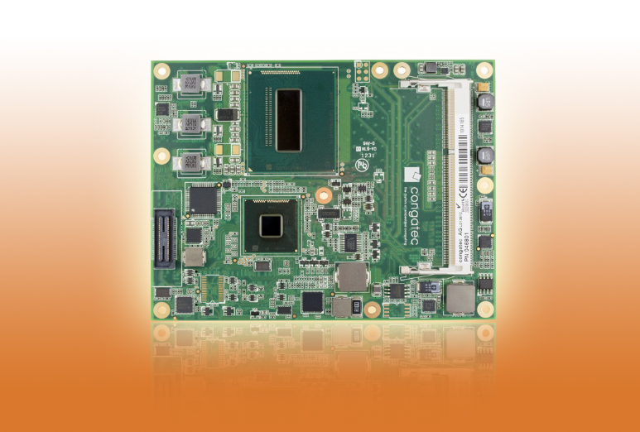
Text and photograph available: http://www.congatec.com/press
Press Release 10 /2014
congatec presents its fastest COM Express module based on 4th Generation Intel® Core™i5-4410E processor
conga-TS87 COM Express Type 6 basic module: Unprecedented vector processing, floating point and graphics performance with no increase in power draw

Deggendorf, Germany, 4 June 2014 * * * congatec AG, a leading manufacturer of embedded computer modules, announces the availability of the conga-TS87, a Type 6 COM Express module featuring 4th Generation with Intel® Core™ i5-4410E processor. The COM Express module offers outstanding performance, featuring improved vector processing, more efficient floating point calculation and amazing graphics without an increase in power consumption.
Improvements to the previous architecture have led to efficiency gains that also boost performance. This is particularly evident in the embedded graphics, where the number of integrated graphics units (execution units) has been increased, resulting in higher 3D performance in the range of 28-60% compared to previous generations.
The most exciting new feature is the introduction of Intel® Advanced Vector Extensions (Intel® AVX) 2.0, which improves performance of floating point instructions. In 4th Generation processors, Intel AVX 2.0 helps enable higher performance in applications like signal and image processing for market segments like medical and avionics.
The conga-TS87 COM Express module with pin out Type 6 takes advantage of integrated graphics and the associated advanced digital display interfaces. The conga-TS87 also utilizes the high bandwidth of USB 3.0 and PCI Express 3.0 with additional PCI Express lanes.
The COM Express module is currently available with the mobile Intel® QM87 Express chipset and embedded dual core Intel® Core™ i5-4410E processor with 3MB L2 cache and can be powered at 2.9 GHz with a TDP of 37W. The chip features up to 16 GB, 1600 MT/s fast LV 1.35V dual channel DDR3 memory. The integrated graphics is significantly more powerful than previous models and supports Intel® Flexible Display Interface (FDI), DirectX 11.1, OpenGL 4, OpenCL 1.2 and high-performance, flexible hardware decoding for parallel decoding of multiple high-resolution full HD videos.
An efficient cooling solution, such as congatec's patented cooling pipes with fast heat dissipation, significantly increases overall performance.
4K2K pixel resolution of up to 3840 x 2160 with DisplayPort, and 4096 x 2304 with HDMI is natively supported in the processor. It is also possible to connect up to three independent display interfaces via DVI, as well as LVDS and VGA.
Native USB 3.0 support ensures fast data transmission with low power draw. A total of eight USB ports are provided, four of which can support SuperSpeed USB 3.0.
Seven PCI Express 2.0 lanes, PCI Express 3.0 graphics (PEG) x16 lanes for high-performance external graphics cards, four SATA ports with up to 6 Gb/s and RAID support and one Gigabit Ethernet interface enable fast and flexible system extensions. Fan control, LPC bus for easy integration of legacy I/O interfaces and Intel® High Definition Audio complete the feature set.

About congatec AG
congatec AG has its head office in Deggendorf, Germany and is a leading supplier of industrial computer modules using the standard form factors Qseven, COM Express, XTX and ETX. congatec’s products can be used in a variety of industries and applications, such as industrial automation, medical technology, automotive supplies, aerospace and transportation. Core knowledge and technical know-how includes unique extended BIOS features as well as comprehensive driver and board support packages. Following the design-in phase, customers are given support via extensive product lifecycle management. The company’s products are manufactured by specialist service providers in accordance with modern quality standards. congatec currently has 141 employees and entities in Taiwan, Japan, USA, Australia and the Czech Republic. More information is available on our website at www.congatec.com or via Facebook, Twitter and YouTube.

* * *

Intel and Intel Core are trademarks of Intel Corporation in the U.S. and other countries.
congatec is a business partner of the Intel® Intelligent Systems Alliance, a joint venture of communications and embedded developers and solution providers.

