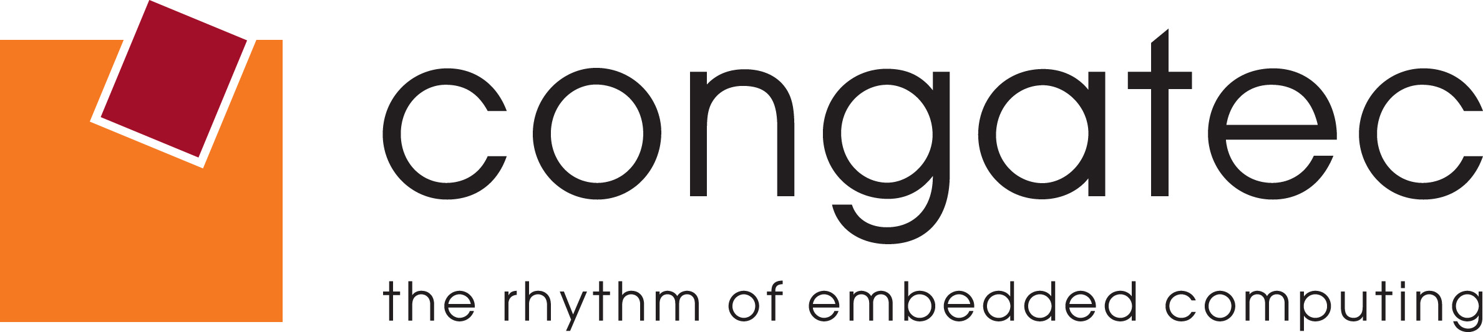

Reader Enquiries: | Press Contact:
congatec AG | PRismaPR  (UK, Scandinavia + Benelux) | PRismaPR
Christian Eder | Monika Cunnington | Bettina Lerchenmüller
Phone: +49-991-2700-0 | Phone: +44-20-8133 6148 | Phone: +49-8106-24 72 33
info@congatec.com  www.congatec.com | monika@prismapr.com  www.prismapr.com | info@prismapr.com  www.prismapr.com

Visit congatec at Embedded World in
Nuremberg, Hall 1, Stand 358
Press Release 05/2014
congatec on the way to global leadership
The no. 2 computer-on-module supplier worldwide now ranks no. 1 in EMEA according to IHS

Embedded World, 25 February 2014 * * * congatec AG, a leading provider of computer-on-modules (COM), is approaching global market leadership in this segment. In a report by information and analytics provider IHS Inc. - "Standalone Boards, Computer-on-Modules and PICMG 1.x" - congatec ranks no. 1 in terms of revenue for computer modules in Europe, the Middle East and Africa (EMEA).
The driving force behind this success is a clear product focus together with global expansion into new regions. In addition to its German headquarters in Deggendorf, congatec AG has offices in the Czech Republic, Taiwan, Japan, USA, Australia and soon in China. The partner network is also undergoing continuous expansion and currently includes 31 partners in 25 countries.
With approximately 300% global growth over a period of 5 years, congatec has twice been among the winners of the Deloitte Technology Fast 50 Awards, which recognizes the fastest growing companies in Germany.
Toby Colquhoun, senior analyst, embedded modules for IHS Technology, indicated: "The COM market has typically grown between 10 to 15 percent per year, for the past five years. congatec has moved from a start-up company to one of the largest embedded suppliers in less than a decade. According to our analysis, congatec had the highest sales, in terms of revenue, in EMEA for COM technology, and the second-highest worldwide.”
congatec CEO Gerhard Edi: "Our embedded technologies are ideally suited to provide solutions to current mega trends such as the "Internet of Things", data security and energy efficiency. We work very closely with our technology partners Intel, AMD and Freescale in the development of our products which have gained a market reputation for their reliability. This is an optimal starting point for continued rapid growth."
Source: IHS Inc. “The World Market for Embedded Computer Boards, Modules and Systems – 2013 Edition”

About congatec AG
congatec AG has its head office in Deggendorf, Germany and is a leading supplier of industrial computer modules using the standard form factors Qseven, COM Express, XTX and ETX. congatec’s products can be used in a variety of industries and applications, such as industrial automation, medical technology, automotive supplies, aerospace and transportation. Core knowledge and technical know-how includes unique extended BIOS features as well as comprehensive driver and board support packages. Following the design-in phase, customers are given support via extensive product lifecycle management. The company’s products are manufactured by specialist service providers in accordance with modern quality standards. Currently congatec has ~160 employees and entities in Taiwan, Japan, USA, Australia and the Czech Republic. More information is available on our website at www.congatec.com or via Facebook, Twitter and YouTube.
* * *

