

Reader Enquiries: | Press Contact:
congatec AG | PRismaPR  (UK, Scandinavia + Benelux) | PRismaPR
Christian Eder | Monika Cunnington | Bettina Lerchenmüller
Phone: +49-991-2700-0 | Phone: +44-20-8133 6148 | Phone: +49-8106-24 72 33
info@congatec.com  www.congatec.com | monika@prismapr.com  www.prismapr.com | info@prismapr.com  www.prismapr.com

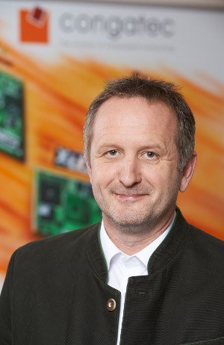
Text and photograph available: http://www.congatec.com/press
Press Release 10/2013
congatec announces record sales and earnings for fiscal year 2012
With sales of 60.6 million euros and 2.5 million euros in EBIT, congatec strengthens its position as the world’s number two player in Computer-on-Modules

Deggendorf, Germany, 6 June 2013 * * * congatec AG, a leading manufacturer of industrial computer modules, announces record sales for fiscal year 2012. With total sales of 60.6 million euros, congatec achieved a revenue increase of 27% when compared to the previous year (47.7 million euros).
As for revenue share of the different geographical regions, the subsidiaries in Taipei, Taiwan and San Diego, U.S. succeeded in expanding their business volume as planned. They accounted for 32% of global sales in 2012, achieving 15% (APAC) and 53% (America) sales increases over the previous year.
Even more significant are the positive earnings developments: The current EBIT of 2.5 million euros exceeds last year’s result (1.2 million euros) by 116%. In total, congatec generated a net profit of 1.9 million euros - an increase of 195% compared with the previous year (0.6 million euros). Return on sales also increased to 3.1% (previous year 1.3%).
"We are very pleased with the economic development of congatec," comments congatec CEO Gerhard Edi. "Our U.S. subsidiary congatec Inc. recently opened a Research & Design Centre in Boca Raton, Florida and as result hired two highly qualified COM experts to our team. These experts have been working in the COM market for many years”.
The new U.S. R&D team will provide technical support to customers in North and South America, react directly to local market conditions and customer needs and as part of the global R&D team, develop new products in collaboration with the R&D design centres in the corporate headquarter in Germany (Deggendorf) and the Czech Republic (Brno and Pilsen).
The next step will be the opening of a sales office in China. Preparations for this are already in full swing.
The CEO, Gerhard Edi is confident both investments will bring congatec closer towards market leadership. He expects a double digit revenue growth for fiscal year 2013.
In order to realize this growth, the global workforce increased from 124 in 2011 to 142 in 2012. About 67% of the workforce are employed in Germany, which makes congatec a major national employer, especially for the emerging region of Lower Bavaria. Asia and the U.S. each employ 13% of the workforce and 8% are employed in the Czech Republic.
The complete annual business report for 2012 is available via the congatec website at www.congatec.com.

About congatec AG
congatec AG has its head office in Deggendorf, Germany and is a leading supplier of industrial computer modules using the standard form factors Qseven, COM Express, XTX and ETX. congatec’s products can be used in a variety of industries and applications, such as industrial automation, medical technology, automotive supplies, aerospace and transportation. Core knowledge and technical know-how includes unique extended BIOS features as well as comprehensive driver and board support packages. Following the design-in phase, customers are given support via extensive product lifecycle management. The company’s products are manufactured by specialist service providers in accordance with modern quality standards. Currently congatec has 141 employees and entities in Taiwan, Japan, USA, Australia and the Czech Republic. More information is available on our website at www.congatec.com or via Facebook, Twitter and YouTube.
* * *

