

Reader Enquiries: | Press Contact:
congatec AG | PRismaPR  (UK, Scandinavia + Benelux) | PRismaPR
Christian Eder | Monika Cunnington | Bettina Lerchenmüller
Phone: +49-991-2700-0 | Phone: +44-20-8133 6148 | Phone: +49-8106-24 72 33
info@congatec.com  www.congatec.com | monika@prismapr.com  www.prismapr.com | info@prismapr.com  www.prismapr.com

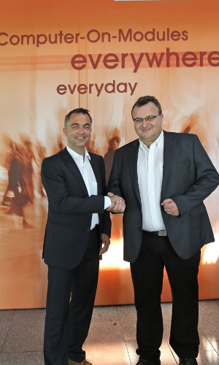
Micheal Klett (Sales Partner Manger congatec) and Thomas Hagios (CEO MCTX)
Text and photograph available: http://www.congatec.com/press

Press Release 12/2013
congatec expands partner network and appoints
MCTX as new sales partner
Deggendorf, Germany, 1 August 2013 * * * congatec AG, a leading manufacturer of embedded computer modules, has entered into a partnership with MCTX Mobile & Embedded Computers GmbH effective 1st of July, 2013. Under the terms of the agreement, MCTX and congatec will cooperate in the distribution of products and the development of customized solutions. In addition, MCTX will support congatec’s OEM customers during design-in with technical know-how.
The cooperation specifically targets customers that require additional services beyond the CPU module. By partnering with congatec, MCTX benefits from the latest CPU technologies and is able to expand its own portfolio of processor platforms. MCTX customers now also receive congatec XTX and COM Express modules and the associated integration services.
For the Qseven form factor, MCTX acts as a full service provider supplying a range of Qseven mini carrier boards, development and rapid prototyping kits, connectors and mechanical components such as spacers and cooling solutions in addition to CPU modules. The MCTX portfolio stretches from technology consulting and key components to the development and delivery of complete system solutions tailored to customer needs.
Depending on the requirements of the specific application, ARM or x86-based COMs can be used. The in-depth know-how of the MCTX team with regards to ARM-based application processors is an additional plus for congatec. Other MCTX areas of key expertise include display technology and mobile applications.
"The easy to integrate CPU modules from congatec support the latest processor platforms on standard form factors, thereby enabling interchangeability and second source strategies. This fits well with the demands of our OEM customers, for whom short time-to-market, scalability, easy maintenance and long-term product availability are particularly important. In our view, congatec is the most innovative provider of COMs and therefore our primary partner in this area," comments MCTX CEO Thomas Hagios.

About MCTX Mobile & Embedded Computers GmbH
MCTX Mobile & Embedded Computers GmbH specializes in the development and distribution of energy efficient embedded computing and display solutions for use in demanding environments. The MCTX team draws on many years of experience in the implementation of customer-specific system solutions in a variety of application areas.
More information at www.mctx.de.

About congatec AG
congatec AG has its head office in Deggendorf, Germany and is a leading supplier of industrial computer modules using the standard form factors Qseven, COM Express, XTX and ETX. congatec’s products can be used in a variety of industries and applications, such as industrial automation, medical technology, automotive supplies, aerospace and transportation. Core knowledge and technical know-how includes unique extended BIOS features as well as comprehensive driver and board support packages. Following the design-in phase, customers are given support via extensive product lifecycle management. The company’s products are manufactured by specialist service providers in accordance with modern quality standards. Currently congatec has 141 employees and entities in Taiwan, Japan, USA, Australia and the Czech Republic. More information is available on our website at www.congatec.com or via Facebook, Twitter and YouTube.
* * *

