

Reader Enquiries: | Press Contact:
congatec AG | PRismaPR  (UK, Scandinavia + Benelux) | PRismaPR
Christian Eder | Monika Cunnington | Bettina Lerchenmüller
Phone: +49-991-2700-0 | Phone: +44-20-8133 6148 | Phone: +49-8106-24 72 33
info@congatec.com  www.congatec.com | monika@prismapr.com  www.prismapr.com | info@prismapr.com  www.prismapr.com

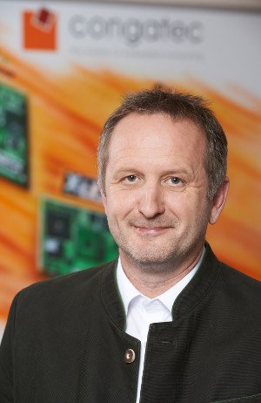
Text and photograph available: http://www.congatec.com/press
Images of the devastating floods: http://goo.gl/gOKnG

Press Release 11/2013
congatec AG shows solidarity with victims of Central Europe's worst floods in decades
congatec donates 52,000 Euro to the victims of the devastating floods to hit company HQ town

Deggendorf, Germany, 24 June 2013 * * * congatec AG, a leading manufacturer of embedded computer modules headquartered in the Bavarian town of Deggendorf, has donated 52,000 Euro to the town's flood victims. The money went to a local newspaper that had called for fundraisers.
The heavy floods that recently hit Germany and parts of Eastern Europe caused widespread devastation. One of the most seriously affected regions was the Bavarian town of Deggendorf where congatec has its company headquarter. While the congatec offices themselves remained unscathed by the floods, management spontaneously shared images of the flood-stricken areas of Deggendorf with its international locations. In response, the managing directors of congatec's offices in San Diego (USA) and Taipei (Taiwan) immediately decided to support the fundraising efforts of their German colleagues.
"Since the company was founded eight years ago, our actions have been shaped by strong human values. So it was a matter of course for us to step in quickly to help here in the region," says congatec CEO Gerhard Edi.
The sum of 52,000 Euro is one of the largest single donations received by the action. congatec also grants paid leave to employees volunteering to help in the flood cleanup.

About congatec AG
congatec AG has its head office in Deggendorf, Germany and is a leading supplier of industrial computer modules using the standard form factors Qseven, COM Express, XTX and ETX. congatec’s products can be used in a variety of industries and applications, such as industrial automation, medical technology, automotive supplies, aerospace and transportation. Core knowledge and technical know-how includes unique extended BIOS features as well as comprehensive driver and board support packages. Following the design-in phase, customers are given support via extensive product lifecycle management. The company’s products are manufactured by specialist service providers in accordance with modern quality standards. Currently congatec has 141 employees and entities in Taiwan, Japan, USA, Australia and the Czech Republic. More information is available on our website at www.congatec.com or via Facebook, Twitter and YouTube.
* * *

