
Reader Enquiries: | Press Contact:
congatec AG | PRismaPR  (UK, Scandinavia + Benelux) | PRismaPR
Christian Eder | Monika Cunnington | Bettina Lerchenmüller
Phone: +49-991-2700-0 | Phone: +44-20-8133 6148 | Phone: +49-8106-24 72 33
info@congatec.com  www.congatec.com | monika@prismapr.com  www.prismapr.com | info@prismapr.com  www.prismapr.com

Visit congatec at embedded world
26 – 28 February 2013
Hall 1, Stand 350
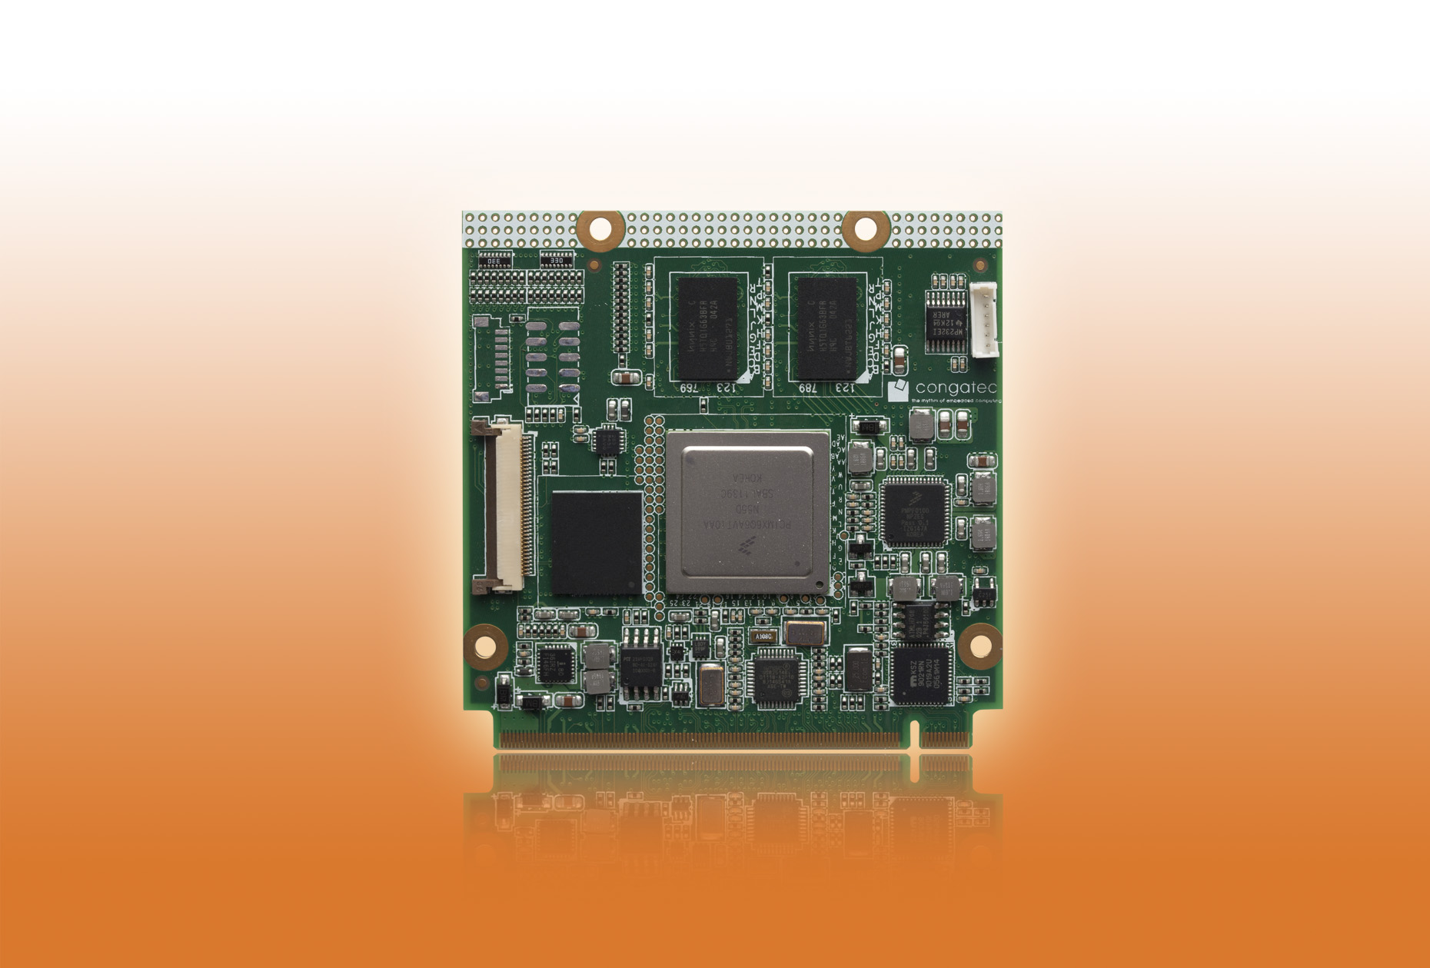
Text and photograph available: http://www.congatec.com/press

Press release 04/2013

congatec presents Windows Embedded Compact 7 Qseven module based on Freescale’s i.MX6 ARM Cortex A9 CPU
embedded world, Nuremberg, 26 February 2013 *** congatec AG, a leading manufacturer of embedded computer modules, announces a Windows® Embedded Compact 7 version of the conga-QMX6 Qseven module based on the Freescale i.MX6 ARM Cortex A9 processor. Windows Embedded Compact 7 (WEC7) is the latest generation of Windows CE operating systems designed for innovative embedded applications such as those based on the Qseven form factor.
WEC7 provides a 32-bit hard real-time operating system with Silverlight support, a customizable user interface, a new multimedia player, Internet Explorer with Flash 10.1 and a powerful development tool. In addition, it provides customized development and design tools for programmers; XAML and C++ can be used.
A ready-to-use WEC7 board support package is provided in partnership with Adeneo for the conga-QMX6 Qseven module with Freescale’s i.MX6 ARM Cortex A9 processor. As a result, customers worldwide now benefit from a cost-effective end-to-end solution that accelerates the development of their embedded applications.
Adeneo, a congatec software partner since late 2012, is a member of the Freescale "Design Alliance Program" and an official Freescale partner for Windows Embedded Compact, Android and embedded Linux developments on the i.MX processor architecture.
The conga-QMX6 is equipped with a state-of-the-art 3D-capable high-end HD graphics interface and is ideal for demanding multimedia applications. Target markets include manufacturers of mobile and ultra mobile industrial devices as well as medical, automotive and industrial automation applications.

About congatec AG
congatec AG has its head office in Deggendorf, Germany and is a leading supplier of industrial computer modules using the standard form factors Qseven, COM Express, XTX and ETX. congatec’s products can be used in a variety of industries and applications, such as industrial automation, medical technology, automotive supplies, aerospace and transportation. Core knowledge and technical know-how includes unique extended BIOS features as well as comprehensive driver and board support packages. Following the design-in phase, customers are given support via extensive product lifecycle management. The company’s products are manufactured by specialist service providers in accordance with modern quality standards. congatec currently has 135 employees and entities in Taiwan, Japan, USA, Australia and the Czech Republic. More information is available on our website at www.congatec.com or via Facebook, Twitter and YouTube.
© 2013 congatec AG

* * *

