

Reader Contact: | Press Contacts:
congatec AG | PRismaPR (UK + Scandinavia) | PRismaPR
Christian Eder | Monika Cunnington | Bettina Lerchenmüller
Phone: +49-991-2700-0 | Phone: +44-20-8133 6148 | Phone: +49-8106-24 72 33
info@congatec.com | monika@prismapr.com | info@prismapr.com
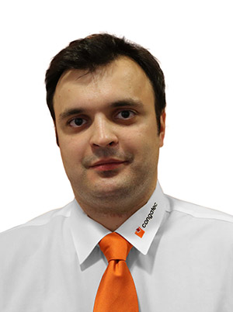

Photo available: www.congatec.com

Press Release 01/2014

congatec expands into Russia

New Regional Sales Manager to drive growth in Russia and CIS
Deggendorf, Germany, 21 January 2014 * * * congatec AG, a leading manufacturer of embedded computer modules, announces the appointment of Pavel Andrievskiy as Regional Sales Manager for the Russian Federation and CIS countries (incl. Ukraine, Belarus, Kazakhstan etc.). He is responsible for direct sales, support and the steady expansion of congatec’s network of sales partners.
Pavel Andrievskiy has more than 3 years of international experience in the application and sales of electronic components. In his previous role as head of sales at a Russian wholesale company, he supported customers purchasing electronic components and devices from Russian manufacturers.
In his new position, Pavel aims to provide customers with high-quality products from congatec coupled with first-class support. “I want to make congatec the first choice for Russian customers in the embedded market and build a reputation as the preferred vendor for innovative embedded solutions,” summarizes Pavel his medium-term goals.
"Russia is a strategic market where we see great potential for growth for our embedded technologies. With Pavel’s support we will be able to successfully expand our position in the region," states Bernd Hacker, VP Sales and Marketing at congatec AG.

Contact details:
congatec AG Sales and Marketing Office Russia and CIS region
Pavel Andrievskiy
Regional Business Development & Sales Region Manager Russia/CIS
Moscow, Gilyarovskogo str. 57, bld.1, office 216
congatec AG
Phone: +7 (495) 684 17 47
Mobile: + 7 929 631 98 65
Email: Pavel.Andrievskiy@congatec.com

About congatec AG
congatec AG has its head office in Deggendorf, Germany and is a leading supplier of industrial computer modules using the standard form factors Qseven, COM Express, XTX and ETX. congatec’s products can be used in a variety of industries and applications, such as industrial automation, medical technology, automotive supplies, aerospace and transportation. Core knowledge and technical know-how includes unique extended BIOS features as well as comprehensive driver and board support packages. Following the design-in phase, customers are given support via extensive product lifecycle management. The company’s products are manufactured by specialist service providers in accordance with modern quality standards. Currently congatec has 150 employees and entities in Taiwan, Japan, USA, Australia, the Czech Republic and Russia. More information is available on our website at www.congatec.com or via Facebook, Twitter and YouTube.
* * *

