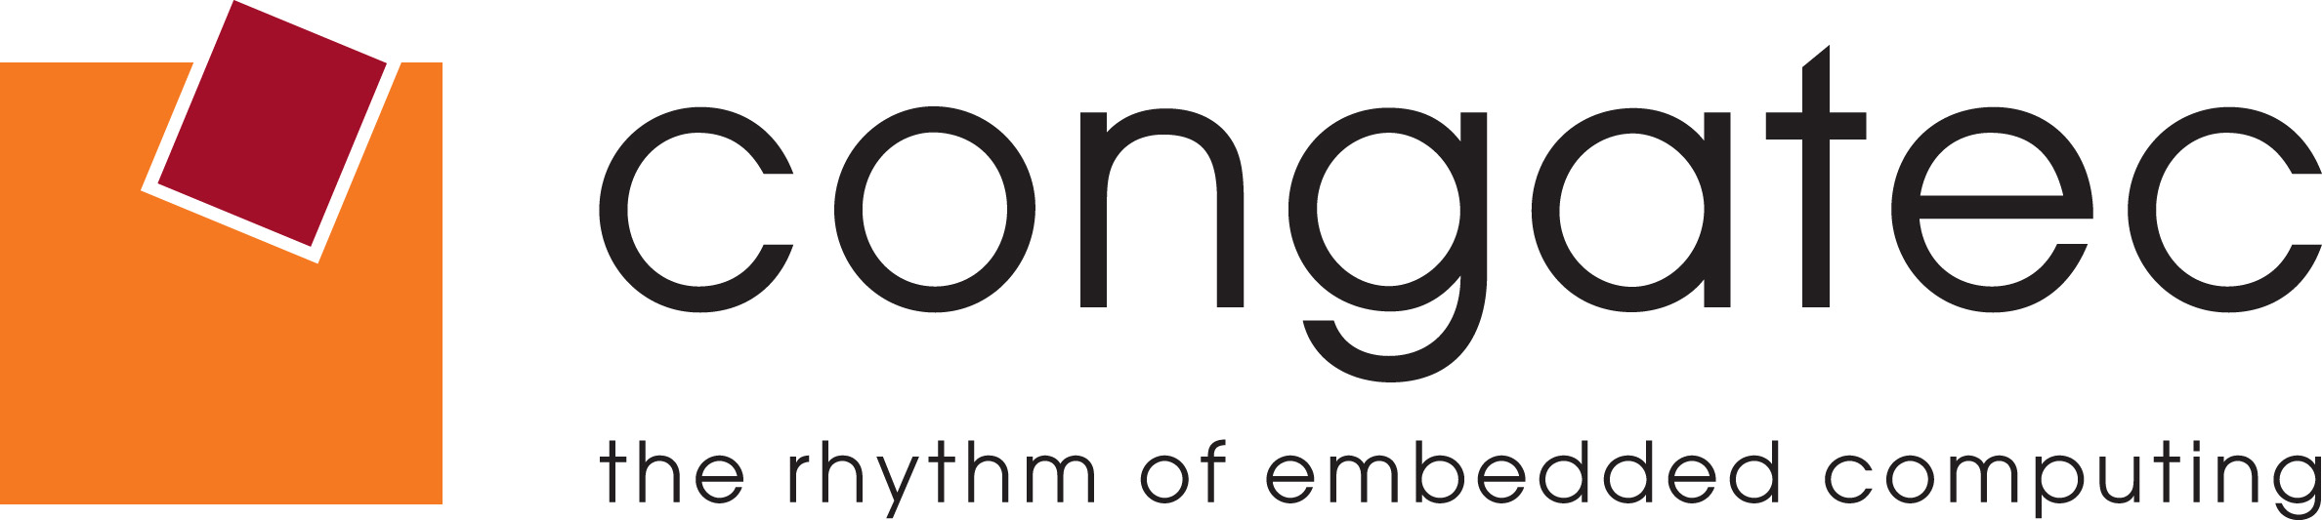
Reader Enquiries: | Press Contact:
congatec AG | PRismaPR  (UK, Scandinavia + Benelux) | PRismaPR
Christian Eder | Monika Cunnington | Bettina Lerchenmüller
Phone: +49-991-2700-0 | Phone: +44-20-8133 6148 | Phone: +49-8106-24 72 33
info@congatec.com  www.congatec.com | monika@prismapr.com  www.prismapr.com | info@prismapr.com  www.prismapr.com
Visit congatec at electronica
13 – 16 November 2012
Hall A6, Stand 306

Press release 20/2012

congatec announces record quarterly earnings for Q3/2012
Turnover reaches € 16.7 million
Deggendorf, Germany, 13 November 2012 * * * congatec AG, a leading manufacturer of embedded computer modules, has concluded the third fiscal quarter of 2012 with record results. Sales rose to €16.7 million, corresponding to an increase of 43% compared with Q3/2011.
congatec also recorded an increase for the period from January to September 2012, compared to the same period last year. The company posted sales of € 37.5 million for Q1-Q3 2011, compared to € 46 million for this year, representing an increase of approximately 30%.
congatec’s growth is not limited to financial performance; the number of employees has also increased by 11 in the current year, bringing the worldwide total to 135.
congatec CEO Gerhard Edi attributes the continued success of the company to the early focus on emerging technologies, in particular COM Express: "Thanks to our clear focus, only eight years after our foundation we are now No. 2 worldwide in Computer-on-Modules. For the fourth quarter, we expect a slight drop in sales, partly for economic reasons and partly because our customers are trying to reduce their inventories at the end of the year. However, our order book is stable and for 2013 we expect similar positive results as in the current year."
Recently, congatec achieved 22nd place in the Deloitte Technology Fast 50, which ranks the fastest growing technology companies in Germany. Rankings are based on the percentage of revenue growth over the last five years, in this case 2007-2011. During this period, congatec grew 293 percent.

About congatec AG
congatec AG has its head office in Deggendorf, Germany and is a leading supplier of industrial computer modules using the standard form factors Qseven, COM Express, XTX and ETX. congatec’s products can be used in a variety of industries and applications, such as industrial automation, medical technology, automotive supplies, aerospace and transportation. Core knowledge and technical know-how includes unique extended BIOS features as well as comprehensive driver and board support packages. Following the design-in phase, customers are given support via extensive product lifecycle management. The company’s products are manufactured by specialist service providers in accordance with modern quality standards. congatec currently has 135 employees and entities in Taiwan, Japan, USA, Australia and the Czech Republic. More information is available on our website at www.congatec.com.
* * *

Source: ISM Research Embedded Computer Boards and Modules, 2012 Edition.

