

Leserkontakt: | Pressekontakt:
congatec AG | PRismaPR
Christian Eder | Bettina Lerchenmüller
Telefon: +49-991-2700-0 | Telefon: +49-8106-24 72 33
info@congatec.com  www.congatec.com | info@prismapr.com  www.prismapr.com
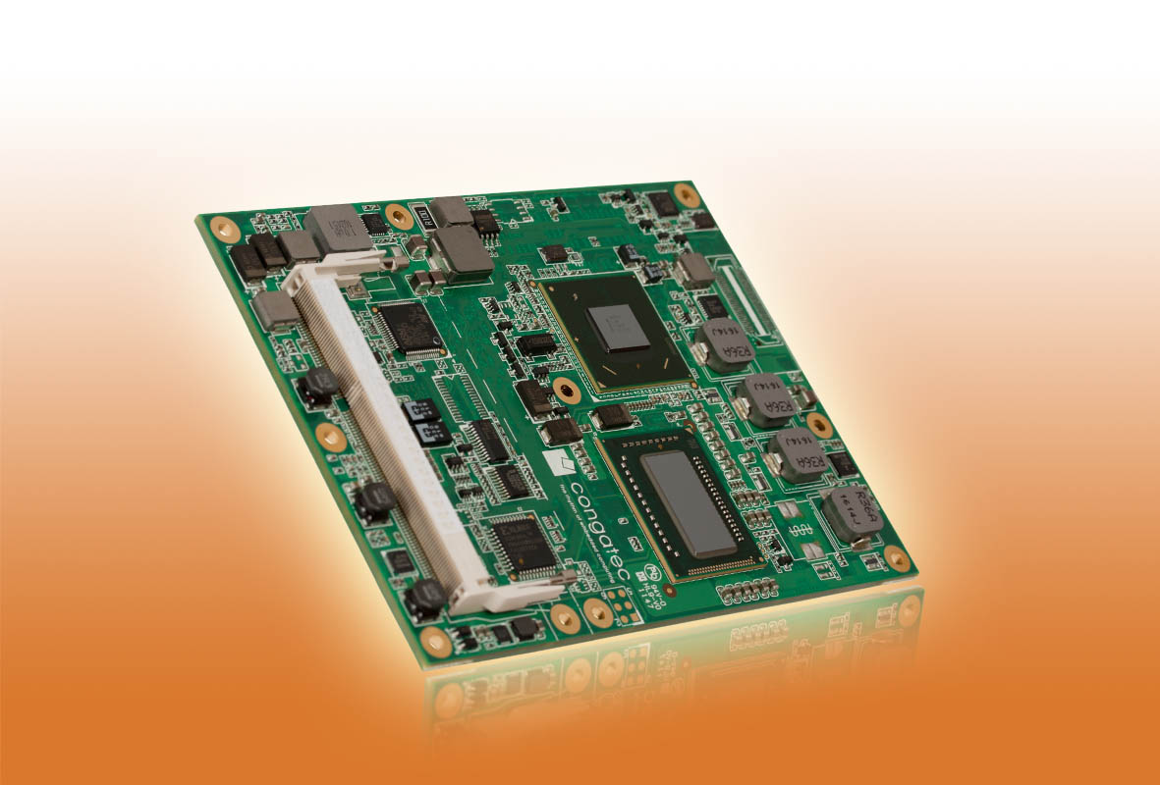
Text and photograph available at: http://pr.congatec.com

Press release 07/2012
congatec introduces new COM Express type 6 module with quad core, 3rd generation Intel® Core™ processors

conga-TM77: increased computing performance with improved
energy efficiency

Deggendorf, April 23rd, 2012 * * * congatec AG, a leading manufacturer of embedded computer modules, has just introduced conga-TM77, a new module with a significant improvement in computing performance combined with enhanced energy efficiency. The crucial innovations in the 3rd generation Intel® Core™ processors relate to the construction, with 3D Tri-Gate transistors and 22 nanometer technology, plus a more powerful integrated graphics core. The type 6 pinout and 3x digital display interfaces provide better display options and increased bandwidths with extra PCI Express lanes.
The COM Express module is fitted with the new quad cores, 3rd generation Intel® Core™ i7-3612QE (4 × 2.1 GHz, 6 MB L2 cache memory, TDP 35W) and Intel® Core™ i7-3615QE (4 × 2.3 GHz, 6 MB L2 cache memory, TDP 45W) processors along with the Mobile Intel® HM76 Express chipset, as well as native USB 3.0 support and the fast dual channel DDR3-1600 MHz memory, providing up to 16 GB. The outstanding newly integrated Intel® HD4000 graphics core is equipped with over 16 execution units performs up to 50 percent better than its predecessors and can control up to three displays independently of each other.
It also provides Intel® Flexible Display Interface (FDI), DirectX 11 OpenGL 3.1 OpenCL 1.1, as well as a high performance MPEG-2 hardware decoding unit in order to decode multiple high resolution full HD videos in parallel.
OpenCL is a powerful programming environment with which computing tasks can be distributed and processed in a variety of processor systems involving a number of hardware units. The special feature of OpenCL is that multiple parallel execution is possible in a single step (SIMD=Single Instruction Multiple Data), so that it can support the classic parallel computer architecture as well. This is of crucial importance, because not only graphic representations but also many analytical problems are very well suited to parallel processing.
In addition to VGA and LVDS, it has three digital display interfaces, each of which can be configured for DisplayPort (DP), HDMI or DVI. This ensures a maximum of three independent displays for applications in the medical, automation and gaming industries.
With the first native USB 3.0 support for the module, data transfer is considerably faster, energy consumption lower and now even simultaneous sending and receiving of data is possible. Eight USB ports are provided, four of those are capable of USB 3.0 Superspeed operation.
Seven PCI Express 2.0 lanes, PCI Express graphics 3.0 (PEG) × 16 lanes for high performance external graphics cards, four SATA interfaces with up to 6 GB/s and RAID support, an EIDE and a gigabit Ethernet interface facilitate fast and flexible system expansions. Fan control, an LPC bus for simple connection of legacy I/O interfaces and the Intel® high definition audio round off the comprehensive range of features.
The congatec board controller provides an extensive embedded PC feature set. The independent x86 processor makes functions such as system monitoring or the I²C bus faster and more reliable, even if the system is in standby mode.
The matching evaluation carrier board for COM Express type 6 is also available, so that all the new features can be tested with ease.

About congatec AG
congatec AG has its head office in Deggendorf, Germany and is a leading supplier of industrial computer modules using the standard form factors Qseven, COM Express, XTX and ETX. congatec’s products can be used in a variety of industries and applications, such as industrial automation, medical technology, automotive supplies, aerospace and transportation. Core knowledge and technical know-how includes unique extended BIOS features as well as comprehensive driver and board support packages. Following the design-in phase, customers are given support via extensive product lifecycle management. The company’s products are manufactured by specialist service providers in accordance with modern quality standards. congatec currently has 120 employees and entities in Taiwan, USA and the Czech Republic. More information is available on our website at www.congatec.com.
* * *
Intel and Intel Core are trademarks of Intel Corporation in the U.S. and other countries.
congatec is a business partner of Intel® Intelligent Systems Alliance, a joint venture by communication and embedded developers and solution providers.

