

Reader Enquiries: | Press contact:
congatec AG | PRismaPR (UK + Scandinavia) | PRismaPR
Christian Eder | Monika Cunnington | Bettina Lerchenmüller
Phone: +49-991-2700-0 | Phone: +44-1462-640779 | Phone: +49-8106-24 72 33
info@congatec.com  www.congatec.com | monika@prismapr.com  www.prismapr.com | info@prismapr.com  www.prismapr.com

Visit congatec at embedded world 2012
Nuremberg, Feb. 28 – March 1 in Hall 1, Stand 350

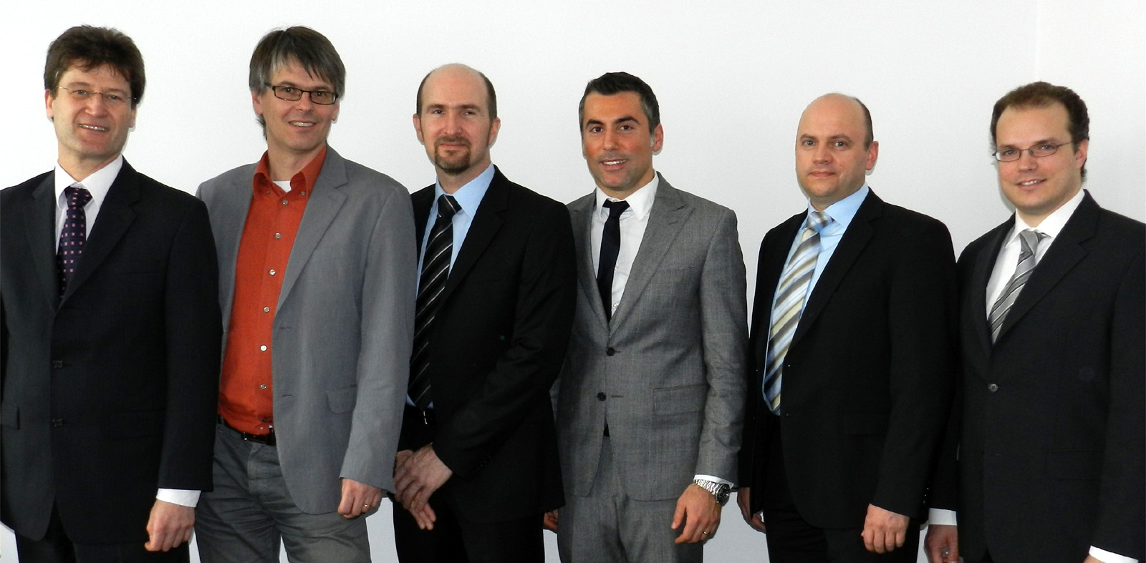

The representatives of the founding members (from left to right): Wolfgang Eisenbarth (MSC), Christian Eder (congatec), Markus Mahl (Data Modul), Gianluca Venere (Seco), Josef Behammer (Kontron) and Carsten Rebmann (Advantech)

Photo and Text available: http://pr.congatec.com

Press Release 05/2012

The new Standardization Group for Embedded Technologies (SGET) is on its way
New embedded consortium for standardization management
Munich/Nuremberg, 28 February 2012 * * * At the Embedded World tradeshow today the founding of the Standardization Group for Embedded Technologies ('SGET' ) has been announced. Leading embedded computer manufacturers Advantech, congatec, Data Modul, Kontron, MSC, SECO, as well as the publishing houses WEKA Fachmedien and Vogel Business Media, are among the founding members.
The SGET will be holding its inaugural meeting at the beginning of March. The group is committed to developing and maintaining embedded computing specifications which will be applicable worldwide, in order to promote new embedded technology standardizations meeting the requirements of the markets.
With the founding of the SGET, a globally-operating, manufacturer-independent consortium has been created, which is in a position to react to the accelerated speed of technological progress and changing market demands in a fast and flexible manner. The founding members of the SGET are confident that more than one hundred ventures worldwide will join the group within a year - underlining the great need for improvement in market orientation and fast specification implementation. Other companies and institutions working in the area of embedded computing are invited to join the new Standardization Group for Embedded Technologies. In particular, the SGET welcomes embedded computer manufacturers on board- and system-level, research and educational institutions as well as embedded system integrators, OEM solution providers and industrial end-users.
"The goal of the founding members of the Standardization Group for Embedded Technologies is to create a new, powerful, worldwide committee for embedded computer specifications which will operate at greater speed and with far less bureaucracy than comparable organizations. To achieve this, the SGET has, amongst other things, established simplified rules and shorter objection periods, enabling specifications to be passed at greater speed", Dirk Finstel, Kontron AG, states as one of the main reasons for the founding of the consortium.
"The fast pace of technological progress in the embedded market requires cooperation even between competing companies. This can only succeed if we follow overall regulations. A committee which can act rapidly enables us to jointly and instantly react to market demands. This is why we very much welcome the founding of this new consortium", Christian Eder, congatec, comments.
"Different manufacturer interests on the component level slow down standardization work on embedded module standards. This is why we are pleased that the SGET consortium of board and module manufacturers has created rules which offer more scope for innovation and which put the interests of the users first", states Wolfgang Eisenbarth, MSC.
"From the new Standardization Group for Embedded Technologies we expect major input in the area of SFF processors, as not only Computer-on-Modules, but also motherboards and SBCs, i.e. 3.5" or IO boards of embedded systems, are in need of standardization. Until now, we have lacked a powerful consortium which addresses these issues permanently and efficiently“, states Carsten Rebmann, Advantech.
"The new processor technologies for tablet PCs and mobile applications in consumer electronics are also having a major impact on the embedded market. It is therefore crucial that we come together and work on these mutual specifications right from the start, which will be valid on a worldwide basis in the shortest period of time“, Gianluca Venere, SECO, describes the most important current field of activity.
"Beyond the issue of form factors, we have to consider the standardization of individual interface implementations, for example via IP stacks. This is where I expect the SGET to play a pioneering role. Ultimately, this subject will also need standardization“, Markus Mahl, Data Modul, names a further potential field of activity for the new Standardization Group for Embedded Technologies.
First working groups for Computer-on-Modules are in place
The Standardization Group for Embedded Technologies, which will be founded as a registered association according to German law, will form the first working groups for the Computer-on-Module specifications Qseven and a dedicated ARM module specification. Under the roof of SGET further groups are welcome to develop specifications.
For further information please visit www.sget.org

* * *

