

Reader Enquiries: | Press contact:
congatec AG | PRismaPR (UK + Scandinavia) | PRismaPR
Christian Eder | Monika Cunnington | Bettina Lerchenmüller
Phone: +49-991-2700-0 | Phone: +44-1462-640779 | Phone: +49-8106-24 72 33
info@congatec.com  www.congatec.com | monika@prismapr.com  www.prismapr.com | info@prismapr.com  www.prismapr.com

Visit congatec at embedded world 2012
Nuremberg, Feb. 28 – March 1 in Hall 1, Stand 350

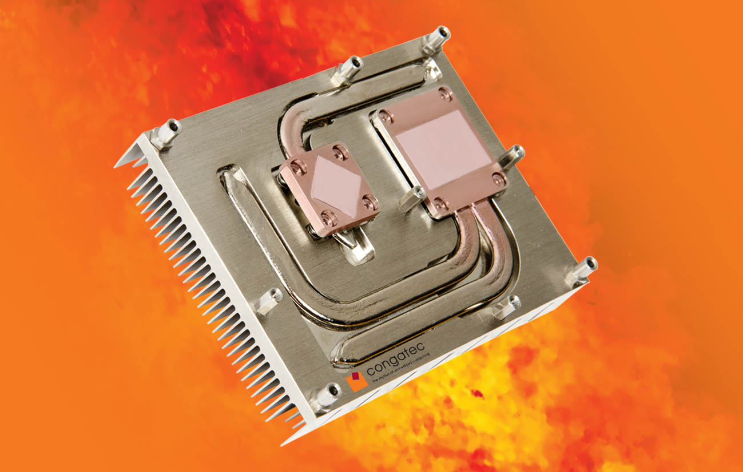

Photo and Text available: http://pr.congatec.com

Press Release 04/2012
congatec’s smart cooling pipes pave the way for unlimited performance growth for COM Express modules

Nuremberg, Embedded World, 28 February 2012 * * * congatec AG, a leading manufacturer of embedded computer modules, announces a new cooling system based on cooling pipes which are integrated in the standardized heatspreader of the COM Express specification. With this solution it becomes possible to cool next generation high-performance processors with a power dissipation of well over 35W TDP.
"The real problem lies with hot spots around the processor and chipset," states congatec product manager Martin Danzer. "Our improved cooling concept results in a lower processor temperature, which is essential for a more frequent activation of Turbo Boost 2 Technology to ensure maximum COM performance and energy efficiency. As a result, the processor can operate at higher levels than the maximum permitted thermal design power (TDP)."
The advantages at a glance:
- Fast spot cooling for full performance
- Elimination of gap filler layer
- Elimination of mechanical stress leads to higher quality
- Better cooling extends the life span of the module
- Heat pipe principle enables innovative customer-specific cooling concepts
congatec’s new heat pipe cooling design is available in different variants comprising a passive, active and customer-specific solution that creates space for innovative ideas. For example, the heat pipe can be designed in such a way that it can be connected to a customer-specific heat sink. Fanless designs are possible provided the casing is equipped with appropriately sized cooling fins. Ultimately, the design depends on the specific application. The key features of the concept are equally applicable to other electronic circuits.
The new cooling solution is also ideal for systems with low power dissipation. The modules have a higher thermal reserve, which increases their life span and reliability. Average temperature reductions of only 5 Kelvin can double the statistical life span – a convincing argument when considering the total cost over the lifetime of a system.
About congatec AG
congatec AG has its head office in Deggendorf, Germany and is a leading supplier of industrial computer modules using the standard form factors Qseven, COM Express, XTX and ETX. congatec’s products can be used in a variety of industries and applications, such as industrial automation, medical technology, automotive supplies, aerospace and transportation. Core knowledge and technical know-how includes unique extended BIOS features as well as comprehensive driver and board support packages. Following the design-in phase, customers are given support via extensive product lifecycle management. The company’s products are manufactured by specialist service providers in accordance with modern quality standards. congatec currently has 120 employees and entities in Taiwan, USA and the Czech Republic. More information is available on our website at www.congatec.com.
* * *
Intel and Intel Core are registered trademarks of the Intel Corporation in the USA and in other countries.
congatec is an Associate Member of the Intel® Embedded Alliance, a community of communications and embedded developers and solution providers. For more information, please visit www.intel.com/go/eca.

