

Reader Enquiries: | Press contact:
congatec AG | PRismaPR (UK + Scandinavia) | PRismaPR
Christian Eder | Monika Cunnington | Bettina Lerchenmüller
Phone: +49-991-2700-0 | Phone: +44-1462-640779 | Phone: +49-8106-24 72 33
info@congatec.com  www.congatec.com | monika@prismapr.com  www.prismapr.com | info@prismapr.com  www.prismapr.com

Visit congatec at embedded world 2012
Nuremberg, Feb. 28 – March 1 in Hall 1, Stand 350

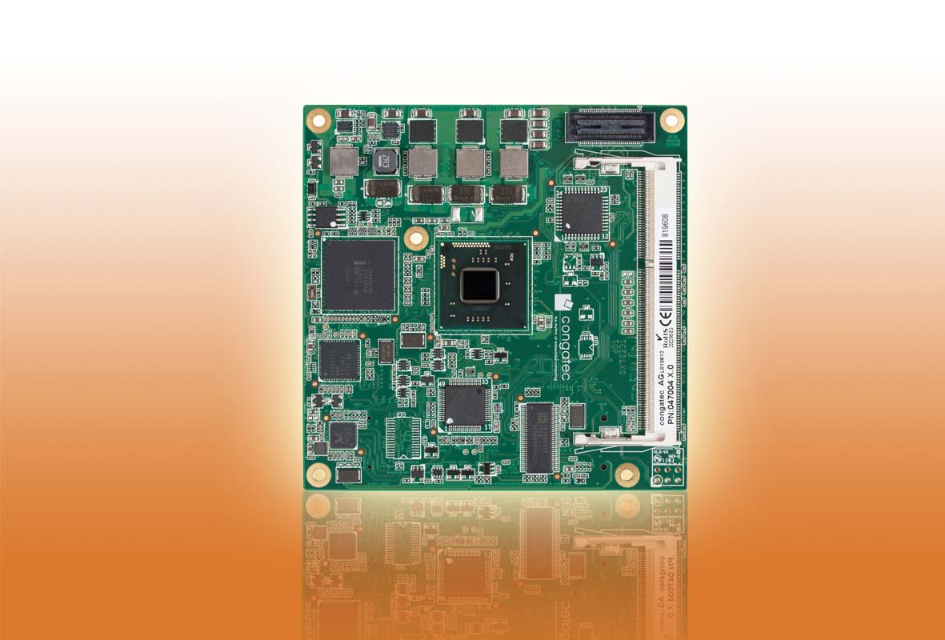

Photo and Text available: http://pr.congatec.com

Press Release 03/2012
congatec introduces entry-level module for COM Express Type 6 with new Intel® Atom™ dual-core processors
The conga-TCA offers lower power consumption and significantly improved graphics performance
Nuremberg, Embedded World, 28 February 2012 * * * congatec AG, a leading manufacturer of embedded computer modules, announces the conga-TCA, an entry-level model of its Type 6 Pin-out COM Express module range. The conga-TCA is available in three variants of the new Intel® Atom™ dual-core processor generation, which are manufactured in 32nm technology – the Intel® Atom™ N2600 processor with only 3.5W TDP (1M Cache, 1.6 GHz); the Intel® Atom™ N2800 processor (1M Cache, 1.86 GHz) with 6.5W TDP; and the Intel® Atom™ D2700 processor (1M Cache, 2.13 GHz) with 10W TDP and up to 4GB single-channel DDR3 memory (1066 MHz). The chipset module, which is based on the Intel® NM10, provides improved memory, graphics and display functionalities plus intelligent performance and greater energy efficiency.
Thanks to its low power consumption and compact measurements (95 x 95 mm) the conga-TCA is particularly well suited for applications in medical and automation technology, POS, kiosks and digital signage. Smart power and battery management guarantee long battery life, an essential factor for cost savings in portable devices.
For multi-processing applications with separate processors hyper-threading enables a logical division of the two physical processor cores into four threads. In this way, the safety-critical application can be kept separate running on a real-time operating system on a separate logical core while the graphical user interface runs, for instance, on a Windows operating system.
The highlight of the COM Express module is the outstanding graphics performance of the integrated Intel® GMA 3650 graphics chip. With a clock rate of 640 MHz it is twice as fast as the GPU of the previous Atom generation. In addition to VGA and LVDS, it has two digital display interfaces which can be executed for DisplayPort, HDMI or DVI, and – unlike Type 2 modules – are no longer multiplexed.
Five PCI Express x1 lanes, two SATA 2.0, eight USB 2.0, two optional USB 3.0 ports and a Gigabit Ethernet interface enable fast and flexible system extensions. Fan control, LPC bus for easy integration of legacy I/O interfaces and Intel® High Definition Audio round off the feature set.
The conga-TCA module is equipped with the new embedded firmware solution UEFI.
The congatec board controller provides an extensive embedded PC feature set. Independence from the x86 processor means that functions such as system monitoring or the I²C bus can be executed faster and more reliably, even if the system is in standby mode.
A matching evaluation carrier board for COM Express Type 6 is also available.

About congatec AG
congatec AG has its head office in Deggendorf, Germany and is a leading supplier of industrial computer modules using the standard form factors Qseven, COM Express, XTX and ETX. congatec’s products can be used in a variety of industries and applications, such as industrial automation, medical technology, automotive supplies, aerospace and transportation. Core knowledge and technical know-how includes unique extended BIOS features as well as comprehensive driver and board support packages. Following the design-in phase, customers are given support via extensive product lifecycle management. The company’s products are manufactured by specialist service providers in accordance with modern quality standards. congatec currently has 120 employees and entities in Taiwan, USA and the Czech Republic. More information is available on our website at www.congatec.com. * * *
Intel and Intel Core are registered trademarks of the Intel Corporation in the USA and in other countries.
congatec is an Associate Member of the Intel® Embedded Alliance, a community of communications and embedded developers and solution providers. For more information, please visit www.intel.com/go/eca.

