Reader Contact: | Press Contacts:
congatec AG | PRismaPR (UK + Scandinavia) | PRismaPR
Christian Eder | Monika Cunnington | Bettina Lerchenmüller
Phone: +49-991-2700-0 | Phone: +44-1462-640779 | Phone: +49-8106-24 72 33
info@congatec.com  www.congatec.com | monika@prismapr.com  www.prismapr.com | info@prismapr.com  www.prismapr.com

Visit congatec at ICE in London, 25–27 January 2011, Booth #4031

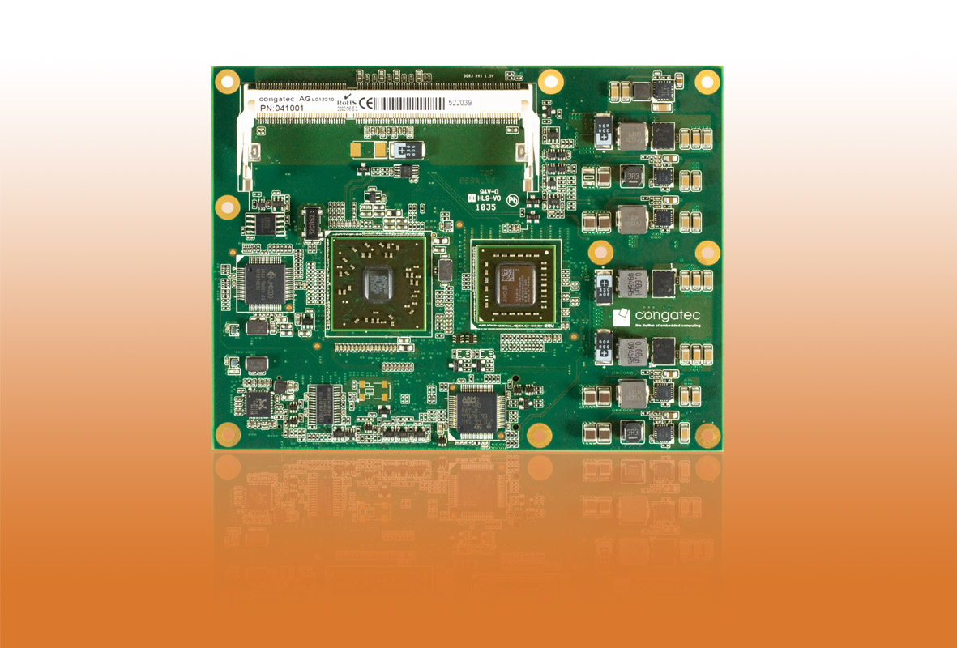
Photo available: http://pr.congatec.com
Press Release 02/2011

congatec unveils new COM Express Basic Module with
AMD Fusion Technology

conga-BAF offers outstanding graphics performance with low power consumption

Taiwan Embedded Forum, 19 January 2011 * * * congatec AG, a leading manufacturer of embedded computer modules, introduces a new COM Express product line based on the AMD Embedded G-Series platform. The integration of AMD Fusion technology expands the COM Express standard with a completely new processor architecture that combines processors and graphics cores in a compact package. System designers benefit from a powerful CPU and an even more powerful graphics performance, excellent performance-per-watt ratio and flexible task allocation on the CPU and GPU.
With the conga-BAF, streaming high-definition multimedia content and playing the latest next generation 3D games becomes easy and straightforward.
“We expect AMD Fusion technology to be a great addition to our computer-on-module family and will be ideally suited for graphics demanding embedded computing applications,” explained Gerhard Edi, CEO at congatec AG. “Our customers will get a wide range of performance on a single platform. That makes designing the system to meet the demands of customer specific applications particularly easy.”
“Embedded computer systems are a fast growing segment and AMD’s easy to integrate design allows for a shorter time to market,” said Richard Jaenicke, director, product marketing, AMD (NYSE: AMD). “The AMD based computer-on-modules from congatec enable customers in the embedded market to immediately access the AMD Fusion technology.”
congatec currently integrates five processors of the AMD Embedded G-Series platform, ranging from an AMD T44R 1.2 GHz single-core (64 KB L1 cache, 512 KB L2 cache) with 9 Watt TDP to an AMD T56N 1.6 GHz dual core (64 KB L1 cache, 512 KB x2 L2 cache) with 18 Watt TDP.
The conga-BAF uses the AMD Hudson E1 Fusion controller hub and provides a powerful compact 2-chip solution with up to 8 GByte dual-channel DDR3 memory.
The integrated graphics core with the Universal Video Decoder 3.0 for seamless processing of Blu-ray content via HDCP (1080p), MPEG-2 HD and DivX (MPEG-4) video interfaces supports DirectX ® 11 and OpenGL 4.0 for fast 2D and 3D image display as well as OpenCL 1.1. The choice of graphics interfaces includes VGA, single channel LVDS as well as DisplayPort and DVI / HDMI enabling the direct control of two independent displays.
Six PCI Express x1 Lanes, eight USB 2.0 ports, four SATA, one EIDE plus one Gigabit Ethernet interface allow flexible system expansion with high data bandwidth. The congatec board controller features, ACPI 3.0 power management and high-definition audio complete the package.

About congatec AG
congatec AG has its head office in Deggendorf in Bavaria. It is an innovative business that specializes in the development and marketing of industrial computer modules using the standard form factors Qseven, COM Express, XTX and ETX. With this focus and annual revenue of 26 million euro (2009), congatec is today a leading manufacturer in this field. The company’s products can be used in a variety of industries and applications, such as industrial automation, medical technology, automotive supplies, aerospace and transportation. Core knowledge and technical know-how includes unique extended BIOS features as well as comprehensive driver and board support packages. Following the design-in phase, customers are given support via extensive product lifecycle management. The company’s products are manufactured by specialist service providers in accordance with modern quality standards. congatec currently has 92 employees and branch offices in the UK, Sweden, the Czech Republic, Israel, Taiwan and the USA. More information is available on our website at www.congatec.com.

AMD, the AMD Arrow logo and combinations thereof, are trademarks of Advanced Micro Devices, Inc. Other names are for informational purposes only and may be trademarks of their respective owners.

