

Reader Inquiries: | Press contact:
congatec AG | PRismaPR (UK + Scandinavia) | PRismaPR
Christian Eder | Monika Cunnington | Bettina Lerchenmüller
Phone: +49-991-2700-0 | Phone: +44-1462-640779 | Phone: +49-8106-24 72 33
info@congatec.com  www.congatec.com | monika@prismapr.com  www.prismapr.com | info@prismapr.com  www.prismapr.com

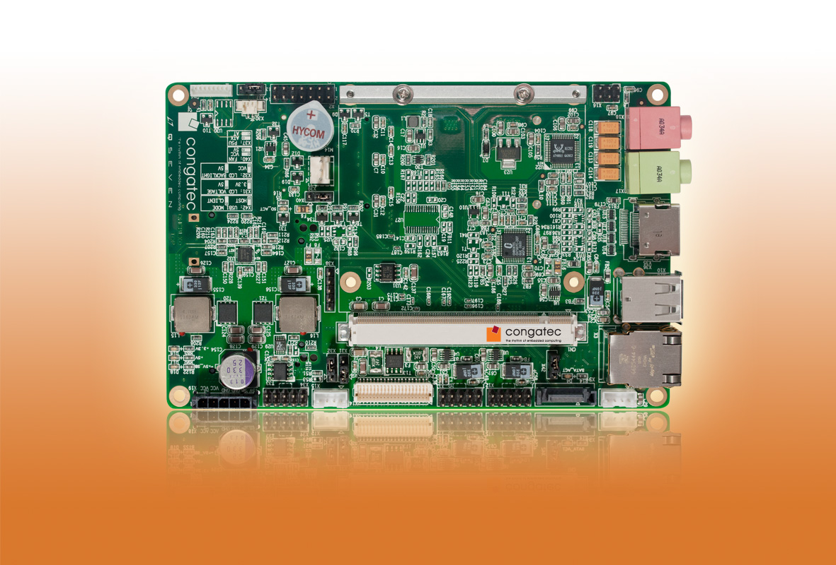
Visit congatec at SPS/IPC/Drives in Nuremberg in Hall 8, Booth #528

Text and photo available: http://pr.congatec.com
Press Release 11/2011

congatec unveils Qseven mini carrier baseboard for accelerated design-in
Nuremberg, SPS/IPC/Drives, 22 November 2011 * * * congatec AG, a leading manufacturer of embedded computer modules, presents the conga-QMCB, a new mini carrier baseboard for space-critical applications based on the Qseven standard. The baseboard is ideal for fast prototype design and compact, mobile applications. Measuring just 145x95 mm, the easy-to-integrate mini carrier board is packed with a wide range of state-of-the-art interfaces and is designed to accelerate the evaluation process in the design-in phase, thereby facilitating faster time-to-market. DisplayPort, HDMI and LVDS 18/24 Bit graphics interfaces have been implemented, together with six USB interfaces and an Ethernet connection. The board also offers additional standard interfaces such as high definition audio and a mini PCI express socket, which can be used for WLAN. SD-Card, 2x SATA and CFast have also been integrated on the baseboard to enable the connection of mass storage devices.
The conga-QMCB is powered by a single 5V DC supply. Battery management signalling is fully incorporated, enabling the use of the congatec Smart Battery Manager (conga-SBM2) and making the baseboard a simple solution for mobile systems. When using ACPI-compatible operating systems such as Linux or Windows, battery system communication is fully implemented; no special software or BIOS adjustment is required.
The conga-QMCB is designed for use with the new conga-QAF computer module, which is based on AMD Fusion technology, and the conga-QA6, which is based on the current Intel Atom E600 series.
The conga-QMCB is available with immediate effect.

About congatec AG
congatec AG has its head office in Deggendorf, Germany and is a leading supplier of industrial computer modules using the standard form factors Qseven, COM Express, XTX and ETX. congatec’s products can be used in a variety of industries and applications, such as industrial automation, medical technology, automotive supplies, aerospace and transportation. Core knowledge and technical know-how includes unique extended BIOS features as well as comprehensive driver and board support packages. Following the design-in phase, customers are given support via extensive product lifecycle management. The company’s products are manufactured by specialist service providers in accordance with modern quality standards. congatec currently has 112 employees and entities in Taiwan, USA and the Czech Republic. More information is available on our website at www.congatec.com.

