

Reader Inquiries: | Press contact:
congatec AG | PRismaPR(UK + Scandinavia) | PRismaPR
Christian Eder | Monika Cunnington | Bettina Lerchenmüller
Phone: +49-991-2700-0 | Phone: +44-1462-640779 | Phone: +49-8106-24 72 33
info@congatec.com | monika@prismapr.com | info@prismapr.com
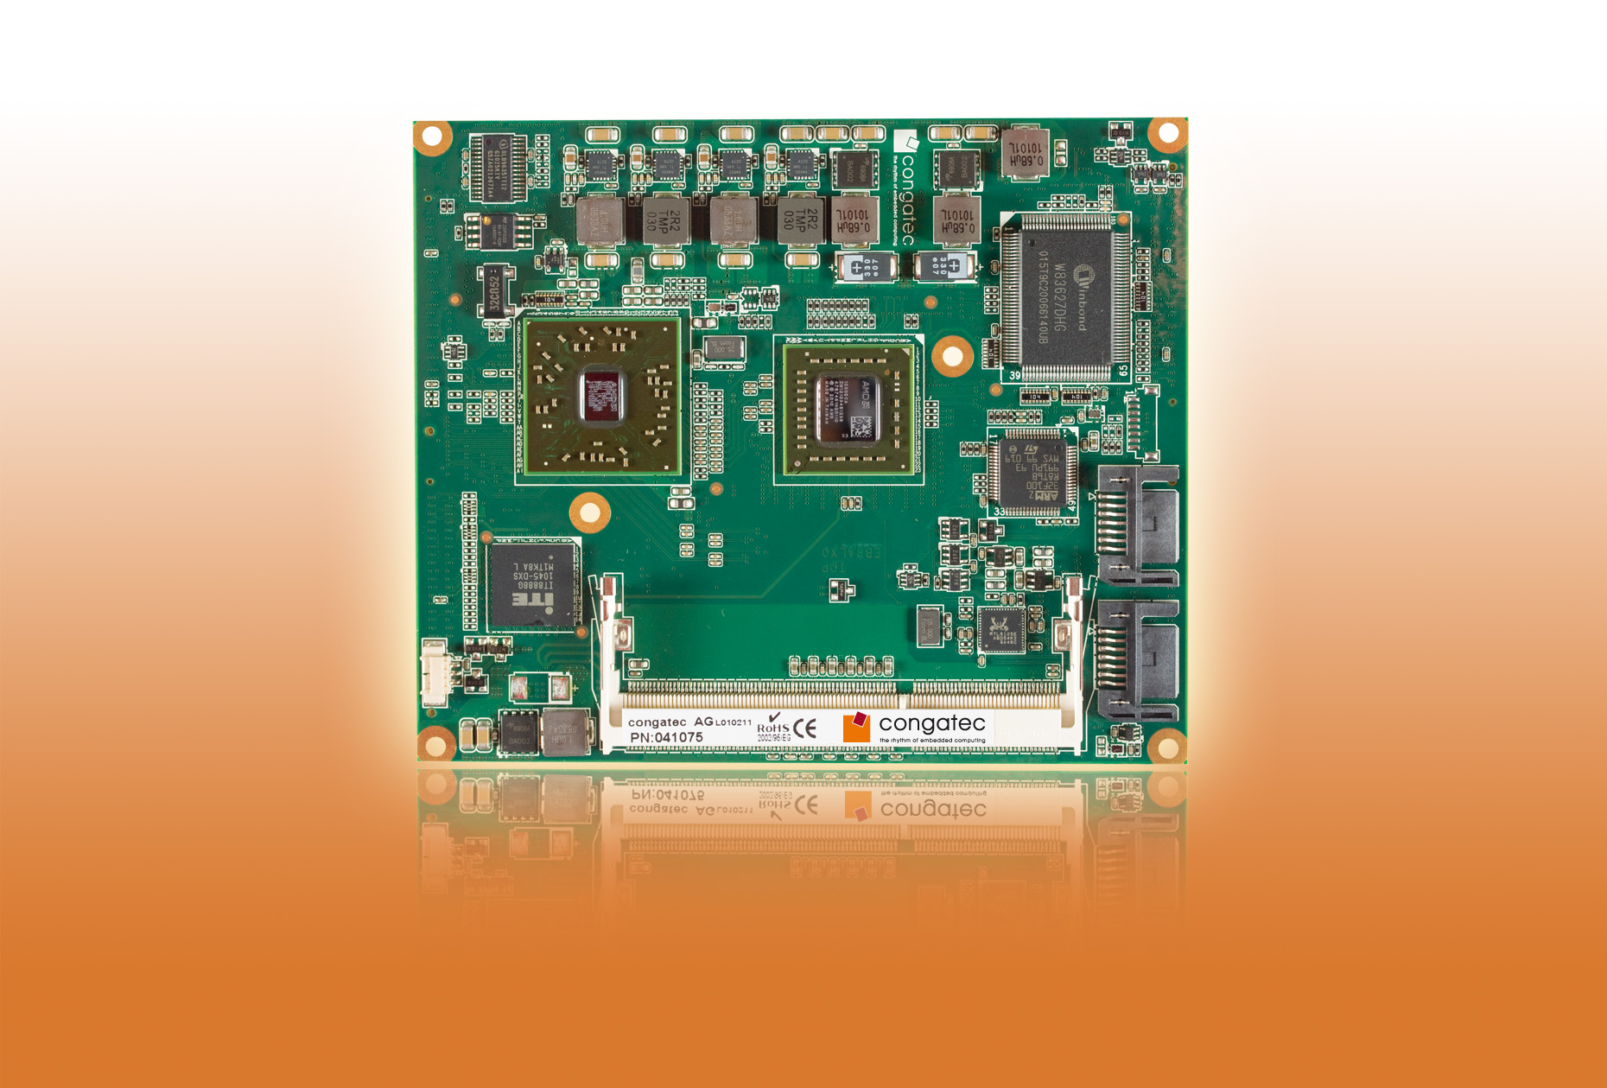
Text and photo available: http://pr.congatec.com
Press Release 08/2011
New conga-EAF module from congatec provides broad scalability for ETX standard
AMD Fusion architecture guarantees best price/performance ratio

Deggendorf, Germany, 01 August 2011 * * * congatec AG, a leading manufacturer of embedded computer modules, is guaranteeing a sustainable future and broad scalability for the ETX standard with the launch of the conga-EAF Computer-on-Module (COM). With a choice of seven AMD G-Series processors, the conga-EAF also offers the best price/performance ratio. Ranging from the AMD T56N 1.6 GHz Dual Core (L1 cache 64KB, L2 Cache 512KB x2, 18 W) multi-core processor to the AMD G-T40R 1.0 GHz (L1 cache 64KB, L2 cache 512KB, 5.5W) single-core processor with extremely low power consumption, the conga-EAF provides a perfect form-fit function setup for ETX. congatec is thereby granting all ETX applications a life-time extension into a second generation.
A particularly noteworthy benefit of the new COMs is native PCI support. ETX applications are based on this primary data bus and therefore continue to rely on unlimited data transfer for the connection of PCI peripherals. Direct native 32-bit PCI support from the chipset has substantial advantages with regard to PCI bus latency over comparable PCI Express bridge solutions.
The discontinuation of the Intel® 855 chipset family left a serious gap in the market for ETX computer modules. Processor manufacturer AMD has closed this gap with the introduction of its Fusion architecture which combines two previously separate computing functions – the CPU (Central Processing Unit) and the GPU (Graphics Processing Unit) – into one Accelerated Processor Unit (APU). Fusion also opened up completely new perspectives for a wide range of innovative graphics-related applications.
The conga-EAF modules are equipped with the embedded controller hub Hudson E1 and provide a powerful and inexpensive compact two-chip solution with up to 4GB of single channel DDR3 memory.
The integrated graphics core with the Universal Video Decoder 3.0 for seamless Blu-ray processing via HDCP (1080p), MPEG-2, HD and DivX (MPEG-4) videos supports DirectX® 11 and OpenGL 4.0 for fast 2D and 3D imaging as well as OpenCL 1.1. The APU comes with two independent graphics controllers providing VESA-compliant video output with resolutions up to 2560 x 1600 pixels.
The conga-EAF supports 2 x Serial ATA interfaces, native 32-bit PCI (Rev. 2.3), 2 x EIDE, 4 x USB 2.0 ports, ISA bus, 2 x COM, PS/2, 10/100M Ethernet and high-definition audio. A choice of LVDS, CRT, DisplayPort, HDMI or DVI graphics interfaces is also provided.
Availability
The conga-EAF is available now in volume production.
About congatec AG
congatec AG has its head office in Deggendorf, Germany and is a leading supplier of industrial computer modules using the standard form factors Qseven, COM Express, XTX and ETX. congatec’s products can be used in a variety of industries and applications, such as industrial automation, medical technology, automotive supplies, aerospace and transportation. Core knowledge and technical know-how includes unique extended BIOS features as well as comprehensive driver and board support packages. Following the design-in phase, customers are given support via extensive product lifecycle management. The company’s products are manufactured by specialist service providers in accordance with modern quality standards. congatec currently has 112 employees and entities in Taiwan, USA and the Czech Republic. More information is available on our website at www.congatec.com.
* * *

AMD, the AMD Arrow logo and combinations thereof, are trademarks of Advanced Micro Devices, Inc. Other names are for informational purposes only and may be trademarks of their respective owners.

Intel and Intel Core are registered trademarks of the Intel Corporation in the USA and in other countries.

