

Reader Contact: | Press Contacts:
congatec AG | PRismaPR (UK + Scandinavia) | PRismaPR
Christian Eder | Monika Cunnington | Bettina Lerchenmüller
Phone: +49-991-2700-0 | Phone: +44-1462-640779 | Phone: +49-8106-24 72 33
info@congatec.com  www.congatec.com | monika@prismapr.com  www.prismapr.com | info@prismapr.com  www.prismapr.com

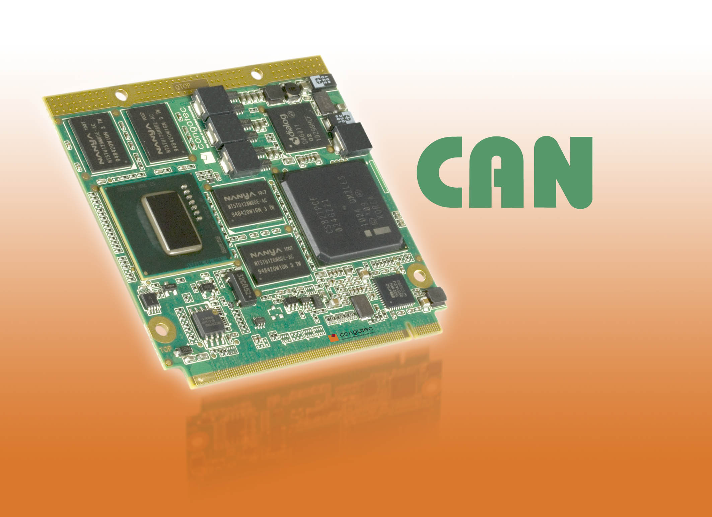

Visit congatec at SPS/IPC/Drives in Hall 8, Booth # 228

Text and Photo available: http://pr.congatec.com

Press Release 14/2010

congatec conga-QA6 supports CAN Bus in accordance to the
Qseven 1.2 specification

Nuremberg, Germany, SPS/IPC/DRIVES, November 23, 2010 * * * congatec AG, a leading manufacturer of embedded computer modules, announces CAN (Controller Area Network) bus support on the conga-QA6 small form factor (SFF) Qseven module. This is the first congatec Qseven module to support this interface.
The CAN bus is an asynchronous serial bus system that has been primarily used in the automotive industry but now is gaining a foothold within the automation industry. The new conga-QA6 is equipped with the Intel® Atom™ E600 processor series and the Intel® Platform Controller Hub EG20T that provides the CAN bus interface.
For many automation engineers, the CAN bus forms an integral part of the X-86 architecture and has become indispensable for many applications. The CAN bus has now been defined in the pinout of the Qseven specification revision 1.2 to meet today's small form factor demands. Previously reserved pins of the pinout have now been designated to the CAN bus interface.
The advantages of the CAN bus show up in a diverse range of applications in the automation sector. Similar to a data network at an industrial level, I/O modules, sensors, motors and controllers can be connected with the embedded computer. Only one line is required to connect all participants in a system; as a result it is possible to design very compact control systems.
The new conga-QA6 Qseven module with dimensions of just 70 x 70 mm and a power consumption of typically <5 watts is ideal in this situation. In addition to the CAN bus, it provides fast, differential interfaces such as PCI Express and SATA. In detail, the conga-QA6 provides 6x USB 2.0, 2x SATA, 1x SDIO, 3x PCIe, LPC bus, I²C bus, Gigabit Ethernet and high-definition audio. All components of this design are specified for the industrial temperature range of -40 to 85° C. The much enhanced internal graphics performance provides a particularly suitable basis for user-friendly applications in the automation industry.

About congatec AG
congatec AG has its head office in Deggendorf in Bavaria. It is an innovative business that specializes in the development and marketing of industrial computer modules using the standard form factors Qseven, COM Express, XTX and ETX. With this focus and annual revenue of 26 million euros (2009), congatec is today a leading manufacturer in this field. The company’s products can be used in a variety of industries and applications, such as industrial automation, medical technology, automotive supplies, aerospace and transportation. Core knowledge and technical know-how includes unique extended BIOS features as well as comprehensive driver and board support packages. Following the design-in phase, customers are given support via extensive product lifecycle management. The company’s products are manufactured by specialist service providers in accordance with modern quality standards. congatec currently has 92 employees and branch offices in the UK, Sweden, the Czech Republic, Israel, Taiwan and the USA. More information is available on our website at www.congatec.com.

* * *
Intel and Intel Core are registered trademarks of the Intel Corporation in the USA and in other countries.
congatec is an Associate Member with the Intel® Embedded Alliance, a community of communications and embedded developers and solution providers. For more information, please visit www.intel.com/go/eca

