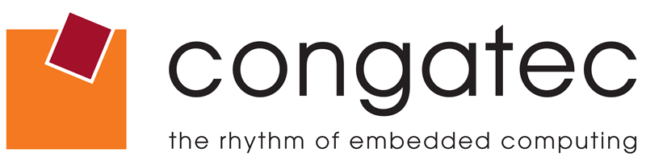

Reader Contact: | Press Contacts:
congatec AG | PRismaPR (UK + Scandinavia) | PRismaPR
Christian Eder | Monika Cunnington | Bettina Lerchenmüller
Phone: +49-991-2700-0 | Phone: +44-1462-640779 | Phone: +49-8106-24 72 33
info@congatec.com | monika@prismapr.com | info@prismapr.com

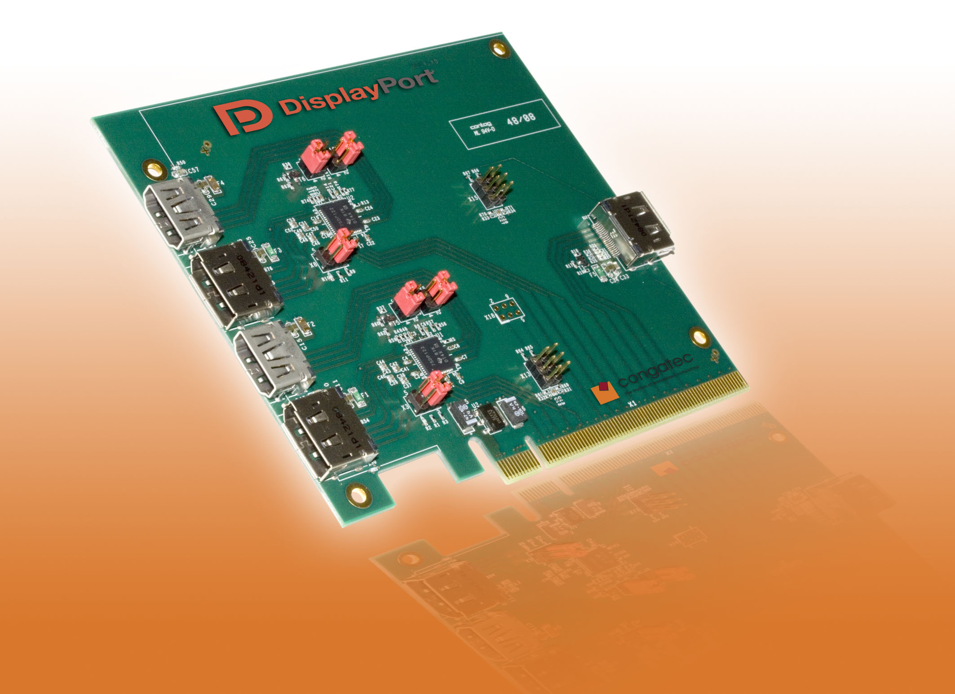
Text and Photo available: http://pr.congatec.com

Press Release 13/2010

congatec provides full DisplayPort Support
for COM Express Type 2

Munich, electronica, November 9, 2010 * * * congatec AG, a leading manufacturer of embedded computer modules, announces support of up to three DisplayPort video interfaces for the current Type 2 COM Express modules conga-BM45 and conga-BM57.
DisplayPort is a fully digital, packet-based and royalty-free display interface for the transmission of video signals and other data, for example multiple audio channels.
In the long term, DisplayPort is set to replace existing interfaces such as DVI and VGA. HDMI will remain the preferred interface for Home TV applications. As a rule, HDMI licensing costs do not allow it to be a viable option for industrial applications. Both DisplayPort and HDMI transmit audio signals. Since DisplayPort provides almost twice the data bandwidth of HDMI, or DVI, it is suitable for use in displays with extremely high resolutions.
DisplayPort consists of a maximum of four "lanes" (differential data pairs) that are automatically configured in line with the required data rate in order to make optimal use of the available transmission capacity. When all four lanes are used, this adds up to approximately 17 Gbit/s of available data bandwidth. This is sufficient for resolutions of up to 4096 × 2560 pixels at 60 Hz frame rates and 24 bit colour depths.
The differential data lines of DisplayPort allow cable lengths of up to 15 meters. But DisplayPort will eventually also replace the now universal LVDS interface in applications that bridge shorter distances within a computer system.
"DisplayPort opens new opportunities, especially for the medical and gaming market," says Martin Danzer, R&D Manager at congatec AG. "According to the COM Express specification, support for DisplayPort is available only with the type 6 pin assignment. Many of congatec’s COM Express Type 2 modules are already capable of transferring DisplayPort signals via PEG lines without violating the specification. So there is no reason not to use DisplayPort today."
Caption:
The conga-ADD2DP for the PEG slot provides access to the available DisplayPort or HDMI signals. Schematics for this ADD2 card are available to developers free of charge.

About congatec AG
congatec AG has its head office in Deggendorf in Bavaria. It is an innovative business that specializes in the development and marketing of industrial computer modules using the standard form factors Qseven, COM Express, XTX and ETX. With this focus and annual revenue of 26 million euros (2009), congatec is today a leading manufacturer in this field. The company’s products can be used in a variety of industries and applications, such as industrial automation, medical technology, automotive supplies, aerospace and transportation. Core knowledge and technical know-how includes unique extended BIOS features as well as comprehensive driver and board support packages. Following the design-in phase, customers are given support via extensive product lifecycle management. The company’s products are manufactured by specialist service providers in accordance with modern quality standards. congatec currently has 92 employees and branch offices in the UK, Sweden, the Czech Republic, Israel, Taiwan and the USA. More information is available on our website at www.congatec.com.

* * *
Intel and Intel Core are registered trademarks of the Intel Corporation in the USA and in other countries.

congatec is an Associate Member with the Intel® Embedded Alliance, a community of communications and embedded developers and solution providers. For more information, please visit www.intel.com/go/eca

