

Reader Contact: | Press Contacts:
congatec AG | PRismaPR (UK + Scandinavia) | PRismaPR
Christian Eder | Monika Cunnington | Bettina Lerchenmüller
Phone: +49-991-2700-0 | Phone: +44-1462-640779 | Phone: +49-8106-24 72 33
info@congatec.com | monika@prismapr.com | info@prismapr.com

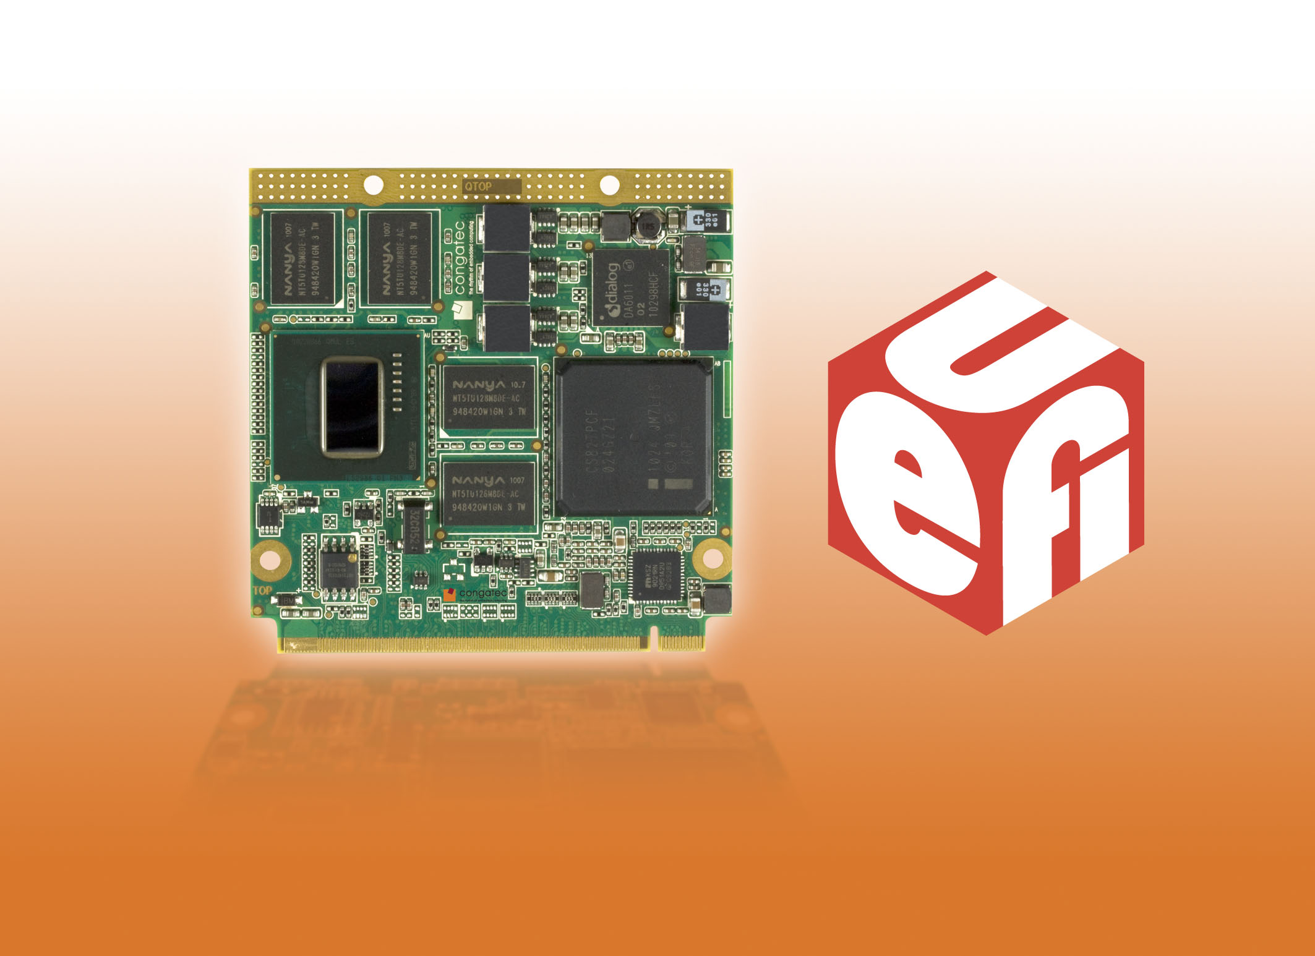
Text and Photo available: http://pr.congatec.com

Press Release 12/2010

congatec AG presents UEFI support on Qseven with new
Intel® Atom™ Processor E600 Series

congatec Embedded BIOS features now implemented in UEFI
Munich, electronica, November 9, 2010 * * * congatec AG, a leading manufacturer of embedded computer modules, announces UEFI support for the new conga-QA6 small form factor module. UEFI stands for Unified Extensible Firmware Interface.
The traditional BIOS, which is required to initialize the hardware before starting up the operating system, is now superseded by the more modern UEFI boot software. Due to its progressive software design, UEFI considerably simplifies the configuration of embedded computers.
The original BIOS no longer meets the demands of modern hardware and operating systems. In particular, it is unsuitable for 64-bit architectures and can not handle hard disks which are larger than 2 terabytes.
"Under UEFI the congatec Embedded BIOS features will continue to be supported and expanded," said Christian Riesinger, who heads the Technical Solution Center’s FAE team at congatec. "For our customers, these features have been a significant improvement, which will increase further with additional UEFI functionality. By adding UEFI support we are able to offer our customers a truly market-leading firmware solution. The graphic user interface and the programming interface of UEFI have been aligned with the previous BIOS to ensure a familiar user interface for our customers."
The new pre-boot application makes it possible to integrate large applications, such as embedded diagnostic tools, network-based service programs or system recovery utilities that can be deployed regardless of the operating system.
As is the case on conga-QA6 with the Intel® Atom™ Processor E600 series, UEFI will be implemented not only into new high-performance COMs but also into low-cost ultra mobile solutions that are based on x86 architecture.
The conga-QA6 is equipped with the Intel® Platform Controller Hub EG20T and optimized for the industrial temperature range. All design components are specified for an ambient temperature range of -40 to 85° C.
The new module provides fast, differential interfaces such as PCI Express and SATA while doing away with old "legacy" interfaces such as EIDE and PCI.

About congatec AG
congatec AG has its head office in Deggendorf in Bavaria. It is an innovative business that specializes in the development and marketing of industrial computer modules using the standard form factors Qseven, COM Express, XTX and ETX. With this focus and annual revenue of 26 million euros (2009), congatec is today a leading manufacturer in this field. The company’s products can be used in a variety of industries and applications, such as industrial automation, medical technology, automotive supplies, aerospace and transportation. Core knowledge and technical know-how includes unique extended BIOS features as well as comprehensive driver and board support packages. Following the design-in phase, customers are given support via extensive product lifecycle management. The company’s products are manufactured by specialist service providers in accordance with modern quality standards. congatec currently has 92 employees and branch offices in the UK, Sweden, the Czech Republic, Israel, Taiwan and the USA. More information is available on our website at www.congatec.com.

* * *
Intel and Intel Core are registered trademarks of the Intel Corporation in the USA and in other countries.

congatec is an Associate Member with the Intel® Embedded Alliance, a community of communications and embedded developers and solution providers. For more information, please visit www.intel.com/go/eca

