

Reader Contact: | Press Contacts:
congatec AG | PRismaPR (UK + Scandinavia) | PRismaPR
Christian Eder | Monika Cunnington | Bettina Lerchenmüller
Phone: +49-991-2700-0 | Phone: +44-1462-640779 | Phone: +49-8106-24 72 33
info@congatec.com | monika@prismapr.com | info@prismapr.com

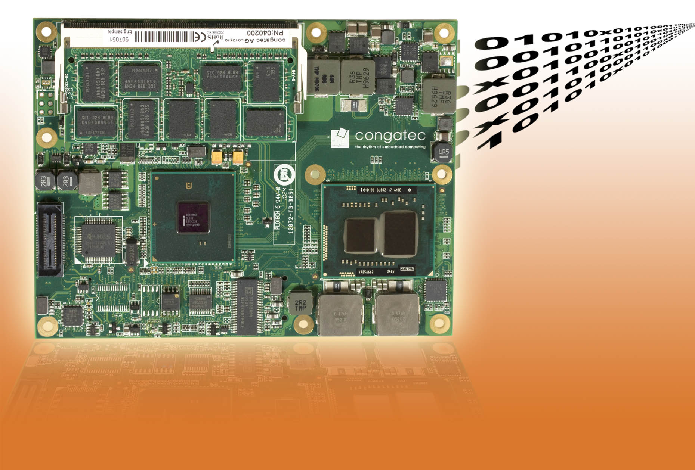
Text and Photo available: http://pr.congatec.com

Press Release 11/2010

congatec Unveils New COM Express Basic Module with
ECC Support

New conga-BE57 (95 x 125 mm) provides memory error correction feature, which ensures maximum reliability
Munich, electronica, November 9, 2010 * * * congatec AG, a leading manufacturer of embedded computer modules, adds the conga-BE57 to its COM Express product family. Designed for DDR3 ECC SODIMM memory modules and equipped with extremely low power Intel® processors in a BGA package, the conga-BE57 is particularly suitable for mission critical applications.
ECC is an abbreviation for Error Correction Code. Unlike ordinary RAM modules, ECC modules offer additional functionalities allowing them to check and control the flow of data and therefore correct errors. Due to this correction code, this type of memory module can detect and correct single bit errors as well as detect multi-bit errors. This constitutes a significant difference to the so-called "parity bit" where errors can only be recognized but not corrected. As a result of this increased reliability, computer-on-modules with ECC support are ideal for demanding applications in medical technology, server systems and the aviation industry.
Depending on the application, the conga-BE57 is based on the Intel® Celeron® U3405 processor (2MB Cache, 1.07 GHz, TDP 18 Watt) or the Intel® Core™ i7-610E processor (4MB Cache, 2.53 GHz, TDP 25 Watt). The module uses the Mobile Intel® HM55 Express Chipset, which provides support for up to 8GB (1066 MT/s) Dual Channel DDR3 SODIMM ECC memory. The integrated graphics controller supports the Intel® Flexible Display Interface (FDI) thereby enabling two independent video channels on VGA, LVDS, HDMI, SDVO and DisplayPort interfaces.
Five PCI Express Lanes, eight USB 2.0 ports, three SATA, one EIDE and a Gigabit Ethernet interface allow flexible system expansion at high data bandwidths. A fan controller and LPC bus, as well as Intel® High Definition Audio, round off the complete package.

Availability
Samples are available now.

About congatec AG
congatec AG has its head office in Deggendorf in Bavaria. It is an innovative business that specializes in the development and marketing of industrial computer modules using the standard form factors Qseven, COM Express, XTX and ETX. With this focus and annual revenue of 26 million euros (2009), congatec is today a leading manufacturer in this field. The company’s products can be used in a variety of industries and applications, such as industrial automation, medical technology, automotive supplies, aerospace and transportation. Core knowledge and technical know-how includes unique extended BIOS features as well as comprehensive driver and board support packages. Following the design-in phase, customers are given support via extensive product lifecycle management. The company’s products are manufactured by specialist service providers in accordance with modern quality standards. congatec currently has 92 employees and branch offices in the UK, Sweden, the Czech Republic, Israel, Taiwan and the USA. More information is available on our website at www.congatec.com.

* * *
Intel and Intel Core are registered trademarks of the Intel Corporation in the USA and in other countries.

congatec is an Associate Member with the Intel® Embedded Alliance, a community of communications and embedded developers and solution providers. For more information, please visit www.intel.com/go/eca

