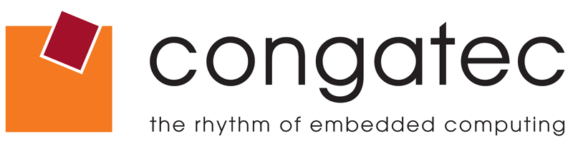

Reader Contact: | Press Contacts:
congatec AG | PRismaPR (UK + Scandinavia) | PRismaPR
Christian Eder | Monika Cunnington | Bettina Lerchenmüller
Phone: +49-991-2700-0 | Phone: +44-1462-640779 | Phone: +49-8106-24 72 33
info@congatec.com | monika@prismapr.com | info@prismapr.com
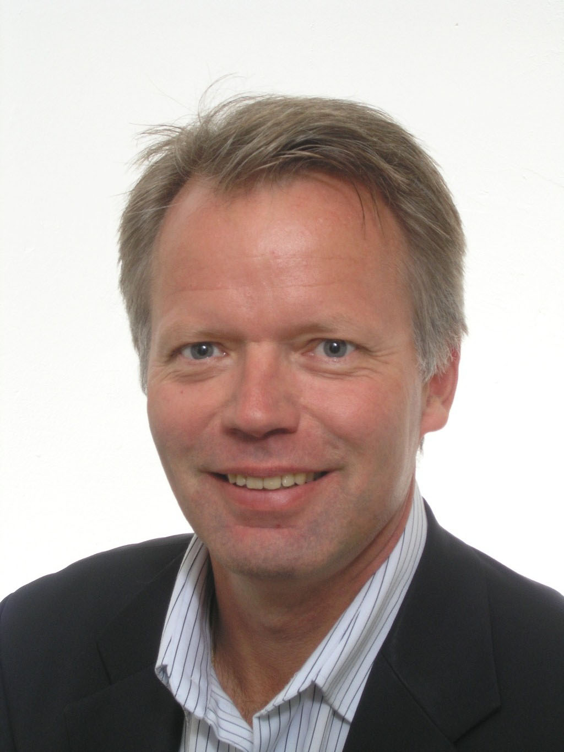

Photo available: www.congatec.com

Press Release 09/2010

congatec opens office in Scandinavia as part of its European growth initiative

Lars Hallberg has been appointed Territory Manager for the Nordic region
Deggendorf, Germany, October 19th, 2010 * * * congatec AG, a leading manufacturer of embedded computer modules, announces the appointment of Lars Hallberg as Territory Manager for Sweden, Denmark, Finland and Norway. Based at congatec's new Nordic sales and marketing office, Mr Hallberg will be responsible for the multi-channel distribution strategy that includes both partner and direct sales.
Lars Hallberg, who has more than 20 years of international experience in the application and sales of electronic components, most recently held the position of Field Sales Engineer (FSE) at Intel Embedded where he focused on servicing the company’s Nordic Broad Market customers.
In his new position, Lars aims to strengthen congatec’s customer relations in the region by delivering excellent products coupled with first-class support. “I want to make congatec the first choice for Nordic customers in the embedded market and build a reputation as the preferred vendor for innovative embedded solutions,” explains Lars.
"With the assistance of Lars we will be able to consolidate and expand our position in the Nordic region this year. His appointment is the next step of several planned sales and marketing expansions in EMEA. We recently opened a sales office in the UK, plans to open further offices are under discussion," states Axel Petrak, Member of the Executive Board responsible for Marketing & Sales at congatec.

Contact details:
congatec AG Sales and Marketing Office Nordic
Lars Hallberg
Mobile: +46 733 691959
Email: lars.hallberg@congatec.com

About congatec AG
congatec AG has its head office in Deggendorf in Bavaria. It is an innovative business that specializes in the development and marketing of industrial computer modules using the standard form factors Qseven, COM Express, XTX and ETX. With this focus and annual revenue of 26 million euros (2009), congatec is today a leading manufacturer in this field. The company’s products can be used in a variety of industries and applications, such as industrial automation, medical technology, automotive supplies, aerospace and transportation. Core knowledge and technical know-how includes unique extended BIOS features as well as comprehensive driver and board support packages. Following the design-in phase, customers are given support via extensive product lifecycle management. The company’s products are manufactured by specialist service providers in accordance with modern quality standards. congatec currently has 92 employees and has branch offices in Plzeň and Brno/Czech Republic, Taipei/Taiwan and San Diego/USA. More information is available on our website at www.congatec.com.
* * *

