

Reader Enquiries: | Press contact:
congatec AG | PRismaPR (UK + Scandinavia) | PRismaPR
Christian Eder | Monika Cunnington | Bettina Lerchenmüller
Phone: +49-991-2700-0 | Phone: +44-1462-640779 | Phone: +49-8106-24 72 33
info@congatec.com  www.congatec.com | monika@prismapr.com  www.prismapr.com | info@prismapr.com  www.prismapr.com

Visit congatec at embedded world 2012
Nuremberg, Feb. 28 – March 1 in Hall 1, Stand 350

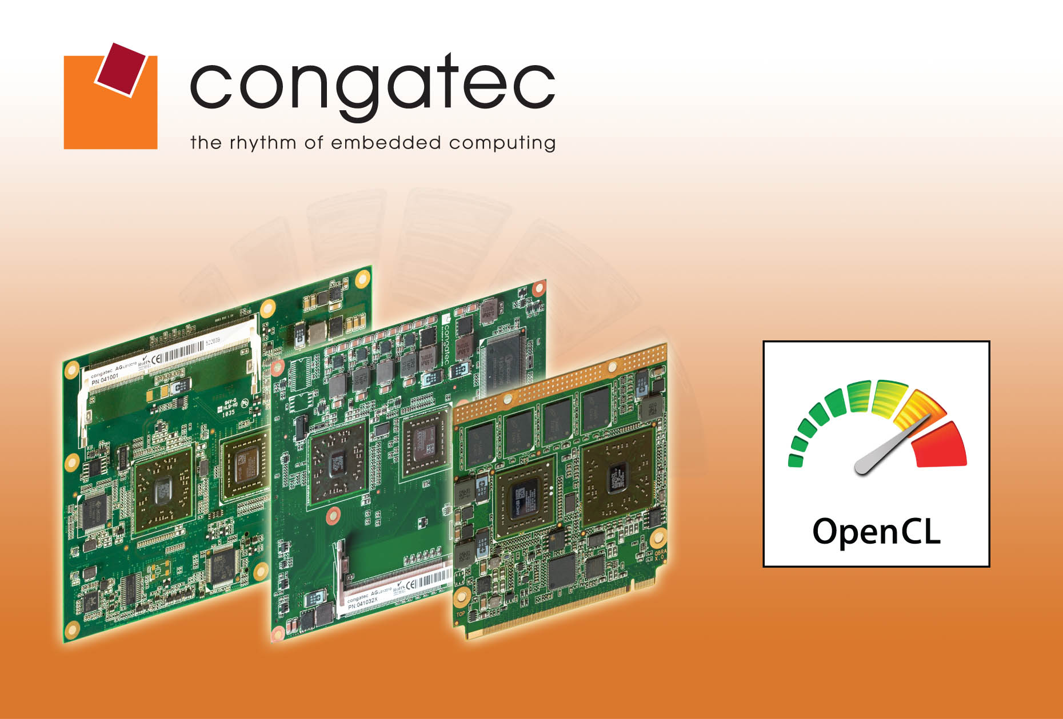
Photo and Text available: http://pr.congatec.com

Press Release 02/2012
AMD Fusion based congatec COMs support OpenCL for flexible task distribution
Computer modules from congatec with AMD Fusion technology provide OpenCL support for ETX, XTX, COM Express and Qseven standards

Deggendorf, Germany, 13 February 2012 * * * congatec AG, a leading manufacturer of embedded computer modules, supports OpenCL (Open Computing Language) for its Computer-on-Modules (COMs) with AMD Fusion technology across the popular module standards ETX, XTX, COM Express and Qseven.
OpenCL is an Application Programming Interface (API), which enables developers to take full advantage of the high performance graphics cores of AMD’s Accelerated Processing Unit (APU) for a variety of non-graphical computing tasks. For parallel tasks, the processor cores can offload jobs to the graphics unit, thereby increasing overall system performance far beyond previously possible levels.
This process can be used, for example, for filtering algorithms of photo editing programs such as Photoshop, programs for encoding and converting video data and Adobe Flash Player. In the past, developers have been struggling with the fact that traditional CPU architectures and programming tools were of limited use for vector-oriented data models with parallel multi-threading.
If the basic requirements for an X86 architecture are met, it makes sense to use a General Purpose Computation on Graphics Processing Unit (GPGPU) instead of a Digital Signal Processor (DSP). The individual GPGPU graphics engines can be programmed via OpenCL and are flexible with the option of allocating different tasks to each engine.
AMD already provides software development kits for OpenCL programming, which makes moving to a new type of data processing easier.
Offering broad scalability with a total of 7 processors in 4 standard form factors (ETX, XTX, COM Express and Qseven), congatec modules range from the multicore processor AMD T56N 1.6 GHz dual core (L1 Cache 64KB, L2 Cache 512KB x2, 18 W) to the AMD G-T40R 1.0 GHz single core (L1 Cache 64KB, L2 Cache 512KB, 5.5W) with minimal power consumption.
The integrated graphics core, with the Universal Video Decoder 3.0 for seamless processing of BluRays via HDCP (1080p), MPEG-2, HD and DivX (MPEG-4) videos, supports DirectX® 11 and OpenGL 4.0 for fast 2D and 3D imaging.
Differential interfaces such as PCI Express 2.0, SATA 3.0, USB 2.0, Gigabit Ethernet and high-definition audio are available.
With OpenCL, the high computing performance of the integrated Radeon graphics can also be used for “non-graphics” applications – a combination yielding unprecedented performance per watt values.

About congatec AG
congatec AG has its head office in Deggendorf, Germany and is a leading supplier of industrial computer modules using the standard form factors Qseven, COM Express, XTX and ETX. congatec’s products can be used in a variety of industries and applications, such as industrial automation, medical technology, automotive supplies, aerospace and transportation. Core knowledge and technical know-how includes unique extended BIOS features as well as comprehensive driver and board support packages. Following the design-in phase, customers are given support via extensive product lifecycle management. The company’s products are manufactured by specialist service providers in accordance with modern quality standards. congatec currently has 120 employees and entities in Taiwan, USA and the Czech Republic. More information is available on our website at www.congatec.com.
* * *

