

Reader Enquiries: | Press contact:
congatec AG | PRismaPR (UK + Scandinavia) | PRismaPR
Christian Eder | Monika Cunnington | Bettina Lerchenmüller
Phone: +49-991-2700-0 | Phone: +44-1462-640779 | Phone: +49-8106-24 72 33
info@congatec.com  www.congatec.com | monika@prismapr.com  www.prismapr.com | info@prismapr.com  www.prismapr.com

Visit congatec at embedded world 2012
Nuremberg, Feb. 28 – March 1 at Hall 1, Stand 350

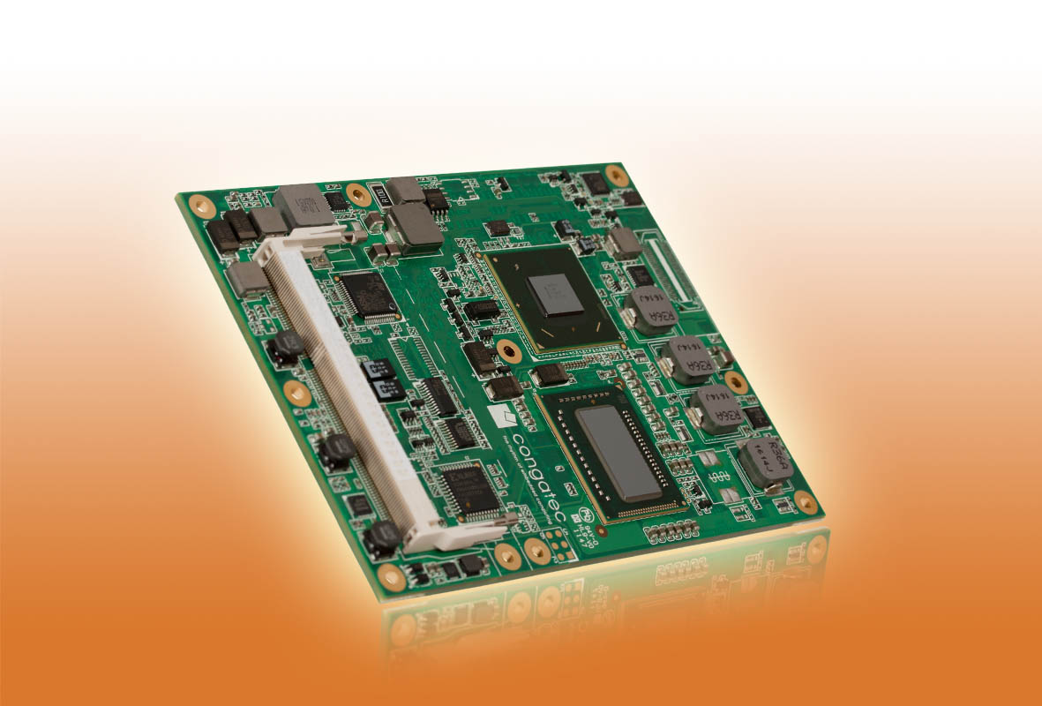
Photo and Text available: http://pr.congatec.com

Press Release 01/2012
congatec presents COM Express Type 6 module with low-power Intel® processors
conga-TS67 supports low-power Intel® processors including the Celeron® 807UE (1M Cache, 1.0 GHz) with just 10 Watt TDP

Deggendorf, Germany, 31 January 2012 * * * congatec AG, a leading manufacturer of embedded computer modules, announces the conga-TS67, a new low-power module for advanced designs. It supports Pin-out Type 6 and provides improved display options along with increased bandwidth thanks to digital display interfaces and additional PCI Express lanes. With new, super low-power Intel® processors soldered on in a BGA package, the module is suitable for vibration-resistant applications.
The module is available in four second generation low-power Intel® Core™ processor versions, from the Intel® Celeron® 807UE processor (1M Cache, 1.0 GHz) with just 10 Watt TDP to the Intel® Core™ i7 2610UE dual core processor (4M Cache, 1.50 GHz) with 17 Watt TDP and up to 8 GB dual-channel DDR3 memory (1333 MHz). Pin-out Type 6 is the ideal solution for the implemented Intel® QM67 Express chipset series and future generations. In addition to VGA and LVDS, it provides three digital display interfaces, which can each be configured for DisplayPort (DP), HDMI or DVI and which – in contrast to Type 2 modules – are no longer multiplexed. Type 6 also features a PEG (PCI Express Graphics) port enabling the connection of additional powerful graphics components for maximum display support, for instance in gaming and medical applications.
The biggest highlight of the COM Express Basic module (95x125 mm) is its outstanding graphics performance. Compared with previous Intel generations the 3D performance has again increased significantly. The Intel® HD graphics supports Intel® Clear Video Technology and DirectX Video Acceleration (DXVA) for faster video processing. In combination with the additional computing power provided by the second generation of Intel® Core™ processors, the conga-TS67 is the ideal solution for demanding graphics applications in the gaming, medical technology, automation and digital signage sector. The integrated video decoding function enables real-time processing of incoming video streams.
Seven PCI Express Lanes, PCI Express Graphics (PEG) x16 Lanes for high-performance external graphics cards, eight USB 2.0 ports, four SATA interfaces with RAID support, one EIDE and a 1GB Ethernet interface enable fast and flexible system updating. Fan control, an LPC bus for the easy connection of Legacy I/O interfaces and Intel® High Definition Audio complete the feature set.
All conga-TS67 modules are fitted with the new UEFI embedded firmware solution.
The congatec board controller comes with an extensive embedded PC feature set. Independence from the x86 processor allows functions such as system monitoring and I²C bus to work faster and more reliably – even when the system is in standby mode.
A suitable evaluation carrier board for COM Express Type 6 is also available.

About congatec AG
congatec AG has its head office in Deggendorf, Germany and is a leading supplier of industrial computer modules using the standard form factors Qseven, COM Express, XTX and ETX. congatec’s products can be used in a variety of industries and applications, such as industrial automation, medical technology, automotive supplies, aerospace and transportation. Core knowledge and technical know-how includes unique extended BIOS features as well as comprehensive driver and board support packages. Following the design-in phase, customers are given support via extensive product lifecycle management. The company’s products are manufactured by specialist service providers in accordance with modern quality standards. congatec currently has 112 employees and entities in Taiwan, USA and the Czech Republic. More information is available on our website at www.congatec.com.
* * *
Intel and Intel Core are registered trademarks of the Intel Corporation in the USA and in other countries.
congatec is an Associate Member of the Intel® Embedded Alliance, a community of communications and embedded developers and solution providers. For more information, please visit www.intel.com/go/eca

