

Reader Contact: | Press Contacts:
congatec AG | PRismaPR (UK + Scandinavia) | PRismaPR
Christian Eder | Monika Cunnington | Bettina Lerchenmüller
Phone: +49-991-2700-0 | Phone: +44-1462-640779 | Phone: +49-8106-24 72 33
info@congatec.com | monika@prismapr.com | info@prismapr.com

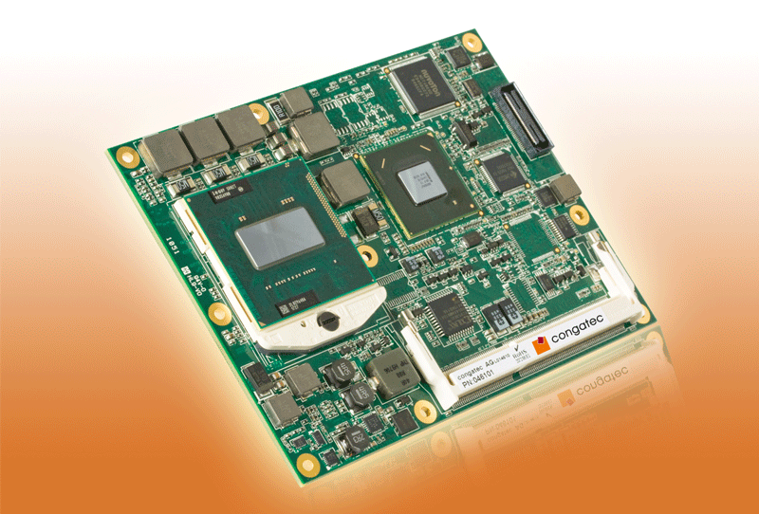
Photo available: http://pr.congatec.com
Press Release 01/2011
congatec announces new COM Express small form factor module based on 2nd Generation Intel® Core™ processor family

New conga-BM67 delivers with the Intel® CoreTM i7-2710QE processor
(2.1 GHz, 45W, PGA), one of Intel's latest mobile quad-core processors supported for the embedded market

Las Vegas, Nevada, Consumer Electronic Show (CES), January 5, 2011 * * * congatec AG extends its Intel® processor-based COM Express product family with the new highest performance module conga-BM67. It features the latest 2nd Generation Intel® Core™ processors lsuch as the Intel® Core™ i7-2710QE processor (2.1 GHz, 45W, PGA) and the dual-core Intel® Core™ i5-2510E processor (2.5 GHz, 35W, PGA) with up to 8 GByte dual channel DDR3 memory (1333 MHz).

The conga-BM67 is a two chip solution that utilizes the new powerful Intel® QM67 Express chipset.
The processor graphics supports the Intel® Flexible Display Interface (FDI), which allows for two independent video channels on the VGA, LVDS, HDMI, DisplayPort or SDVO interfaces.
The major highlight of the Type 2 pinout COM Express Basic (95x125mm) module is the boost in graphics performance. The 3D performance has been increased substantially when compared to Intel's previous generation of processor-graphics. The Intel® HD graphics supports Intel® Clear Video Technology and DirectX Video Acceleration (DXVA) for accelerated video processing. Paired with the additional computing performance of the 2nd Generation Intel® Core™ processor family, the conga-BM67 is an ideal solution for intense graphics applications that are often found in gaming, medical, automation or digital signage applications.

Six PCI Express lanes, eight USB 2.0 ports, four SATA with RAID support, one EIDE and a Gigabit Ethernet interface allow for fast and flexible system extensions. Fan control, LPC bus for slow speed extensions and Intel® High Definition Audio complete the feature set.

All conga-BM67 modules are equipped with an embedded UEFI and board controller that enhance embedded features such as system monitoring, watchdog timer and the I²C bus. The board controller has the ability to isolate itself from the main x86 processor and therefore can provide these features even when in stand-by mode, which in turn offers further power saving functionality. In addition to enhanced power management, the congatec embedded UEFI also supports ACPI 3.0 battery management.

About congatec AG
congatec AG has its head office in Deggendorf in Bavaria. It is an innovative business that specializes in the development and marketing of industrial computer modules using the standard form factors Qseven, COM Express, XTX and ETX. With this focus and annual revenue of 26 million euros (2009), congatec is today a leading manufacturer in this field. The company’s products can be used in a variety of industries and applications, such as industrial automation, medical technology, automotive supplies, aerospace and transportation. Core knowledge and technical know-how includes unique extended BIOS features as well as comprehensive driver and board support packages. Following the design-in phase, customers are given support via extensive product lifecycle management. The company’s products are manufactured by specialist service providers in accordance with modern quality standards. congatec currently has 92 employees and branch offices in the UK, Sweden, the Czech Republic, Israel, Taiwan and the USA. More information is available on our website at www.congatec.com.

* * *
Intel and Intel Core are registered trademarks of the Intel Corporation in the USA and in other countries.
congatec is an Associate Member with the Intel® Embedded Alliance, a community of communications and embedded developers and solution providers. For more information, please visit www.intel.com/go/eca

