Reader enquiries: | Press contact:
congatec AG | SAMS Network
Christian Eder | Michael Hennen
Phone: +49-991-2700-0 | Phone: +49-2405-4526720
info@congatec.com  www.congatec.com | info@sams-network.com  www.sams-network.com

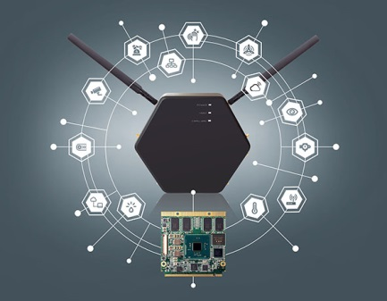

Text and photograph available at: http://www.congatec.com/press

Press release

congatec introduces highly flexible IoT gateway

Easily customizable for rapid field deployments

Deggendorf, Germany, August 16, 2016 * * * congatec, a leading technology company for embedded computer modules, single board computers and embedded design and manufacturing services, introduces its flexible IoT gateway. This new, highly flexible IoT gateway hardware platform is application ready and easily customizable for rapid field deployment. The congatec IoT gateway offers extreme levels of flexibility in terms of processing performance and software integration, able to host up to 8 wireless antennas that can be connected to 3 mini PCI Express slots and 6 internal USB based slots for wireless and wired connectivity modules. Customized system designs can be created upon request.

OEMs utilizing the conga IoT gateway platformbenefit from a pre-configured, pre-certified IoT gateway that can easily connect a wide range of heterogeneous sensors and systems to cloud-based services. Target uses include Industrial Internet of Things (IIoT) applications such as smart cities, smart agriculture, connected homes and vehicles, digital signage systems and other IoT applications.

congatec’s CEO Jason Carlson explains its IoT gateway strategy: “The large and fast growing IoT market is well served by congatec’s traditional embedded computer boards and module products, but OEMs are increasingly demanding application-ready IoT gateways. To meet this growing need, congatec has designed a highly flexible and configurable gateway platform that can be optimized to meet a wide variety of specific application demands. Together with our embedded design and manufacturing services, we can now meet any specific IoT gateway requirement.” As well as the engineering and production of optimized IoT solutions, congatec‘s embedded design and manufacturing service also includes certification services, an increasingly essential element of deploying wireless technologies and edge devices that connect to carrier grade infrastructures.

The wireless connectivity of the congatec IoT gateway is extremely scalable: 6 internal USB ports and 3 miniPCIe slots are available and able to support LTE 3GPP modems, 2x WI-FI, 2x LAN with PoE and PROFINET features, low power BlueTooth (BTLE) and 6LoWPAN. Other low power wide area networks including LORA, 3GPP, LTE-MTC, Sigfox or UNB can be supported upon customer request. This allows for maximum flexibility in supporting all major IoT connectivity requirements. The housing is equipped to mount up to 8 antennas supporting multiple wireless standards in parallel, while enhancing signal quality by utilizing antenna diversity. The small size (200x230x40mm³) metal housing is certified to IP53 protection class for outdoor applications.

In order to deliver optimal and rapid IoT gateway designs, congatec developed the platform to support scalable computing performance utilizing Qseven modules, which range from the NXP single-core i.MX6 processor up to a quad core Intel® Pentium® CPU. The gateway also supports the upcoming next generation of Intel® Atom™ processors (Intel code name “Apollo Lake”) for deployment in emerging IoT gateway and edge computing application scenarios, up to high availability fog computing systems.

The congatec embedded board support packages cover all major operating systems – including Windows 10 IoT – to enable easier software integration. The congatec IoT gateway platform also supports all the features of congatec’s embedded board controller, which are a must for reliable IoT applications. Amongst other functions, the congatec feature set enables secure boot, management of Multi-Master I²C Bus, Multi Stage Watchdog, non-volatile User Data Storage, Manufacturing and Board Information, Board Statistics, as well as Power Loss Control.

Talk to your congatec sales representative today to discover how your IoT applications can be implemented using the congatec IoT gateway hardware platform.

About congatec AG
Headquartered in Deggendorf, Germany, congatec AG is a leading supplier of industrial computer modules using the standard form factors COM Express, Qseven and SMARC as well as single board computers and EDM services. congatec’s products can be used in a variety of industries and applications, such as industrial automation, medical, entertainment, transportation, telecommunication, test & measurement and point-of-sale. Core knowledge and technical know-how includes unique extended BIOS features as well as comprehensive driver and board support packages. Following the design-in phase, customers are given support via extensive product lifecycle management. The company’s products are manufactured by specialist service providers in accordance with modern quality standards. Currently congatec has entities in Taiwan, Japan, China, USA, Australia and the Czech Republic. More information is available on our website at www.congatec.com or via Facebook, Twitter and YouTube.

* * *

Intel and Intel Atom, Pentium are registered trademarks of Intel Corporation in the U.S. and other countries.

